Case 21 Kickbacks on US Concentration Camps--KBR

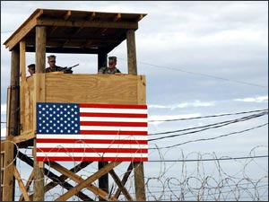

Table of Contents

US Concentration Camps 1
Obstruction of the Investigation of the Shadow Government by Director of CIA, Michael Hayden 1
Concentration Camp Kickback Exposed 1
Another Article on the 600 US Concentration Camps 1
Epilogue 1
US Concentration Camps

Ex-US Intelligence operative Al Martin exposed the Shadow Government’s plan to arrest all those that opposed them in the future in his book The Conspirators. That CIA operation Sledgehammer started under Reagan with Bush, Sr. as Vice President. It is important for people to take non-violent action against that before it becomes more difficult. Educate yourself and your friends in non-violent resistance such as by reading Gene Sharp’s book


Waging Nonviolent Struggle: 20th Century Practice And 21st Century Potential by Gene Sharp, Joshua Paulson, Christopher A. Miller, and Hardy Merriman (Paperback - Mar 30, 2005)

Non-violent resistance is extremely powerful, more powerful than any army or amount of money and power, if you know what to do and have courage. The Shadow Government refuses to let US soldiers be trained in effective forms of it; they are afraid that the US soldiers would stop obeying illegal orders.

San Francisco Chronicle
Rule by fear or rule by law?
Lewis Seiler,Dan Hamburg

Monday, February 4, 2008

"The power of the Executive to cast a man into prison without formulating any charge known to the law, and particularly to deny him the judgment of his peers, is in the highest degree odious and is the foundation of all totalitarian government whether Nazi or Communist."

- Winston Churchill, Nov. 21, 1943

“Since 9/11, and seemingly without the notice of most Americans, the federal government has assumed the authority to institute martial law, arrest a wide swath of dissidents (citizen and noncitizen alike), and detain people without legal or constitutional recourse in the event of "an emergency influx of immigrants in the U.S., or to support the rapid development of new programs."

Beginning in 1999, the government has entered into a series of single-bid contracts with Halliburton subsidiary Kellogg, Brown and Root (KBR) to build detention camps at undisclosed locations within the United States. The government has also contracted with several companies to build thousands of railcars, some reportedly equipped with shackles, ostensibly to transport detainees.

According to diplomat and author Peter Dale Scott, the KBR contract is part of a Homeland Security plan titled ENDGAME, which sets as its goal the removal of "all removable aliens" and "potential terrorists."

Fraud-busters such as Rep. Henry Waxman, D-Los Angeles, have complained about these contracts, saying that more taxpayer dollars should not go to taxpayer-gouging Halliburton. But the real question is: What kind of "new programs" require the construction and refurbishment of detention facilities in nearly every state of the union with the capacity to house perhaps millions of people?

Sect. 1042 of the 2007 National Defense Authorization Act (NDAA), "Use of the Armed Forces in Major Public Emergencies," gives the executive the power to invoke martial law. For the first time in more than a century, the president is now authorized to use the military in response to "a natural disaster, a disease outbreak, a terrorist attack or any other condition in which the President determines that domestic violence has occurred to the extent that state officials cannot maintain public order."

The Military Commissions Act of 2006, rammed through Congress just before the 2006 midterm elections, allows for the indefinite imprisonment of anyone who donates money to a charity that turns up on a list of "terrorist" organizations, or who speaks out against the government's policies. The law calls for secret trials for citizens and noncitizens alike.

Also in 2007, the White House quietly issued National Security Presidential Directive 51 (NSPD-51), to ensure "continuity of government" in the event of what the document vaguely calls a "catastrophic emergency." Should the president determine that such an emergency has occurred, he and he alone is empowered to do whatever he deems necessary to ensure "continuity of government." This could include everything from canceling elections to suspending the Constitution to launching a nuclear attack. Congress has yet to hold a single hearing on NSPD-51.

U.S. Rep. Jane Harman, D-Venice (Los Angeles County) has come up with a new way to expand the domestic "war on terror." Her Violent Radicalization and Homegrown Terrorism Prevention Act of 2007 (HR1955), which passed the House by the lopsided vote of 404-6, would set up a commission to "examine and report upon the facts and causes" of so-called violent radicalism and extremist ideology, then make legislative recommendations on combatting it.

According to commentary in the Baltimore Sun, Rep. Harman and her colleagues from both sides of the aisle believe the country faces a native brand of terrorism, and needs a commission with sweeping investigative power to combat it.

A clue as to where Harman's commission might be aiming is the Animal Enterprise Terrorism Act, a law that labels those who "engage in sit-ins, civil disobedience, trespass, or any other crime in the name of animal rights" as terrorists. Other groups in the crosshairs could be anti-abortion protesters, anti-tax agitators, immigration activists, environmentalists, peace demonstrators, Second Amendment rights supporters ... the list goes on and on. According to author Naomi Wolf, the National Counterterrorism Center holds the names of roughly 775,000 "terror suspects" with the number increasing by 20,000 per month.

What could the government be contemplating that leads it to make contingency plans to detain without recourse millions of its own citizens?

The Constitution does not allow the executive to have unchecked power under any circumstances. The people must not allow the president to use the war on terrorism to rule by fear instead of by law.

Lewis Seiler is the president of Voice of the Environment, Inc. Dan Hamburg, a former congressman, is executive director.

This article appeared on page B - 7 of the San Francisco Chronicle”
http://www.sfgate.com/cgi-bin/article.cgi?f=/c/a/2008/02/04/ED5OUPQJ7.DTL

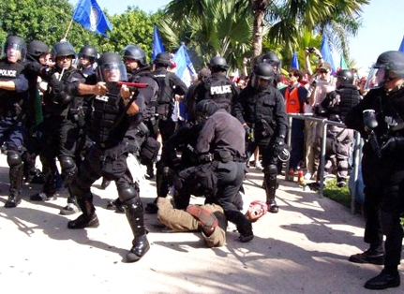
Halliburton Detention Camps For Political Subversives
Paul Joseph Watson/Prison Planet.com | February 1 2006
  - “In another shining example of modern day corporate fascism, it was announced recently that Halliburton subsidiary Kellogg, Brown and Root had been awarded a $385 million dollar contract by Homeland Security to construct [more] detention and processing facilities in the event of a national emergency.
  - The language of the preamble to the agreement veils the program with talk of temporary migrant holding centers, but it is made clear that the camps will also be used "as the development of a plan to react to a national emergency."
  - Discussions of federal concentration camps is no longer the rhetoric of paranoid Internet conspiracy theorists, it is mainstream news.
  - Under the enemy combatant designation anyone at the behest of the US government, even if they are a US citizen, can be kidnapped and placed in an internment facility forever without trial. Jose Padilla, an American citizen, has spent over four years in a Navy brig and is only just now getting a trial.
  - In 2002, FEMA sought bids from major real estate and engineering firms to construct giant internment facilities in the case of a chemical, biological or nuclear attack or a natural disaster.
  - Okanogan County Commissioner Dave Schulz went public three years ago with his contention that his county was set to be a location for one of the camps.
  - 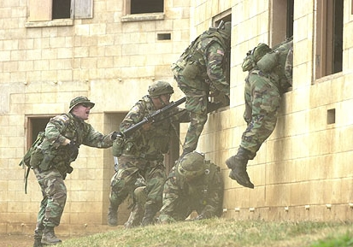
  - Alex Jones has attended numerous military urban warfare training drills across the US where role players were used to simulate arresting American citizens and taking them to internment camps.
  - The move towards the database state in the US and the UK, where every offence is arrestable and DNA records of every suspect, even if later proven innocent, are permanently kept on record, is the only tool necessary to create a master list of 'subversives' that would be subject to internment in a manufactured time of national emergency.
  - The national ID card is also intended to be used for this purpose, just as the Nazis used early IBM computer punch card technology to catalogue lists of homosexuals, gypsies and Jews before the round-ups began.
  - Section 44 of the Terrorism Act in Britain enables police to obtain name and address details of anyone they choose, whether they are acting suspiciously or not. Those details remain on a database forever. To date, 119,000 names of political activists have been taken and this is a figure that will skyrocket once the post 7/7 figures are taken into account. At the height of the Iraq war protests, around a million people marched across the country. However, most of these people were taking part in a political protest for the first time and as a one off. Even if we take a figure of half, 500,000 people being politically active in Britain, that means that the government has already registered around a quarter of political activists in the UK.
  - In truth the number is probably above half because we are not factoring in those already on MI5 'subversive' lists and those listed after the 7/7 bombings, when the powers were used even more broadly.
  - 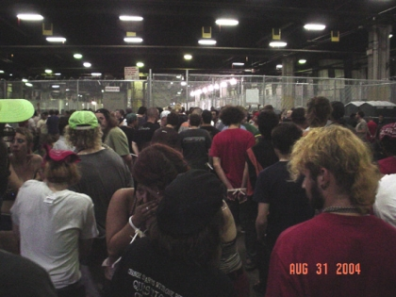
  - Concurrently in the US, a new provision in the extended Patriot Act bill would allow Secret Service agents to arrest and jail protesters accused of breaching any security perimeter, even if the President or any other protected official isn't present. The definition of 'free speech zones' can be shifted around loosely and this would open the floodgates for protesters to be grabbed and hauled away in any circumstance at the whim of the Secret Service.
  - During the 2004 RNC protests, thousands of New Yorkers were arrested en masse in indiscriminate round-ups and taken to Pier 57 (pictured), a condemned, asbestos poisoned old bus depot, where they were imprisoned without charge for up to 24 hours or more.
  - The existence and development of internment camps are solely intended to be used to round up en masse and imprison 'political dissidents' (anyone who isn't prepared to lick government boots) after a simulated tactical nuke or biological attack on a major US or European city.”
  - http://www.prisonplanet.com/articles/february2006/010206detentioncamps.htm

Concentration Camps identified in U.S.A.!
http://www.youtube.com/watch?v=ZYi9n8K1d3M

13-minute video Concentration Camps being built for U.S citizens
http://www.youtube.com/watch?v=dJBxdRIQx7Y

122-minute documentary Alex Jones - Police State 2000
“The powerful central government is gearing up for the TOTAL TAKEOVER Alex Jones exposes the growing relationship between the military and police. Witness US marines training with foreign troops and learning how to control and contain civilian populations as practiced during Operation: Urban Warrior. You will see special forces helicopter attacks on south Texas towns, concentration camps, broad Unconstitutional police actions, search and seizure and more…”

Alex Jones - The Masters of Terror

2-minute clip Concentration Camps in United States
http://www.youtube.com/watch?v=yMhA4nzuoUM

5-minute clip FEMA: Part I - The Truth
http://www.youtube.com/watch?v=4zr0_9P-gz8

5-minute clip FEMA: Part II - The Camps Put in Nazi Section
http://www.youtube.com/watch?v=e3rl1FbDT2o

Please see more information and videos at;
http://www.prisonplanet.com/articles/february2008/180208camps.htm
www.prisonplanet.com

http://www.apfn.org/apfn/camps.htm
http://www.abovetopsecret.com/pages/camps.html

Obstruction of the Investigation of the Shadow Government by Director of CIA, Michael Hayden

Now that you know that a Shadow Government exists by the fact of the existence of massive numbers of Concentration camps having been built in the US, I will show you how a person can expose those who are conspirators in it.

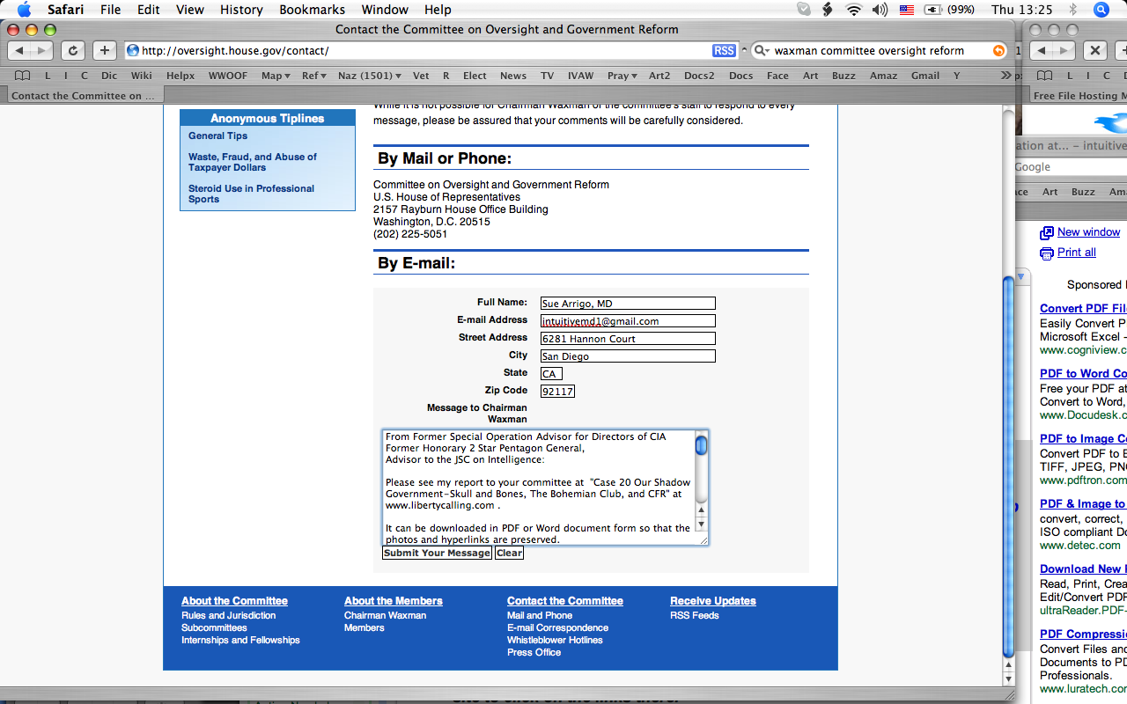

Here is the screenshot showing my submitting Case 20 to Congressman Waxman’s Committee on Oversight and Government Reform today at 13:25 Rome time on July 3, 2008. The print is a little hard to read so here is the text inside the webform window;

  - “From Former Special Operation Advisor for Directors of CIA
  - Former Honorary 2 Star Pentagon General,
  - Advisor to the JSC on Intelligence:

  - Please see my report to your committee at "Case 20 Our Shadow Government-Skull and Bones, The Bohemian Club, and CFR" at www.libertycalling.com .

  - It can be downloaded in PDF or Word document form so that the photos and hyperlinks are preserved.

  - I am very concerned about the Congress, which in my opinion is not doing an effective job in protecting our Constitution and ensuring that the government is "for the people, by the people, and of the people". Clearly, allowing a shadow government to operate behind the scenes is to allow a coup against the United States of America. Since each member has taken a sworn oath to protect it from all enemies foreign and domestic, any failure to do so is clearly treason.

  - Please let me know when you have finished giving each member of your committee a copy of my submission which includes Cases 1 to 20. They are all at www.libertycalling.com under Special Report.

  - Thank you for your prompt attention to this matter which is of vital importance to our National Security, our Freedom, and our Democracy.”

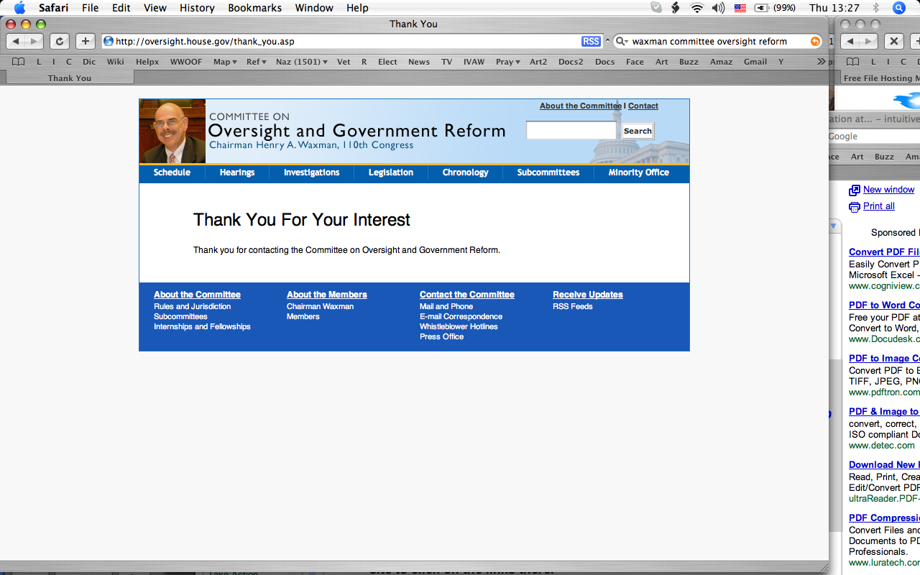

This screenshot confirms that the Committee got my message. That is important documentation because if they do not act appropriately on the information that proves their treason. Perhaps we will only precipitate a Warren Commission style cover up. That’s fine because in the JFK Assassination Case I am close to finishing, I will show you how to use the coverup to show who is guilty of conspiracy.

Congress people are in a very vulnerable position when they undermine the Constitution because their votes are a matter of public record. So, in a future case we will use their votes in a counter intelligence analysis to show you who is part of the conspiracy to destroy American Democracy and build the concentration camps

Since it is also the duty of the FBI to investigate domestic enemies to our country’s sovereignty, I wanted to send Case 20 off to the FBI to investigate as well. When I tried to get to their Tip Hotline which I have used successfully from my computer recently, here is what happened this time.
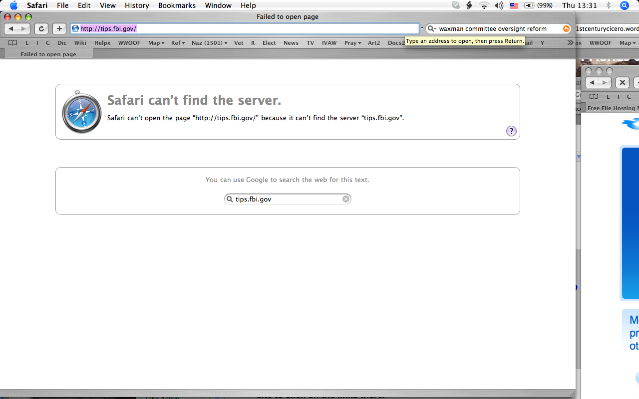

The error message says that my web browser Safari can’t open the page “http://tips.fbi.gov/” because it can’t find the server “tips.fbi.gov” . That is pretty shocking that it can’t find the FBI, unless I have typed the web page wrong.
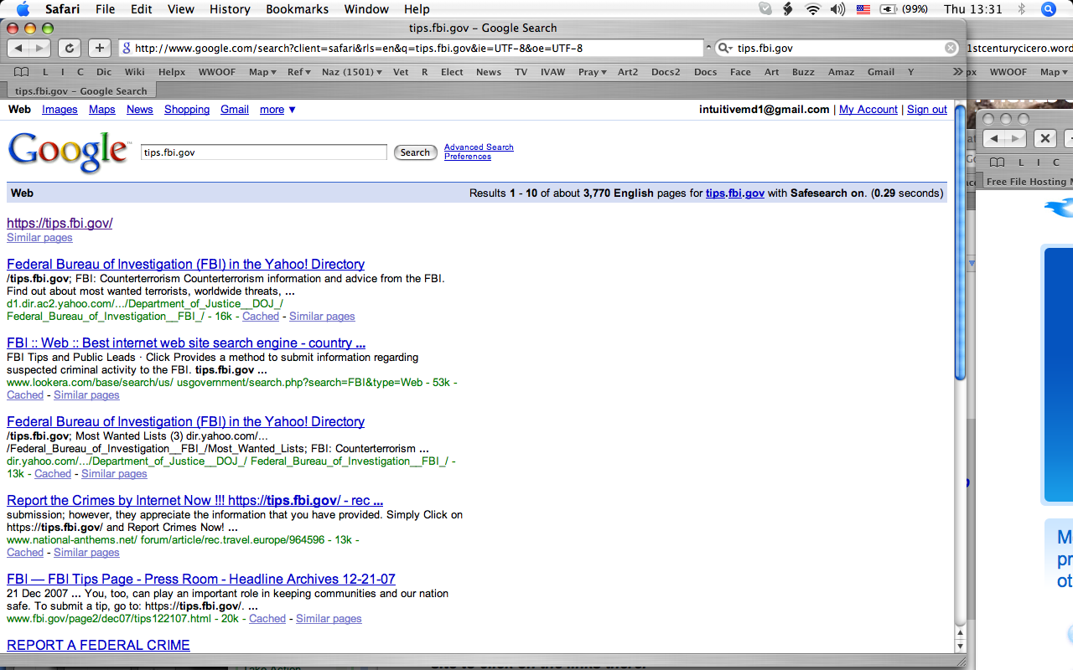There it is over and over again on the page, https://tips.fbi.gov , just as I typed it. 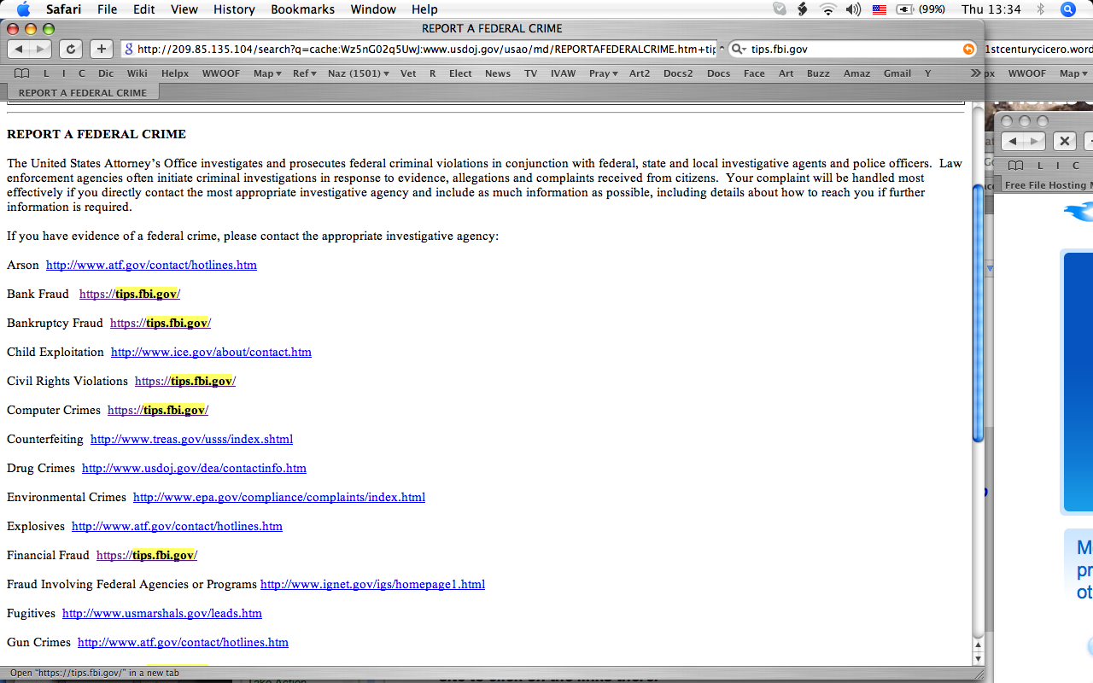

Because the Hidden Hand does not want to be caught interfering with my computer since I am not a terrorist but a non-violence expert, they sometimes back off their obstruction of me. Here at 13:34 a page has loaded which has links to report a Federal Crime on. I click on the one for Financial Fraud. It is still that same https://tips.fbi.gov/ one. This time the FBI Hot Tip Webform loads the exact same web page that it would not just a couple of minutes before.

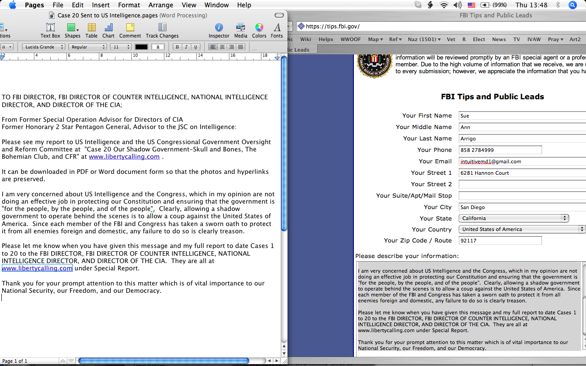

Here is the FBI Tips page filled in with my letter in the webform also displayed on the left so that you can see it in full. Since it is a bit hard to read here is the letter which is almost the same as to Congress;

  - “TO FBI DIRECTOR, FBI HEAD OF COUNTER INTELLIGENCE, NATIONAL INTELLIGENCE DIRECTOR, AND DIRECTOR OF THE CIA;

  - From Former Special Operation Advisor for Directors of CIA
  - Former Honorary 2 Star Pentagon General, Advisor to the JSC on Intelligence:

  - Please see my report to US Intelligence and the US Congressional Government Oversight and Reform Committee at ‘Case 20 Our Shadow Government-Skull and Bones, The Bohemian Club, and CFR’ at www.libertycalling.com .

  - It can be downloaded in PDF or Word document form so that the photos and hyperlinks are preserved.

  - I am very concerned about US Intelligence and the Congress, which in my opinion are not doing an effective job in protecting our Constitution and ensuring that the government is ‘for the people, by the people, and of the people’. Clearly, allowing a shadow government to operate behind the scenes is to allow a coup against the United States of America. Since each member of the FBI and Congress has taken a sworn oath to protect it from all enemies foreign and domestic, any failure to do so is clearly treason.

  - Please let me know when you have given this message and my full report to date Cases 1 to 20 to the FBI DIRECTOR, FBI HEAD OF COUNTER INTELLIGENCE NATIONAL INTELLIGENCE DIRECTOR, AND DIRECTOR OF THE CIA. They are all at www.libertycalling.com under Special Report.

  - Thank you for your prompt attention to this matter which is of vital importance to our National Security, our Freedom, and our Democracy.”

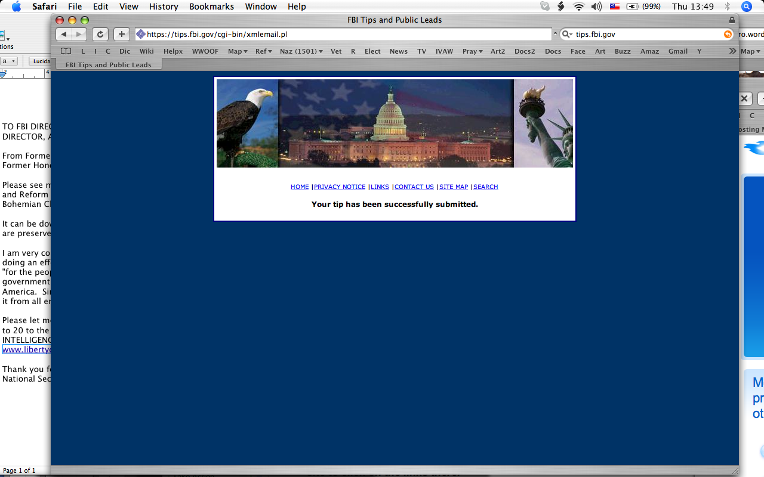

Here is the acknowledgment that the FBI received my letter.

This is a bit boring, I know, but bear with me because we are establishing witting guilt for who is preventing the investigation of the Shadow Government; they are the conspirators in it.

The CIA Director also has the sworn responsibility to protect our country from all enemies foreign and domestic. I have also used the CIA’s webform from this computer. This time when I type in the address it goes right through without the Hidden Hand’s interference.

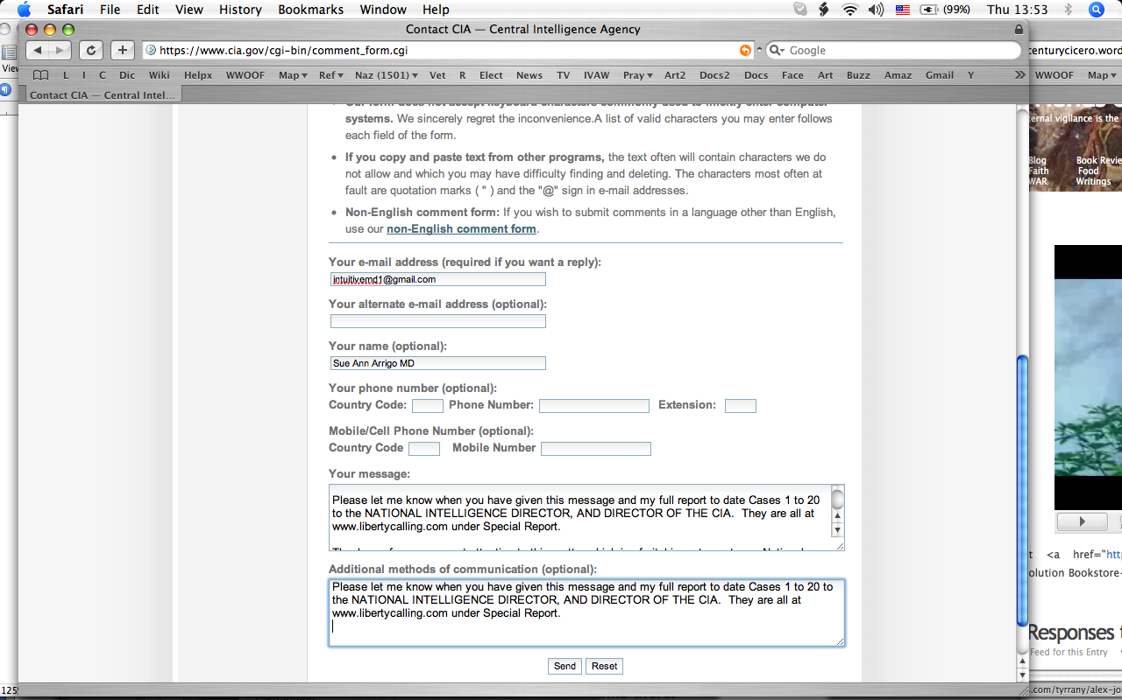

  - Note that the address is www.cia.gov/cgi-bin/comment_form.cgi and that we are at the CIA’s website. Here I have entered the same letter omitting the FBI officials from it. Notice that I have added my full name and my email address. I entered the whole letter in the window that says “Your Message” and reiterated just three lines of it in the window that says “Additional methods of communication (optional).

  - Then I clicked on the send button. I just tried to navigate back to the CIA’s webform to show you what I saw after I sent the letter. But the CIA would not let me load the page to show you, more on that below. The CIA’s webform is quite tricky because after you send it you see a new page. That change makes it appear that your message was received. But the page does not acknowledge receipt in words. That allows the CIA plausible deniability, if you did not check further; they could say that they never received your message. When I scrolled down to the bottom of that page this is what I saw.
  - 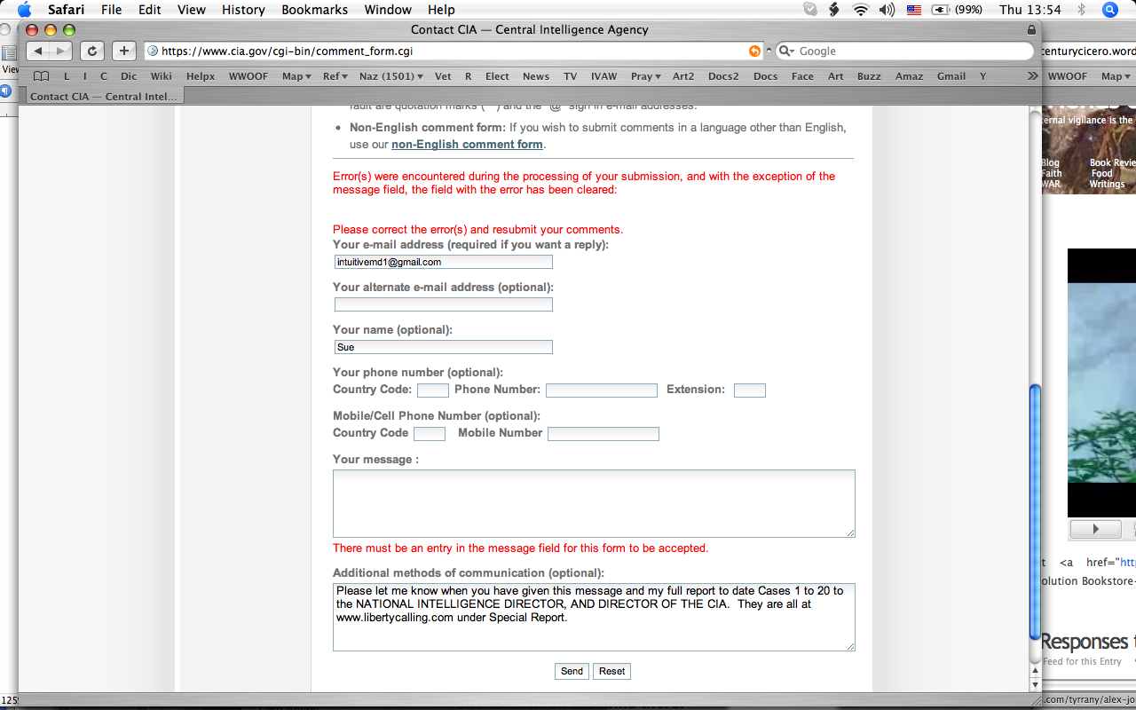

  - The CIA’s form says in red

  - Errors were encountered during the processing of your submission, and with the exception of the message field, the field with the error has been cleared.

  - Please correct the error(s) and resubmit your comments.

  - Then under the “Your Message:” window it reads

  - There must be an entry in the message field for this form to be accepted.

  - Note that they said that they would not strip out the message window. That is so you could correct an error in another field without having to type in the whole message over again. It is the standard behavior of the form to not strip it out. But in my case the CIA did strip it out because it was the content in the message window that they did not want and was the error on the page from their point of view. I allege that they knew enough time in advance because they had been watching my computer. In addition to stripping out my message they stripped out my middle and last name. They might then try to use that as an excuse later by saying, “Well, we didn’t know who the message was from because the sender never entered their full name!”

  - Here they are blaming me for not filling in the message field which I did fill in. The CIA is in the business of collecting information. They start watching any computer that logs onto their site by snooping inside of it. They record every message written to them as well as much more that was not written to them. They are just “playing dead” here to try to deny that they received my message. To know that they want to “play dead” and not receive it they have to have been watching what I was up to just prior to that. They showed that they knew that because they tried to keep me from sending a message to the FBI. And what was the message about? The Shadow Govt. So, they are part of the Shadow govt. that does not want the FBI to investigate.

  - Next, I put the same message back in both windows this time. Here is what that looked like before I pressed the submit button again.

  - 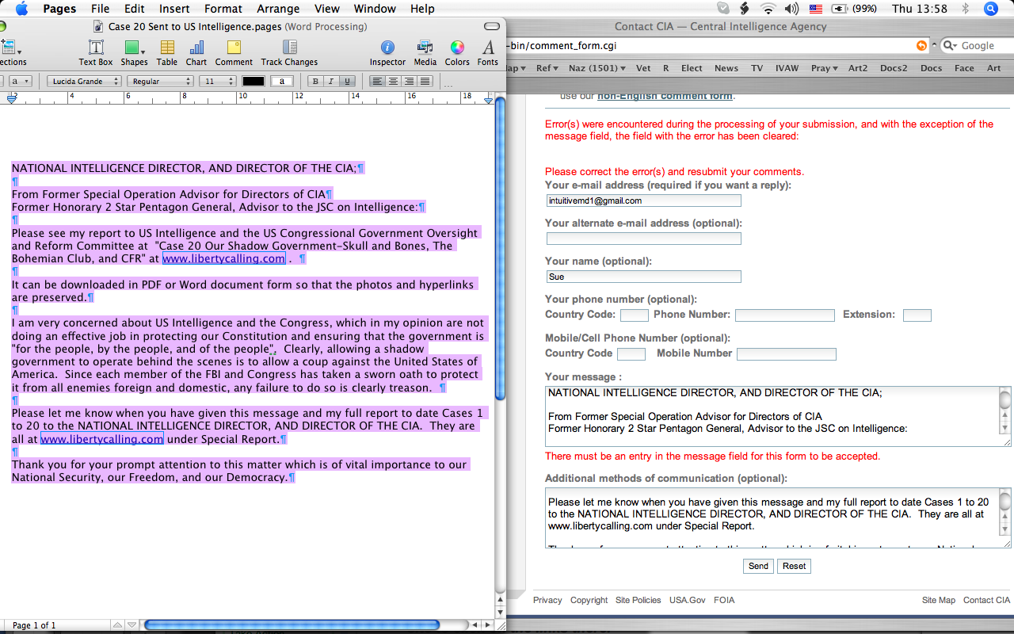

  - Again there really is a message in the message window. The full message is seen on the left.

  - After I pressed Send, I again saw a screen change making it seem like the message was received.

  - 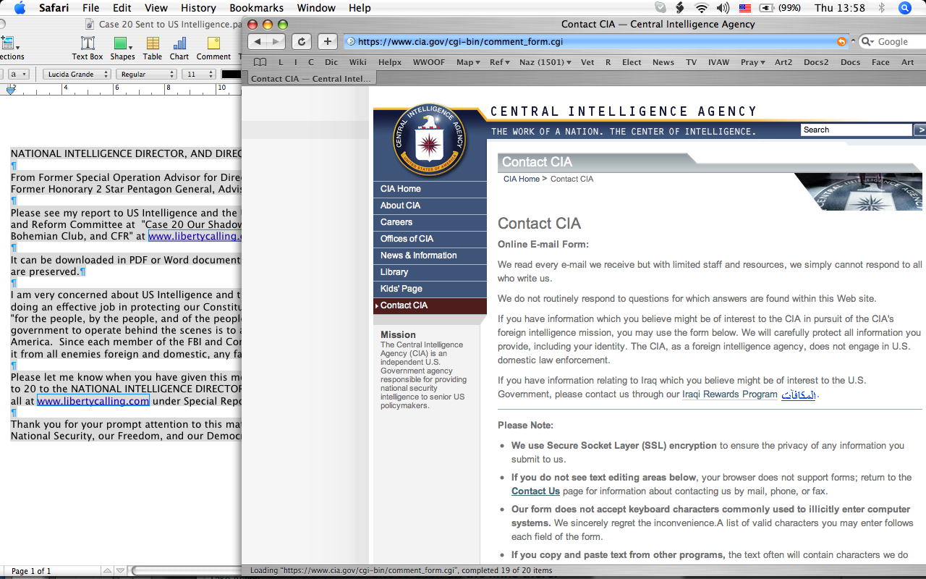

But when I scrolled down again, again the form had been partially cleared. Last time my last name was removed, this time they have removed my email address and my first name as well. And again the content of the message window was deleted. Here you see the form after I have pasted the message into both main windows again.

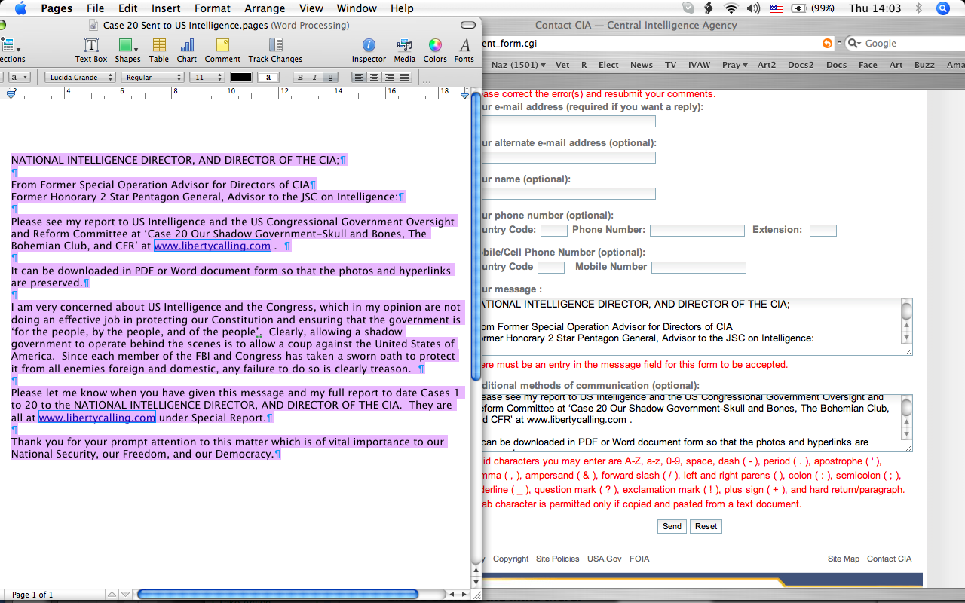

The new writing in red says that only certain character are acceptable. The CIA wants intelligence tips from Russians, Chinese, Arabs, etc. Their computer is set up to receive every conceivable script and punctuation. This is just another ploy to pretend that they were unable to receive the message. That is clear because they did not announce any restrictions at the beginning or even after the first presumed rejection of the message. I have entered the exact same text so it is not as if the text has triggered this. Nonetheless, I waste a bit of time and correct the “ to the ‘ which they say that they will accept. Then I click the Send button again.

They know perfectly well who I am, this message will be saved with my IP address attached to it and any names that they think could be linked to that IP address.

Here is the screen after I pressed the send button.

Here is the bottom of that window.

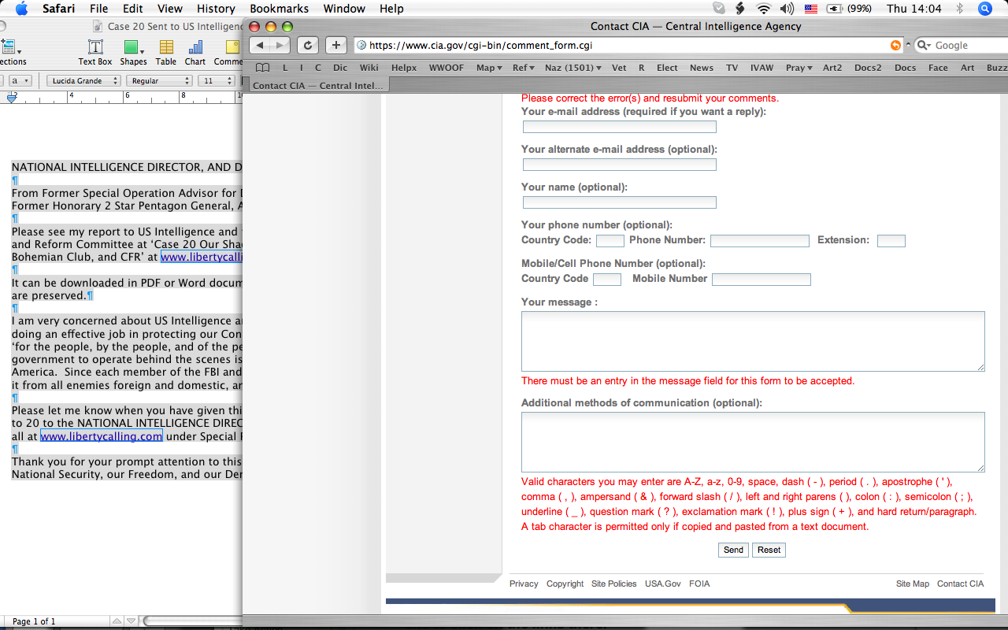

Look at that! This time they stripped out the message from both main windows, not just the “Your Message” one. I believe that change is due to a human at the CIA monitoring the form. I think they read the content of the “Additional methods of communication (optional)” window, recognized it as content that they did not want and deleted it. If there were just a computer on the other side of the form, the form would have deleted only fields with errors in them that a computer could tell was an error like an email address without a @ sign in it. So, it is very likely from this series of photos that a human made the decision to reject the content of those fields as “error” after reading them! I believe that the CIA did receive my message and took many actions to try to pretend that they did not receive it. Why? It is my opinion that the Director of the CIA knows full well he has taken illegal actions under the instigation of that the Shadow Government that harmed US citizens and does not want to correct his behavior. He had a duty to expose the Shadow Government, not help it carry out its crimes against humanity. His unwillingness to receive information about them and correct them is self-evident. I have used this CIA webform several times in the past to ask him to stop the crimes being committed by the CIA. His response has been to pretend that he has not received my messages.

Now, some people might say, but it could be a lesser CIA official making those decisions, not the Director. The Director has command responsibility of the CIA. Because I worked at high level inside the CIA for decades, I know how the flow of information inside it happens. When the Director of CIA stands to be fired for not dealing with information correctly, he takes a personal role in managing the flak out of self-defense. I have been writing about the crimes of the US Administration and the former Director of CIA Tenet. So, this is a very high profile case in the minds of high officials in intelligence. In such a situation, the Directors get briefed immediately whenever there is a new potential problem. That is because those below the Director do not want to be fired for making a decision that the Director does not like later. My sending the Skull and Bones, Bohemian Club, and CRF case out yesterday was sure to be noticed by the CIA, since they watch my computer to try to block me as much as possible without being too obvious about it. They do know that what they are doing is wrong and do not want to be caught at it.

The average person working inside the CIA has no risk of going to jail over my sending out that case. I have not named a single operative or lower level person in them. The Director has the need to pay attention to what I do to avoid jail time for reasons that I have not elucidated yet. I will get to them in later cases. So, I am sure that he is “staying on top of” what I do. That is shown by the CIA trying to block my access to the FBI’s webform today. About a week ago, I sent a tip to the FBI that the CIA did not try to block. So, I allege that today it was different because the Director of the CIA was personally liable for following Shadow government orders which he knew were unConstitutional and illegal. Aiding and abetting the Shadow Government’s coup by Executive Order and destruction of the Constitution is treason.

So, how serious was the Director of the CIA in trying to pretend that he did not receive my message and did not read the cases that I have written? When in the midst of writing this, I again tried to go back to the CIA’s webform here is what happened.



My computer hung up as it tried to load the page www.cia.gov at 15:56.


It remained hung up for about 3 minutes without loading the CIA’s web page. Then at 15:59 it gave me this error message--You are not connected to the Internet. But the little fan shape on the top line shows two bars worth of signal. From experience I know that my computer can load web pages with one bar of signal. So, I clicked the Network Diagnostics button because I did not believe the message to be the literal truth.

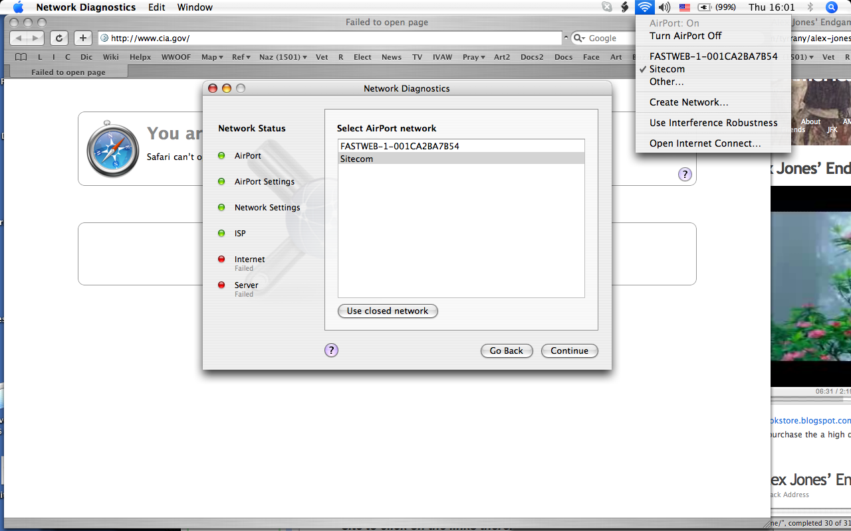

Here we see that the signal is coming through Sitecom and Sitecom is the Airport Network that network Diagnostics is testing.

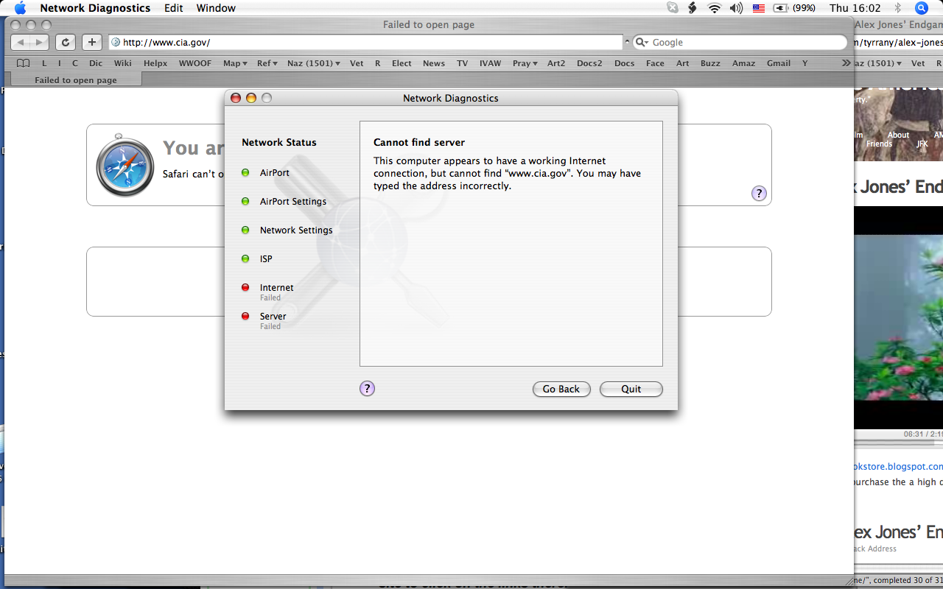

Network Diagnostics concludes “Cannot find server--This computer appears to have a working Internet connection, but cannot find “www.cia.gov”. You may have typed the address incorrectly.” No. That is the CIA’s website’s address and the same one I used just a couple of hours before.

It is my opinion that that reflects how guilty the Director of the CIA is; that he knows that he is aiding and abetting the Shadow Government’s coup against the US government and has asked the CIA’s staff not to take messages from me. He has command responsibility at the CIA. It is his sworn duty to ensure that the CIA’s policies are not influenced by undemocratic forces, including the Shadow Govt. and the war profiteers.

Has the CIA under his leadership exposed the corruption occurring in the war zones? In my opinion the answer to that question is No, that he has aided and abetting both corruption and torture of innocent people. I have been writing these cases for some months now. In all that time, he did not once contact me about my allegations that Halliburton and the US Administration had made a shambles of US National Security. Did he decide to ignore US National Security in the execution of his responsibilities in favor of protecting the war crimes of the US Administration? It is my opinion that he did and that he is part of the traitorous Shadow Government that has built concentration camps to house not hundreds of thousands of Al Queada terrorists, but innocent loyal US citizens.

Why have you had to learn about those concentration camps from concerned citizens, and not from the Director of the FBI, CIA, National Security, NSA, and Homeland Security? Did they not have the responsibility to protect you from all enemies foreign and domestic?

Concentration Camp Kickback Exposed

As an Honorary 2-Star General and advisor on intelligence to the Joint Chiefs of Staff (JCS), I was at a JCS meeting in which funding for building more Concentration Camps was discussed. This was shortly after Tenet resigned in early summer 2004. I stood up and stated that not only were no more Concentration Camps needed, but that the funding should be spent to tear down the ones that already existed. I said that they were a threat to our democracy and to the continued existence of the United States.

One general laughed at that and said that the point of the Concentration Camps was to put down insurrection to protect the United States. I asked him what insurrection he was referring to that required 2.4 million Concentration Camp inmates. There was dead silence for a moment. Then a younger officer, a minute taker, rose to that general’s defense and said, “Well, he means the anticipated insurrection when martial law is declared. Everyone knows that we could have trouble maintaining order then.”

I turned to him, as he was behind me at the moment, and said, “Sir, if the US government has a staged incident to justify martial law, then it is the US government officials, not the public, that should be rounded up and put in those Concentration Camps. Then I turned back to the JCS generals and said, “Sirs, if you do not want to occupy those Concentration Camps , I suggest that you dismantle them immediately.”

One of the other generals said, “No, we will not be in them. Those that oppose us will be in them.” I asked him how he could be so certain. Then I launched into a review of history. Stalin put in prison many generals who helped him gain and maintain power. Under Hitler, Generals ended up in prison and also executed. The history of supporting tyrants shows that the generals supporting them are much more likely to die from the orders of the dictator than any enemy. So, when I got done with my brief historical review I again asked them to dismantle the Concentration Camps, if nothing more than for their own self interests. They refused. The vote showed that only 3 of us at that meeting voted to dismantle them to over 20 voting to give KBR millions of dollars more to build another 700,000 prisoner places.

The total number of prisoners that could be housed was 3.4 million, roughly 1% more of the population, on the face of it. But when I looked into it further at the CIA, I found out that the true figure intended was double that, 6.8 million because overcrowding was intended to “further the goal of dispiriting opposition”--i.e. dehumanizing people. Furthermore, the capacity could be raised to almost 30 million by extreme overcrowding and emergency use of additional makeshift facilities.

Since the population of the US is roughly 300 million, that capacity is the equivalent of intending to put 10% of the population into Concentration Camps. That means 90% could not be housed. That means that people could easily resist that coup by executive order and the ordering of martial law, if they chose to.

No population can be forced to submit no matter how powerful and strong the military is against them IF THEY SIMPLY REFUSE TO BE INTIMIDATED INTO ACQUIESCENCE! That is the take home lesson of the conflicts since WWII. The British were forced to give up their colonies in India, Africa, and the Middle East. The French were forced out of Algeria and Vietnam. The tiny and poor country of Vietnam after fighting the French for 20 years went on to fight the US--they succeeded against all odds. That was merely because they decided to.

An American general said in recent years, “Never has military might been so powerful as in the US Army, and never has military might been so useless in achieving foreign policy goals” (paraphrased from memory). I am sorry that I do not remember names well. What he said it really true. Military power can invade a country but it cannot conquer a population.

The US public has been fooled into giving up its rights through giving into its fear of an external enemy. That is a trick as old as the Roman Caesars to claim that there is a threat that justifies denying people human rights. It is simply not true. One should protest nonviolently vigorously whenever any human rights are violated if you want to remain free.

When I looked into what was really behind the building of all of those prisons, it was money. KBR made a lot. If I remember correctly, the figure I saw was about $425 million all told for the previous year on US Concentration Camps alone--not prisons in actual use. They had plenty of money to give in kickbacks. Using the CIA’s Creative Accounting computer, I looked up how those kickbacks were given and documented it. Then I gave that information to the GAO.

Per my memory, Bush, Jr. received $400,000, Cheney $600,000, Rice $165,000, Rumsfeld $240,000, and David Rockefeller $12.5 million. The Rockefeller “cousins” each received about $385,000. The members of the JCS voting for the Concentration Camps each received about $40,000. Tenet received about $330,000. The Clintons about $225,000 and other Skull and Bones people some as well. My memory is not recalling some of the lesser people. Oh, yes, Attn. General Gonzales got about $60,000. Many Congressmen got about $20,000 for their votes on legislation.

Forget Democrat vs Republican; both parties have been taken over by Corporate backers, especially the Rockefeller Family. The CFR is one of their many instruments. Anyone getting the nomination for President will have the CFR behind them in order to get it, the way it stands now--that is how corrupt the system is at the moment. And that is because the average voter has been lazy and not demanded accountability.

People pretend that they don’t know what to do and are helpless to change things. That is another form of corruption, wanting an easy life of leisure without having to take risks. Everyone knows how to order a book and read it. Everyone knows how to talk to their neighbors about issues and form small groups to campaign for human rights. Everyone knows that non-violent resistance such as Martin Luther King, Jr., Nelson Mandela, and Gandhi did makes a real difference.

“Military power wins battles, but spiritual power wins wars.” General George Catlett Marshall quotes (American military commander during WWII 1880-1959)

Another Article on the 600 US Concentration Camps

See the video clips and text at http://www.apfn.org/apfn/camps.htm

U.S. CONCENTRATION CAMPS

FEMA AND THE REX 84 PROGRAM

BREAKING HURRICANE KATRINA CONSPIRACY STORY!
September 5, 2005:
"I just got back from a FEMA Detainment Camp"

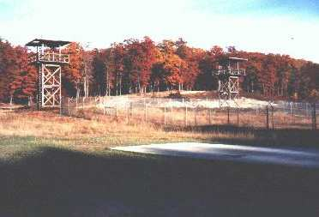
There over 600 prison camps in the United States, all fully operational and ready to receive prisoners. They are all staffed and even surrounded by full-time guards, but they are all empty. These camps are to be operated by FEMA (Federal Emergency Management Agency) should Martial Law need to be implemented in the United States.
The Rex 84 Program was established on the reasoning that if a mass exodus of illegal aliens crossed the Mexican/US border, they would be quickly rounded up and detained in detention centers by FEMA. Rex 84 allowed many military bases to be closed down and to be turned into prisons.
Operation Cable Splicer and Garden Plot are the two sub programs which will be implemented once the Rex 84 program is initiated for its proper purpose. Garden Plot is the program to control the population. Cable Splicer is the program for an orderly takeover of the state and local governments by the federal government. FEMA is the executive arm of the coming police state and thus will head up all operations. The Presidential Executive Orders already listed on the Federal Register also are part of the legal framework for this operation.
The camps all have railroad facilities as well as roads leading to and from the detention facilities. Many also have an airport nearby. The majority of the camps can house a population of 20,000 prisoners. Currently, the largest of these facilities is just outside of Fairbanks, Alaska. The Alaskan facility is a massive mental health facility and can hold approximately 2 million people.
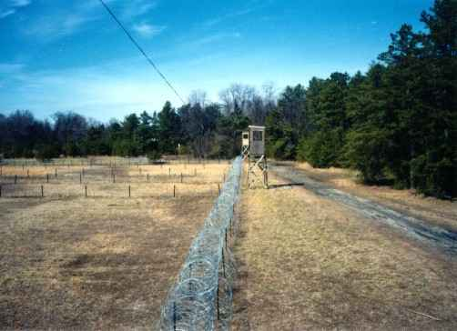

A person named Terry Kings wrote an article on his discoveries of camps
located in southern California. His findings are as follows:
Over the last couple months several of us have investigated three soon-to-be prison camps in the Southern California area. We had heard about these sites and wanted to see them for ourselves.
The first one we observed was in Palmdale, California. It is not operating as a prison at the moment but is masquerading as part of a water facility. Now why would there be a facility of this nature out in the middle of nowhere with absolutely no prisoners? The fences that run for miles around this large facility all point inward, and there are large mounds of dirt and dry moat surrounding the central area so the inside area is not visible from the road. There are 3 large loading docks facing the entrance that can be observed from the road. What are these massive docks going to be loading?
We observed white vans patrolling the area and one came out and greeted us with a friendly wave and followed us until we had driven safely beyond the area. What would have happened had we decided to enter the open gate or ask questions?
This facility is across the street from the Palmdale Water Department. The area around the Water Department has fences pointing outward, to keep people out of this dangerous area so as not to drown. Yet, across the street, the fences all point inward. Why? To keep people in? What people? Who are going to be it's occupants?
There are also signs posted every 50 feet stating: State of California Trespassing Loitering Forbidden By Law Section 555 California Penal Code.
The sign at the entrance says: Pearblossom Operations and Maintenance Subcenter Receiving Department, 34534 116th Street East. There is also a guard shack located at the entrance.
We didn't venture into this facility, but did circle around it to see if there was anything else visible from the road. We saw miles of fences with the top points all directed inward. There is a railroad track that runs next to the perimeter of this fenced area. The loading docks are large enough to hold railroad cars. [lrec]
I wonder what they are planning for this facility? They could easily fit 100,000 people in this area. And who would the occupants be?

Epilogue

When I tried to proofread and correct this case, I ran into a new problem. Suddenly, and for the first time, I was unable to position my cursor in the text to select the portion of it that I wanted. When I made a single first click, a random section of text was highlighted instead. I collected 7 examples of that before I tired of doing so. Here are two examples of it.

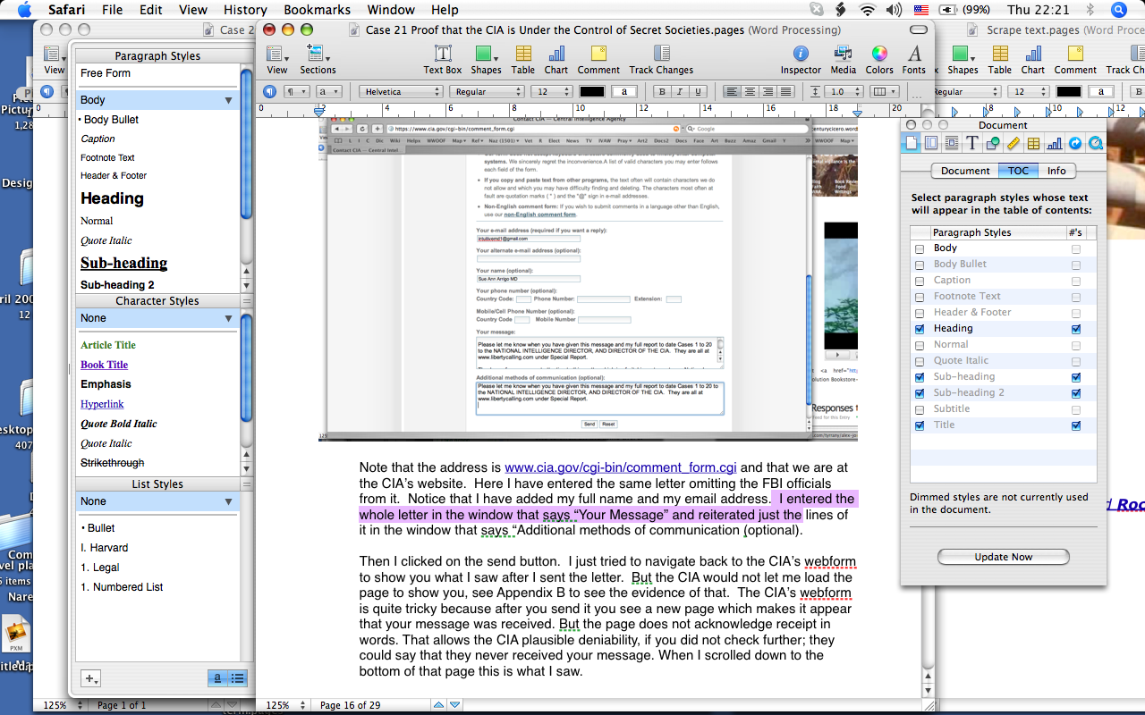

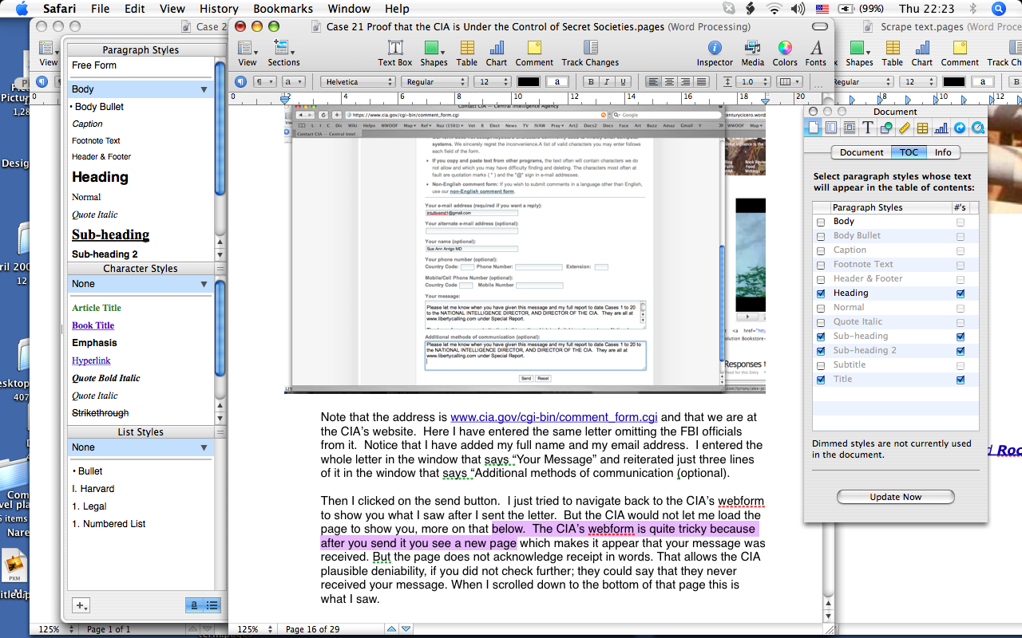

I had to use the arrow keys instead to change the position of the cursor. Now, after I have written that problem down, it has suddenly disappeared. Was the Hidden Hand trying not to be caught at it again?

When I finished proofreading this case, to the best of my ability given my circumstances, I wanted to send it out by email. Here is what happened when I tried to access my gmail account by clicking on my bookmark for gmail.

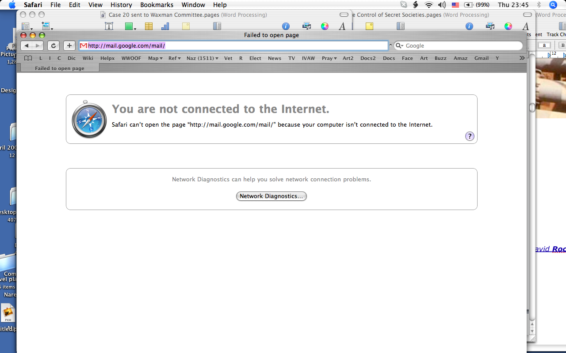

The error message says that I am not connected to the internet, but the signal is strong. When I checked the network diagnostics, I again get that the internet connection is good but can’t find the server.

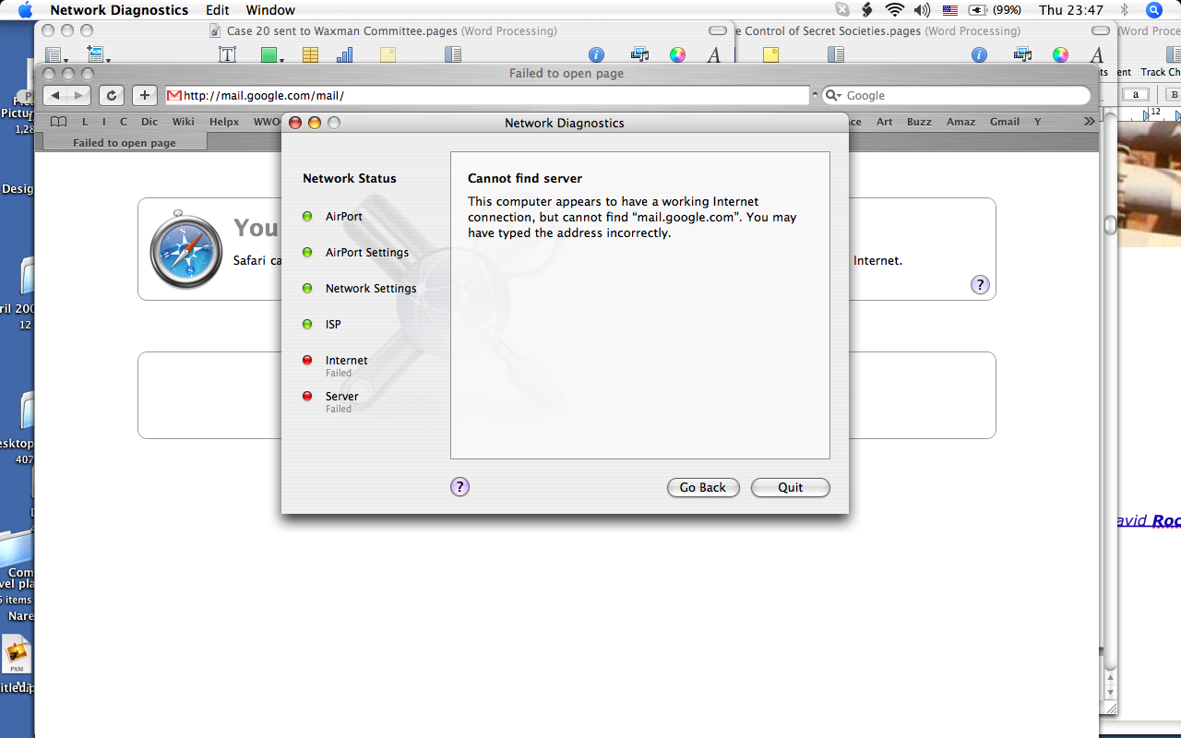

Was mail.google.com really not working? I doubted that. I decided to see if the CIA’s server was mysteriously “down” at the same time. I wrote in the URL of www.cia.gov and tapped the carriage return.


The loading of the page is hung up again at the same amount of blue bar progress as before.

Two minutes later, still no change.


Then the error message again saying that I am not connected to the internet.

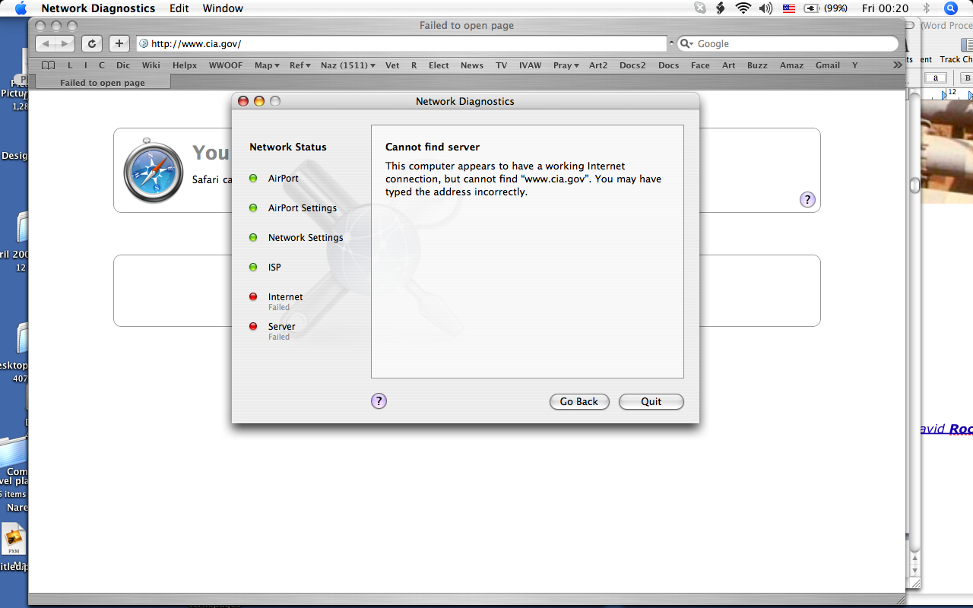

Then the Network Diagnostics again says that the internet connection is working but cannot find www.cia.gov. That is puzzling--is the CIA’s server down too?

Next I investigated whether it made a difference whether the first part of the address was http or https and tried the URL with https as you see in this next 2 slides.


Again, after a 2 minute time out period I get the message that I am not connected to the internet though the amount of signal is fine.
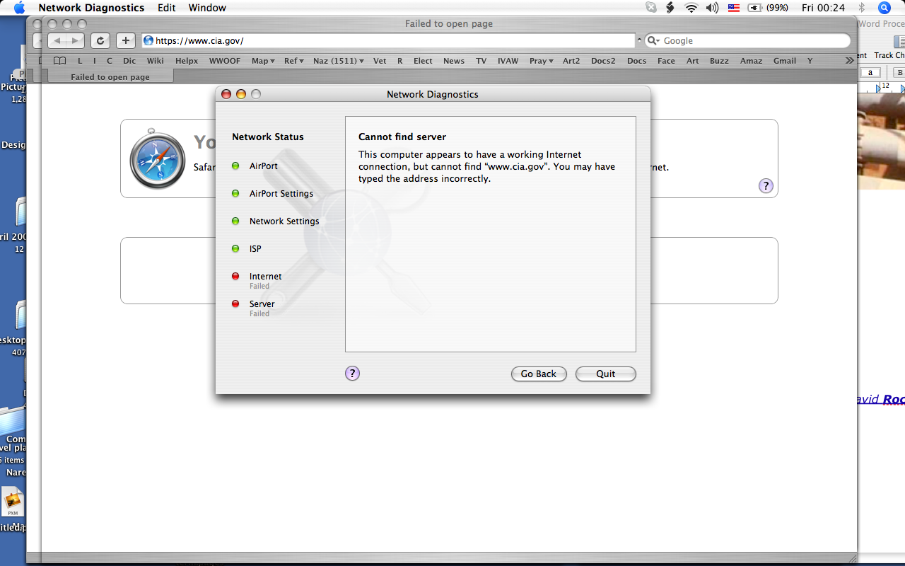

And again, Network diagnostics says that my internet connection is working but it can’t find the CIA’s server.

It is exceedingly unlikely that gmail and the CIA’s servers are both down just when I want to email you this case. It is much more likely that the CIA decided to block my computer. Why would the Director of the CIA want to block my computer from giving you this information? Is it because he has no intention of investigating the Shadow Govt. because he agrees with their agenda of torture and concentration camps? That is my opinion. You can form your own.

