Case 22D Hot Sodas Courtesy of Those Who Funded the Bolshevik Revolution?

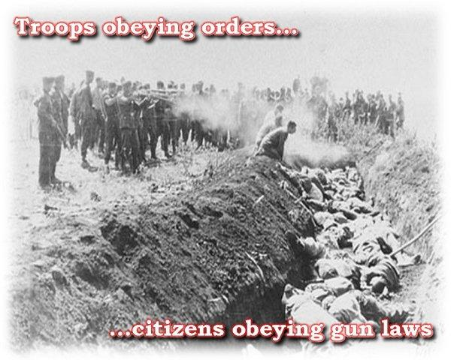

The wife of Mayer Amschel Rothschild, Gutle Schnaper, said, “If my sons did not want wars, there would be none”. See the 5-minute clip THE ROTHSCHILDS at http://www.youtube.com/watch?v=fXVJzXsraX4. Perhaps she was right. Perhaps the person claiming that the Rockefellers were the American agents of the Rothschilds were right too. Some people claim that there is a Jewish banking conspiracy that started WWI. After extensive reading in the Rockefeller Archives, I agree that there was a conspiracy to cause WWI and WWII involving bankers. But I did not find them to be practicing Judaism as their religion of belief. They were practicing greed, death worship, and Satanism, not the worship of our One God. It is not possible to worship both Money and God at the same time.

I also did not find convincing evidence that the Nazis were dedicated to eliminating all Jews because wealthy “Jewish bankers” were destroying Germany. The Nazis often left the wealthy Jews in place after accepting big bribes. They liquidated the wealth and bodies of the middle class and poor Jews. Thus, it seemed to me that they were also practicing greed and death worship, not worship of our shared One God.

The Nazis claimed to be Christians. But, I would no more judge all Christians by their behavior, than I would judge all Jews by the behavior of the greedy, death worship bankers who might claim to be Jewish.

It is frankly silly to judge a group of people by a few criminals among them. No one makes the mistake to think that all Italians are Mafia just because some are and commit murder. And it is equally absurd to think that all Republicans are the same, or all Democrats. Or that all Muslims are terrorists. When our leaders kill others, they are terrorists or murderers also, according to whether many innocent people died, or just one.

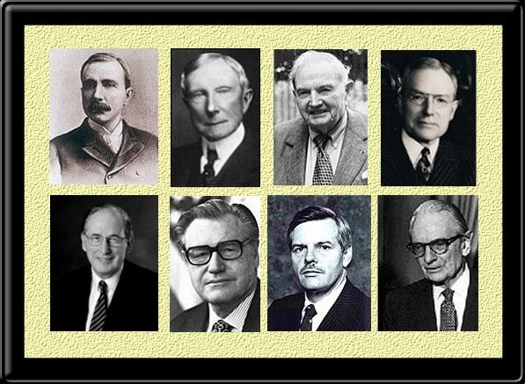Rockefellers, from top left to right, John D., Sr., John D., Jr., David and John D., III.
From bottom left to right, Jay, Nelson, Winthrop, and Laurance.
Rothschilds/John D. Rockefeller, Sr. funded the Bolshevik Revolution

Per his writings in the Archives, John D. Rockefeller helped fund the Bolshevik Revolution to get the wealth of the Czars, the labor of the Russian people, and much the Southern Oil fields in Russia. That wealth changed its name from Czarist, to Russian Government owned. Ignore the names, what happened to it? Did the people of Russia get it? No. The Rockefeller Archives show that he built a private army in Russia, much like the Brown Shirt army later. His accountant said that for each 2 cents that he spent to build that Army he got a dollar back. That Army was not staying up late to knit socks to sell. They were beating people up and committing assassinations, massacres, and mayhem to terrorize the populace into submission. And he was bribing officials to get what he wanted. He was apparently famous for that in the US as well. See www.reformation.org/rockefeller-bribery.html . Here is a photo and its caption from that article.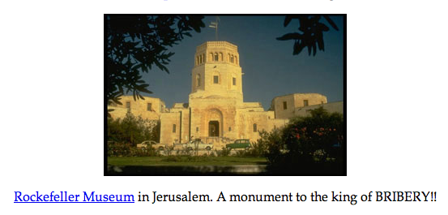In exchange, Rockefeller got some of the Czars crown jewels. The Rockefeller Family stored some of them in the Metropolitan Museum of Art in New York. I was able to prove that to the satisfaction of the Director of CIA at the time. They also got most of the profits from the Southern Russian oil fields. In about 1994, I went on a tour of them with Rodman Rockefeller so I know that for a fact. In addition, the Rockefellers charged about 18% interest on the money that they loaned Lenin for the Revolution. The way that agreement was set up made all of the loot that Lenin could seize in Russia, the Rockefellers/Rothschilds.
The Russian Famine Under Stalin and the Rockefellers

That meant that Lenin and Stalin could never get out of debt unless they could work people nearly to death to produce the goods Rockefeller/Rothschilds wanted. People thought that the ridiculous factory quotas the Russians tried to accomplish were the result of communism. That was not what I thought after reading the Archives. The Rockefellers were setting the quotas and delighting in the profits. They also delighted in giving the Russians quotas they could not meet as a way of humiliating them.
As the CIA’s intelligence negotiator to make an agreement with the Russians on how to form a single German Intelligence agency after the Berlin Wall fell, I had a chance to meet Gorbachev. That was not the only occasion. He once told me how he was motivated to help the Russian people because aunts/uncles of his had died in a famine when he was a 4-year old-boy. It was known that the agricultural policies under Stalin had caused that famine in the early 1930’s.
I found a video of the part of that famine that affected the Ukraine. Given racists tendencies it was likely worse in the Ukraine than in Russia.
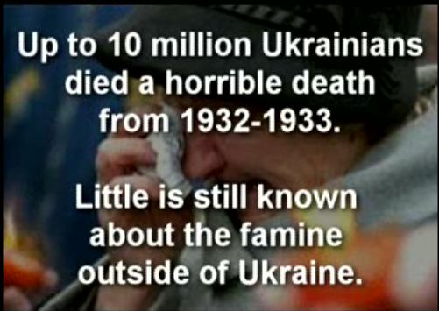
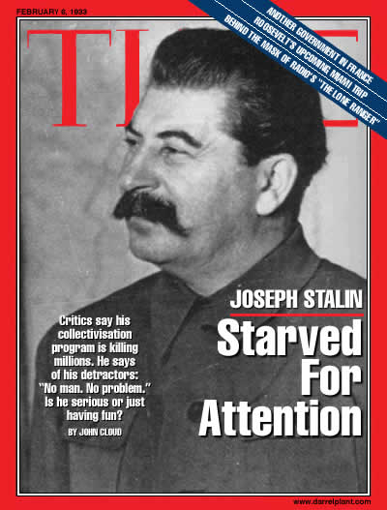
See the 10-minute video clip The 1932-1933 Famine-Genocide in Soviet Ukraine at http://video.google.com/videoplay?docid=-3782479548759037983&hl=en . Gorbachev had feared that Stalin had contributed to the famine in a major way and said that he wanted to do better. 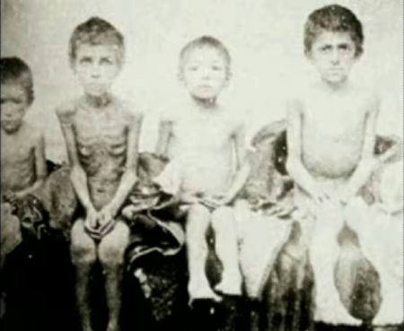Knowing how important this event was to him, I sent him copies from the Archives of documents that showed those policies had been forced upon Stalin by Rockefeller. While the people of Russia starved, Rockefeller was also insisting that Stalin sell him the grain at the price and amounts previously agreed to. But Rockefeller did not need that grain. And Rockefeller was, to a large extent, responsible for the bad policies that caused the poor crop yields and meant that selling that same amount of grain overseas ensured famine. It appeared to be a deliberate attempt, not just to get grain cheaply, but to starve people. The private journals of John D. Rockeller, Jr. confirmed that. The Rockefeller Family seemed obsessed by the desire to kill people off, including by warfare and starvation. The Rockefellers have long backed population control measures fairly publicly. That was not a secret, nor their funding of ‘eugenics’ research’. See http://www.theforbiddenknowledge.com/hardtruth/omegafile29.htm , http://www.eugenics-watch.com/eugbook/,euod_ch1.html , http://illuminati-news.com/nazi-california.htm . But, the behind the scenes maneuvers on how they were committing those Crimes Against Humanity were secret. To them Communism was a lovely excuse to steal the wealth of the rich Russians and then kill off the poor who were not working in their factories. The factories and the oil fields had the name of the Soviet Union on them, as if they belong to the Russian Govt.. But an examination of the chain of command structure and the flow of money made it look like the Rockefellers et al were already well on their way to being Kings of the World.

The Battle of Stalingard and the Rockefeller Ploy to Spread WWII Across Russia

Let me give you an example of that so you can understand how this system worked in practice. John D. Rockefeller, Jr, wanted to crash prices in South America of a type of goods to force his competitors into closing. If I remember correctly, the country was Argentina and the goods were stainless steel cookware--pots and pans, bowls, and cutlery. They were items peasants had to buy to live. They were also heavy and it made absolutely no sense to ship them from Russia since they were already made in adequate quantities by factories in that country. But they were not Rockefeller’s factories so a part of the markets’s share of money was not going to them. That was an anathema to John. D., Jr.. He wanted to own everything and everyone, or kill them.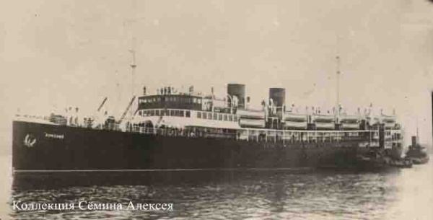 So, he wrote a letter to Stalin and told him how much and what kind of each item he wanted. It was a huge order, perhaps several Latin American countries worth. Rockefeller was was going to dropped the prices of the goods to drive the Latin American factories out of business. Then he would buy them cheaply. Having a monopoly he would then raise the price of the goods to steal even more from the peasants. His journal shows that he intended to cause their children to starve, if at all possible. It was not an unintended consequence of his business practices. I saw instances in which he was willing to lose money to make others starve. It was really quite sad to read about the life of a man who was so desperately unhappy that this was what it took to distract him from that fact.
Making money is like eating, you can only take in so much of it before it makes you sick. Those who go past that amount become like bulimics; they destroy what should be given to others. They are unable to get satisfaction from it anymore and keep wanting ever more of it. Finally, they get to the point that the only way that they can feel happy is to make others suffer and then say to themselves “I must be happy because I am better off than that suffering person or group”. But their souls are not better off usually than others, far from it. Their sickness is one of the soul. Since they refuse to acknowledge that it needs their integrity to be healthy, they are unable to fix their intense suffering. They may try to hide that suffering out of their awareness, but it is there nonetheless.

Stalin got the order and wrote back saying that he could not meet those deadlines in 2 months time. Rockefeller wrote back saying he had to ‘or else’. I wanted to know what the “or else” was. Later I came across invoices for the guards of Stalin which Rockefeller was paying. They were not just regulars, they were a special outfit chosen by Rockefeller. They were not ethnically the same as Stalin. It appeared that they had been chosen by Rockefeller to have no qualms about killing Stalin, if ordered to do so. The head of them was writing reports on Stalin’s activities to John D. more often than Stalin was writing to John D. After looking into it even further than I have said, I concluded that John D.’s threat to kill Stalin was a credible one.
Stalin was humiliated in more ways that one by trying to fill that order in time. He did not succeed, as hard and as desperately as he tried. He was a week late. Furthermore, this was during the height of the German attack on Russia, about a month before the battle of Stalingrad when the order was completed. It meant that steel and railway transport that would have gone into making of rifles did not. Russian soldiers went into the battle of Stalingard, Stalin’s namesake, with only about 35% of them carrying a rifle! They had to rush forward into battle defenselessly or be shot in the back. Only after one of their buddies got killed could them pick up a fallen weapon to defend themselves. That caused a hugh rift among them which they could not solve. It was designed to destroy their team spirit and turned them against each other.

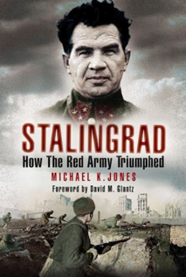
The Battle of Stalingard was almost a defeat for the Russia people because of what John D. did. His journal showed that he intended for the battle to be a Russian defeat and allow him to spread the war all across Russia. He agonized on the pages of his journal about whether his timing was right and the order big enough. He wanted the fighting to continue all across Russia and not just lead to a Russian capitulation. He wanted to destroy all the shop keepers and small enterprises that had not yet been nationalized and brought under his control. His journal said that he cried at his loses when the Russians bravely managed to force the Germans to retreat. But he did not call them brave in his journal and I will not repeat the derogatory phrases. Skull and Bones calls people not in it Barbarians will they help the Rockefellers plan and execute mass murders, such as at Auschwitz and other Nazi death camps. It is clear that they have some problems in their thinking.
There are many documentaries and clips on Stalingrad, including at YouTube e.g. Battlefield I: " Stalingrad " 1 of 12 http://www.youtube.com/watch?v=s5okHg-RKHE
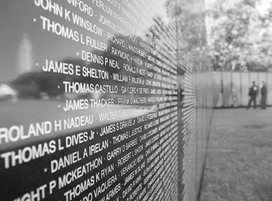
The US soldiers and even the US administration suffered humiliation in Vietnam and in the recent wars. Frankly, I thought the wars were unnecessary. One could have bought the oil for less. But if your goal was not just oil, but to break the US military to allow you to seize more power in some fashion, than that is another issue. It is one for future cases.
The revised Auschwitz Labor concept of “Work N Starve” in Guatemala and Beyond

In the 1950’s, the CIA began overthrowing democratically elected leaders, setting up dictator puppet governments, and making a ghetto of the Third World. Their methodology was the same as the Skull and Bones and the Brown Shirts; undermining of international and national laws, intimidation, blackmail, torture, sexual exploitation, propaganda, racial profiling, and unquestioning obedience to authority. They used taxpayer’s money to economically enslave the world for their own private profit. The CIA was a direct continuation of their drugs, slaves, and weapons running operations from WWII and before. One of the first things they did in the early 1950’s was to take thousands of daughters of loyal American officers that had beaten the Nazis and enslaved them as a kind of retribution in Operation MKULTRA.
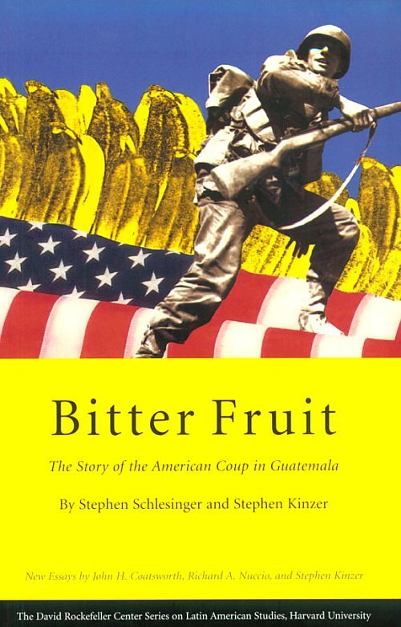
When Allan Dulles headed the CIA, he covered-up Rockefeller’s illegal business operations. He also ran black-ops and overthrew the democratically elected leader of Guatemala, Arbenz, to help Rockefeller’s United Fruit Company in which he also owned shares. President Arbenz wanted to buy United Fruit’s unused land at market value to give it to the poor so that they could grow their own food (see http://en.wikipedia.org/wiki/Arbenz).
United Fruit refused to sell. Children starved to death when their parents worked for United Fruit because the wages were so low. The Rockefellers wanted depopulation. Arbenz’s policies would have allowed the peasants to get out of having to work for United Fruit. Dulles’s overthrow of Arbenz meant decades of enslaved labor and starvation of children for the Guatemalan people. It also meant decades of massacres, torture, and over 100,000 deaths by CIA trained death squads to repress those who rebelled.
Note: The historians writing about the coup had their work overseen by David Rockefeller! See above book cover. That mirrors the what we will see later in this case.
The coup even had the same CIA villain E. Howard Hunt, who lead this CIA campaign, appointed by Vice President Nixon. He was later in the WaterGate burglary of the Democractic Convention which ended in the resignation of Nixon. E. Howard Hunt figures prominently in the book Plausible Denial: Was the CIA involved in the JFK assassination? as a suspect for the assassination. It was in their selfish interests to starve the peasants and to make them willing to work for next to nothing, as serfs dependent on them for their food. The CIA overthrew Arbenz to put their own puppet in power. That continued the severe poverty and starvation of children in Guatemala. The Guatemalan government carried out systematic massacres over decades against its indigenous peoples while the US government funded that with military aid and I know of instances in which US Generals were present at the massacres of whole villages down to every man, women, and child, in order to try to ensure a thorough job was done of it. Clearly, had that killing of the indigenous people been against what the CIA/Cabal wanted done, they would just have gone back in and changed the government again. But the Guatamalan government doing those massacres was in the CIA/Cabal’s good graces—they were doing what the Cabal wanted and the funding and military aid to do it kept flowing like a broad river towards it.

  - "Why should we worry about the death squads? They're bumping off the commies, our enemies. I'd give them more power. Hell, I'd give them some cartridges if I could, and everyone else would too...Why should we criticize them? The death squad - I'm for it."
  - -- Fred Sherwood, the former president of the American Chamber of Commerce in Guatemala, September 1980

But the villagers were not Communist per the CIA’s internal documents; they were just trying to labor organize so that they did not have to watch their children starve to death. In any case the Communist Revolution(s) were funded by the Rockefellers and Rothschilds as an excuse to steal the wealth of others and to divide and conquer the masses.
PLEASE WATCH THE CIA COOK US AND GUATEMALAN PUBLIC OPINION in the 7-minute clip “Engineering of Consent: guatemala coup 1954” at www.youtube.com/watch?v=jnYZVNVqBgU ;
  - “For decades, United Fruit had controlled Guatemala through pliable dictators” ...Rockefeller’s chosen PR man said, “The only way to deal with the public was to connect with their unconscious desires and fears. ...Instead of trying to reduce people’s fears of Communism, one should actually encourage and manipulate the fear. In such a way it became a weapon in the Cold War.
  - Larry Tye, Boston Globe Journalist stated--“What United Fruit had to do was change this from being a popularly elected government which was doing some good things for people there, into this being a threat to American democracy close to its shores ...He transformed this into the issue of a Communist threat...taking United Fruit as a commercial client out of the picture and making it look like a question of American democracy and American freedom and values being threatened.
Regarding how the Rockefeller-engineered coup in Guatamala was intended, Howard Hunt says;
  - “What we wanted to do was have a terror campaign...to terrify Arbenz particularly, and his troops, much as the German Stuppabombers terrified the population of Holland, Belgium, and Poland at the onset of WWII and just rendered everybody paralyzed.” [Reminds me of “Shock and Awe” in Iraq].
PLEASE WATCH THE CIA COOK US AND GUATEMALAN PUBLIC OPINION in the 7-minute clip “Engineering of Consent: guatemala coup 1954” at www.youtube.com/watch?v=jnYZVNVqBgU ;
  - “For decades, United Fruit had controlled Guatemala through pliable dictators” ...Rockefeller’s chosen PR man said, “The only way to deal with the public was to connect with their unconscious desires and fears. ...Instead of trying to reduce people’s fears of Communism, one should actually encourage and manipulate the fear. In such a way it became a weapon in the Cold War.
  - Larry Tye, Boston Globe Journalist stated--“What United Fruit had to do was change this from being a popularly elected government which was doing some good things for people there, into this being a threat to American democracy close to its shores ...He transformed this into the issue of a Communist threat...taking United Fruit as a commercial client out of the picture and making it look like a question of American democracy and American freedom and values being threatened.
Regarding how the Rockefeller-engineered coup in Guatamala was intended, Howard Hunt says;
  - “What we wanted to do was have a terror campaign...to terrify Arbenz particularly, and his troops, much as the German Stuppabombers terrified the population of Holland, Belgium, and Poland at the onset of WWII and just rendered everybody paralyzed.” [Reminds me of “Shock and Awe” in Iraq].
It was as if the CIA had been created at the end of WWII precisely to allow those Americans who funded/profited from Nazi violation of human rights to continue their reign of death, terror, and enslavement. President Truman later said, “Had I known the CIA would become the American Gestapo, I never would have signed it into existence!” Not only did the CIA help many Nazi war criminals escape prosecution, it continued committing war crimes unabated!

Those at the top ordering the war crimes were desperate to keep the workers of countries from uniting to get them from stealing their labor, their resources and their lives. To do that they keep up the perception of an external threat. Those in the West were told that the Russians and the Cubans were coming and that Communism was the threat. But at the same time the Rockefellers were instructing their people inside the Russian govt. and the KGB that the Americans and the British were the threat. By playing on the fears of each side they kept the workers from uniting to form true democracies and have the right to organize for fair wages. Europe was able to largely seek a middle ground of socialism, and some measure of rights and the rule of law. That is better than failing completely prey to the Robber Barons. But much needs to be done still to prevent the corporations from destroying the environment.

Rockefeller Undermined the Freedom and Livable Wages of Others

Nelson Rockefeller as Vice President of the US, was still in partnership with the Russian government during the Cold War, a partnership that bordered on treasonous. In 1968, the Czechoslovakians were resisting Soviet domination in what was called the Prague Spring. The CIA was supplying them with logistical help. It looked they had a real chance to get free of Soviet rule. Then Nelson Rockefeller called the CIA and told them not to help anymore; he had factories in Czechoslovakia and was enjoying their very low labor costs. After he made that call to Helms, the CIA pulled out of important ways that it was supporting the Czechs. The effect on the Prague Spring was that it withered. The Soviets, no longer afraid of US disapproval at the higher levels rolled into Czechoslovakia and clamped down. That is, while Nelson Rockefeller appeared to be a loyal freedom fighting American, what he was really loyal to was his wealth not the freedom of others. Loyalty to his wealth caused him to undermine the freedom of others, while pretending that he was for it.

It is just as an example of the framework that I am speaking of--- powerful politicians in the US government who got there by family wealth amassed partly by raising private armies. They used liberal doses of intimidation to terrorize people opposing them, or killed them out right to further their personal agendas of wealth and privilege. The distinction between robber baron and warlord can be a narrow one; they are opposite sides of the same coin.

"They are going to arrest us all and execute us for Shell."
-- Ken Saro-Wiwa, Nigerian democracy activist, after reading a secret Nigerian military memo in May 1994. He was executed by the Nigerian military dictatorship in 1995.

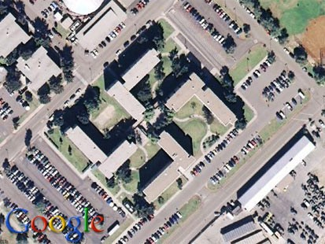
US Navy buildings in San Diego built in 1967 show that America apparently housed Nazi elements high up in US military circles at http://i.abcnews.com/print?id=3654325 .

It is not an accident that Bush, Jr is dismantling the US Constitution. He has said that he doesn’t mind if the US becomes a dictatorship as long as he is the dictator (see clip at http://www.youtube.com/watch?v=YNo0_klKzis ). The goal of Rockefeller and his henchmen, such as Bush and Cheney, and the Council on Foreign Relations, is alas, not to bring democracy to the US ( see the excellent 4-minute clip “CFR Council Of Foreign Relations How They CONTROL THE MEDIA” at http://www.youtube.com/watch?v=Tcgd67Sxvzo and “a must see on the [agenda of the] CFR” http://www.youtube.com/watch?v=IlUkfM-AJDk and Busy [David] Rockefeller at http://www.youtube.com/watch?v=A3XtL4HFH0M ). To do that they would have to step down and let the government act transparently, driven by public concerns not private profits.

