http://www.balkaninsight.com:80/en/article/bulgarian-arms-producer-investigated-for-arms-found-in-aleppo-12-29-2016
NEWS 29 DEC 16

Bulgaria Probes Arms Company Linked to Syria
Prosecutors are investigating whether a local arms company broke the embargo on exporting weapons to Syria, following Russian claims that Bulgaria-made arms were found in Aleppo.
Mariya Cheresheva

BIRN
Sofia
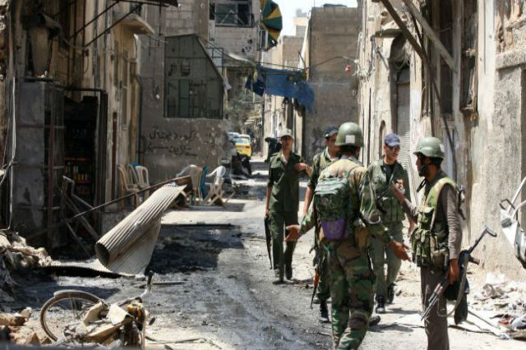
Syrian military forces parolling in Aleppo. Photo: Abayomi Azikiwe/Flickr
Prosecutors in Gorna Oryahovitsa, northern Bulgaria, have launched a probe into a local arms company whose products have reportedly been found in former rebel-controlled areas of Aleppo in Syria.
The probe, announced on Thursday, follows an investigation published by the newspaper Trud in December, which revealed that some arms found by Russian troops in eastern Aleppo were made by Arcus, a company located in Lyaskovets, in northern Bulgaria.
The aim of the probe is to identify whether the company has a license to trade in arms, the prosecution explained.
Ivan Gromov, commander of de-mining group in Aleppo, told Russian TV on Wednesday that the group had found “huge amounts” of arms produced in Germany, Bulgaria and the US.
Among them were various types of shells, hand grenades, grenade launchers and other weapons - enough for “a whole battalion”, Gromov said.
Maria Zaharova, from the Russian foreign ministry, on Tuesday said “questions have been raised in Moscow” about the arms produced in Bulgaria and with an expired Russian licence.
Bulgarian Foreign Minister Daniel Mitov dismissed the Russian claims on Thursday, saying that Bulgaria strictly followed international arms trading standards and had not exported any arms to Syria since the beginning of the conflict in 2011.
“I will not accept accusations from a country which is responsible for civilian victims in Aleppo,” Mitov told private broadcaster BTV, referring to Russian military support for the Syrian government offensive in the city.
He added that Russia is not a party to the UN Arms Trade Treaty and the Convention on Certain Conventional Weapons and that “such a country cannot moralize against Bulgaria”.
A recent investigation by BIRN and the Organized Crime and Corruption Reporting Project, OCCRP, revealed that since 2012, Bosnia, Bulgaria, Croatia, the Czech Republic, Slovakia, Serbia and Romania had agreed exports of weapons and ammunition worth at least 1.2 billion euros to four countries supporting Syria’s armed opposition.
The bulk of the deals, totalling 829 million euros, were made with Saudi Arabia.
The exporting countries granted the licences despite evidence that many weapons were being diverted to Syria, ending up with opposition as well as Islamist groups accused of atrocities.
EU members and countries seeking to join the EU are obliged to carry out eight different checks before agreeing arms export licences.
The checks include assessing the risk that sold weapons could be diverted to or end up in the hands of terrorist groups.
Bulgaria’s economy minister in August admitted that some weapons from the country may have ended up in the hands of fighters in Syria and Iraq, but insisted that the state was not responsible for this.

TALK ABOUT IT!

