**Trip Report**

**Australasian Vertebrate Pest Conference**

**1-4May2017**

The Australasian Vertebrate Pest Conference (AVPC) was held in Canberra, AU the first week of May. The title if this triennial conference was “Innovative Solutions and Future Directions”. The meeting had a broad representation from governmental (CSIRO, LandCare Research, NZ Dept of Conservation, USDA, AU state gov’t reps, etc), private, and non-profit entities. The focus was on improving techniques and operations for dealing with vertebrate pests, mostly invasive, but some native species were included. GBIRd received much attention. The program can be found here: <http://avpc.net.au/program/>

Key aspects:

* Conference was opened by an indigenous elder and keynote was from Barnaby Joyce (Deputy Prime Minister of Australia).
* Approximately 150-200 in attendance (my estimation skills are unrefined).
* Two of the first three opening plenary speakers mentioned GBIRd by name and gave a bit of background.
* Several sectional talks and posters including GBIRd specific (attached) focused on new genetic technologies.
* About half of the research presented was focused on technology improvement including pathogen development (process to improve effectiveness of pest specific diseases – rabbit calicivirus, rabbit hemorrhagic virus, carp herpes, etc.), bait effectiveness, and contraceptive technologies.
* About Half of the conference focused on stakeholder and community engagement. This was more than I expected.
* GBIRd associates included:
  + **CSIRO**-Peter Brown, Tanja Strive, Mark Tizard, Andy Sheppard, Steve Henry and Peter Caley
  + **Landcare Research** – Dan Tompkins
  + **Island Conservation** – Karl Campbell, Ray Nias, Royden Saah
  + **USDA** – Kurt Vercauteren, Doug (?Eckery?)
  + In the sidebar convos, the stakeholder/community engagement lead for NZ was designated by Dan. Her name is Edy MacDonald from NZ Dept of Conservation.
* The genetic technologies, especially gene drives and GBIRd, received extensive focus.
* The final session was a panel discussion to be broadcast on the national radio program “Big Ideas”. The panel consisted of Karl Campbell, Mark Tizard, Edy MacDonald and Bidda Jones of the RSPCA-Australia. The panel discussion was exceptional.
  + Dr. Jones was an easy person to speak with, explaining to me the difference between animal rights (e.g. all individual animals have similar rights and protections) and animal welfare (e.g. if this society chooses to eat animal, they should be processed in the least stressful way possible).
* Because Andy Sheppard (signatory for the MOU) was there, we took the opportunity to knock that task out as well.

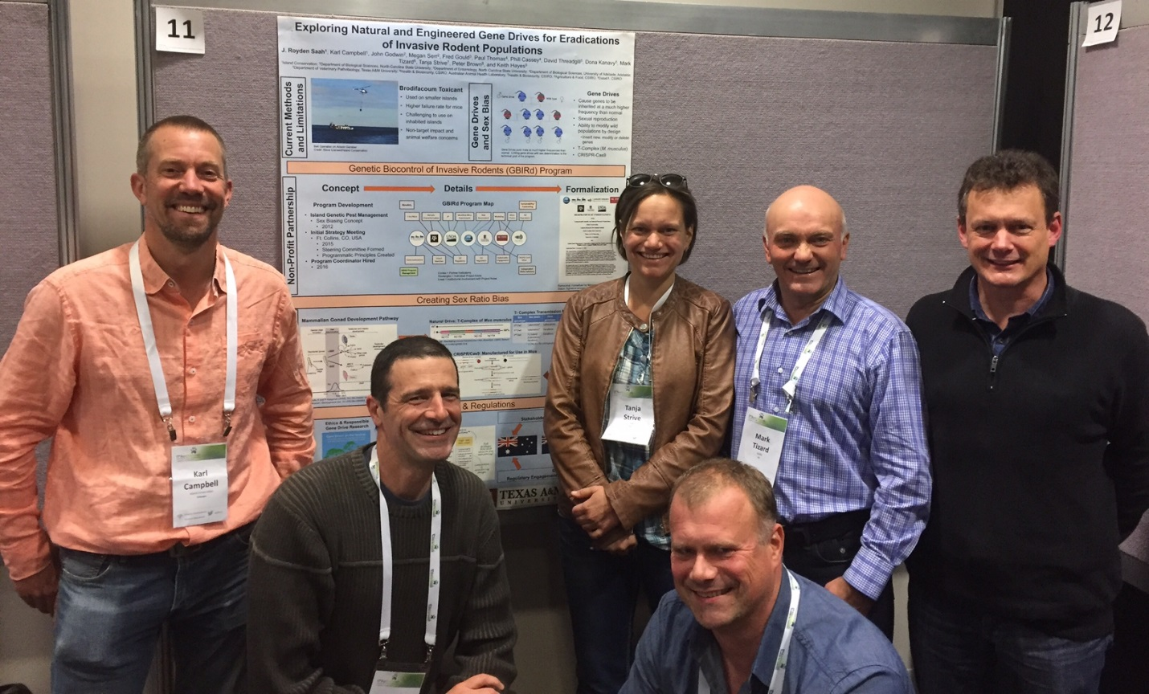

Image: Most of the authors (in attendance) at the poster. From Left-Karl, Royden, Tanja, Dan, Mark, Peter

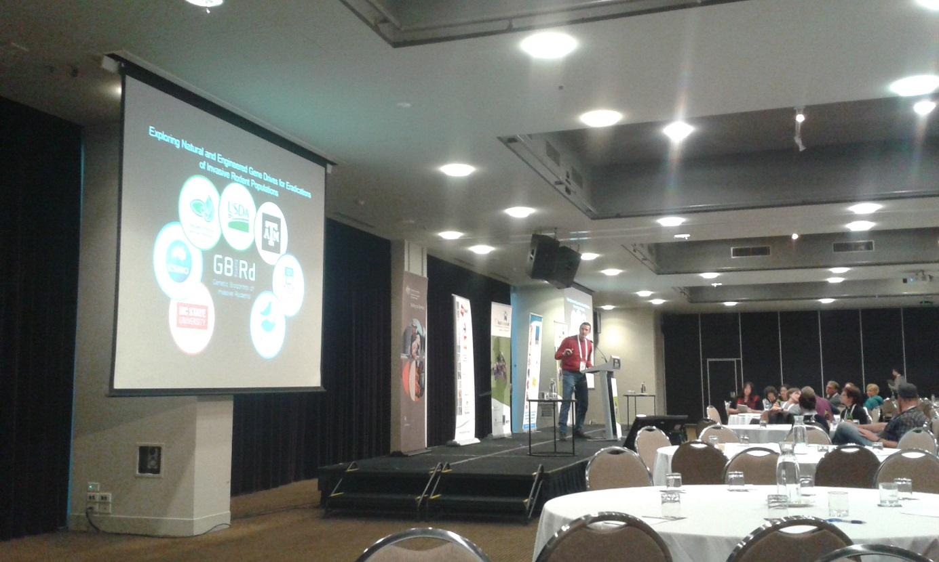

Image: Royden speaking about GBIRd

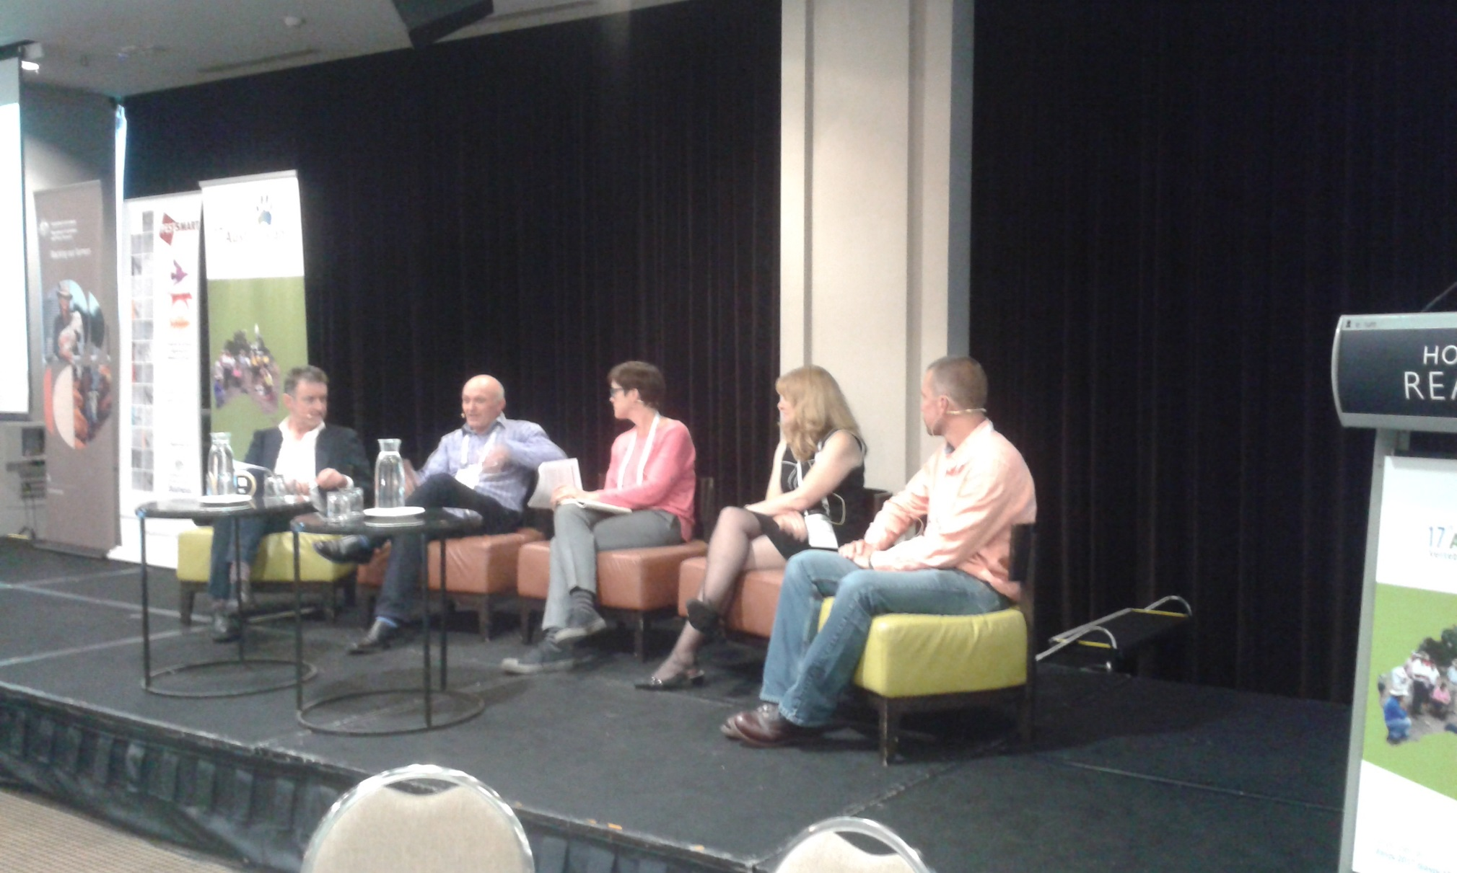

From Left: Radio Host, Mark, Bidda, Edy, Karl

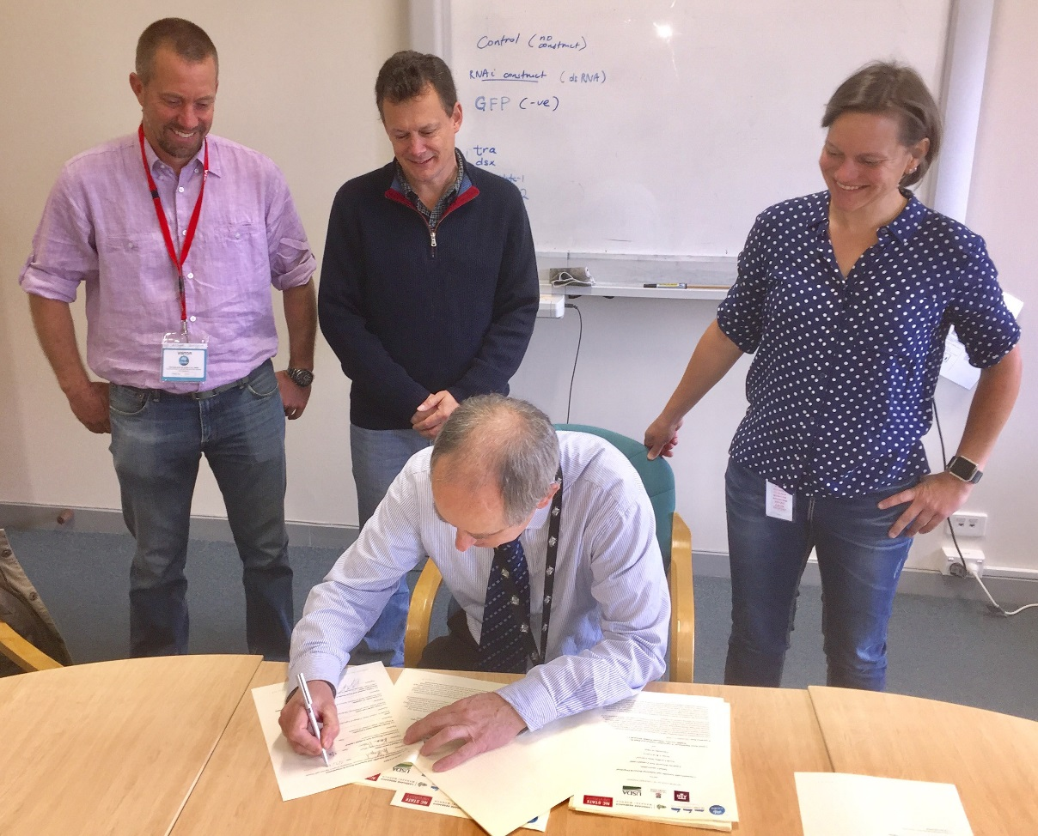

Andy signing MOU: From back left: Karl, Peter, Tanja