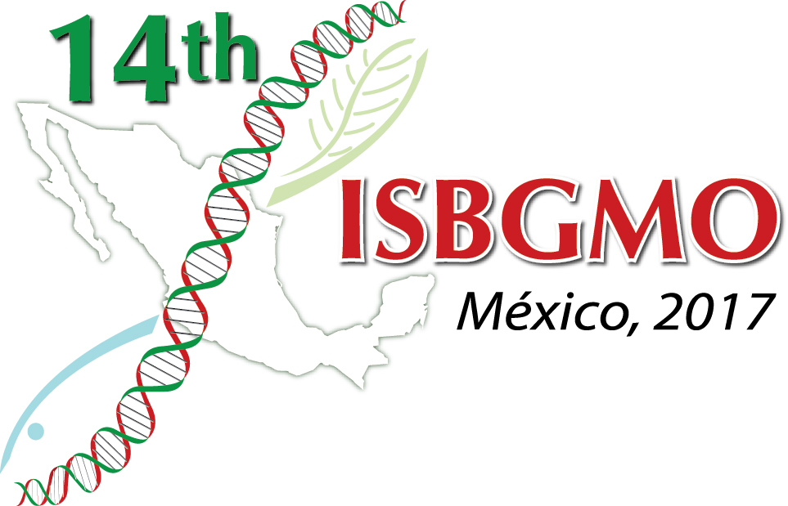

IMPORTANT INFORMATION 2

Hello All

Please find attached the very latest version of the Book of Abstracts so you can start enjoying the Symposium before you get there, and can plan your activities!!

This will also be available on our ISBGMO14 website as PDF to download

Also please follow the event in our Facebook and Twitter pages

http://www.facebook.com/14thISBGMO/

http://twitter.com/ISBGMO?lang=en

AND DON’T FORGET TO LIKE THEM!!

And, so you can meet the Session and Open Session organizers we have included short Bio's of them.

Finally, there is a document with all the changes to the BoA done from printing up to now.

LOGISTICS 2

Some people have also enquired about the following

TAXIS
The taxi service from the airport runs 7/24 and should be paid at the stand, not the driver, and they usually take US currency as well as Mexican pesos and Credit Cards

CURRENCY
In Mexico the official currency if Mexican Pesos, and excluding the airport and some hotels, you must always use Mexican currency or credit cards at shops, restaurants, etc.

FORMAL DRESS FOR GALA DINNER
This just means that preferably you should not use shorts or sport wear, I guess a best description would have been CASUAL (really, whatever makes you feel comfortable to enjoy the evening!)

