Is The “Coronavirus” Actually Microwave Illness?
http://www.radiationdangers.com/5g/is-the-coronavirus-actually-microwave-illness/?fbclid=IwAR2OyxcubRu2DnYVi3Hke-_IXuz1IbHW_XWtaFaniBYd5H6B2jWqyquNiZw

January 31, 2020 admin 9 Comments

* * * * * *

Note – this article is a work-in-progress. As new information comes to my attention, I will add it to the article if appropriate.

* * * * * *

Dear friends – a lot of information has been circulating around the internet regarding the alleged “coronavirus” in China. Alarmist headlines abound such as this one from Alex Jones’ Infowars:

“Computer Models Show 183 Million Infected by Coronavirus February 29”

and this one from Mike Adams of Natural News:

“Over the Last 7 Days, Coronavirus Infections Have Increased 1000%”

Top names in the health movement are scrambling to write articles about what we need to do to protect ourselves from this impending, life-threatening “virus” (see here and here). And, right on queue, the World Health Organization has declared a “Global Coronavirus Pandemic” (see also here).

All of this has occurred in just a matter of days.

Based on the speed with which this terrible “virus” seems to be “spreading” around the globe, it appears that now would be an excellent time to take a few steps back to see if we can determine what in the world is actually going on here.

No doubt, the dark ones are gearing up to introduce yet another allegedly “life-saving” vaccine, and no doubt they are rubbing their hands together imagining that this “viral pandemic” will be the one that will finally enable them to mandate vaccines around the globe.

In fact, this article just came out today (Jan 31, 2020) alerting us to the fact that “vaccine trials” for this “virus” are scheduled to begin in the U.S. in three months. Miraculously the CDC already has diagnostic tests for this and “will start shipping out test kits to state and local public health partners in the coming days.”

Interestingly, the photo that appears at the top of the article speaks volumes about what might actually be going on.
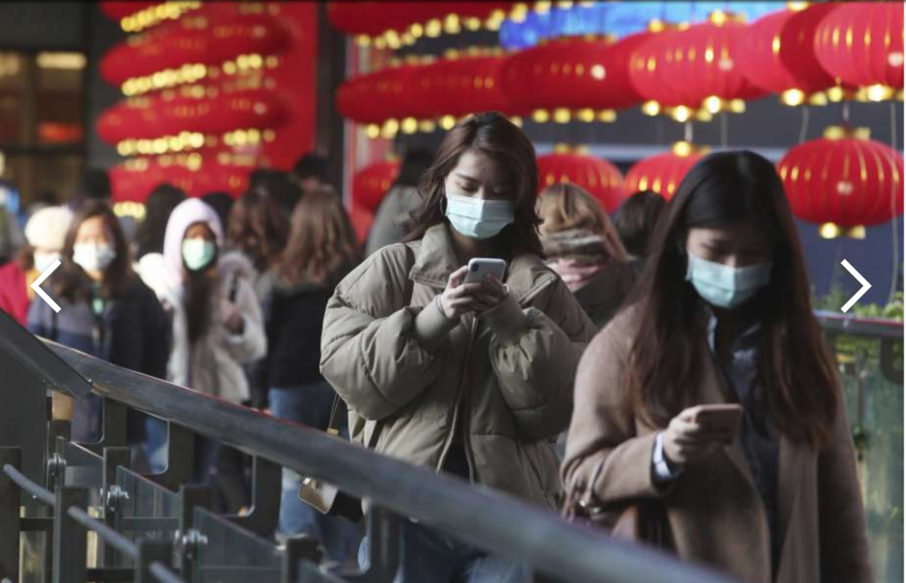

Notice how all of these people have their faces in their phones. These people believe their masks are going to protect them. Yet, in Truth, their radiation-emitting devices may be the very cause of the problem. Are the media subtly trying to tell us this?

In any event, I strongly suspect that what might actually be occurring in China has nothing to do with any “virus” at all, but rather, is related to radiation-induced illness being brought on by the 5G rollout now being streamlined in Wuhan (see here and here) and other parts of China.

The mainstream media and the powers-that-shouldn’t-be will never tell us the Truth about this. Instead, they will babble on about “viruses” and present us with bogus ideas about so-called “climate change” so that nobody will ever suspect that the warming of our planet is likely due to radiation heat from increased cell tower density and wireless devices (after all, microwaves do COOK things), or that any epidemics we experience over the next 5-15 years are going to be related to radiation poisoning from exposure to increasing densities of noxious, non-ionizing radiation.

So let’s begin at the beginning. But first, here’s a comment I recently made on a youtube video that is being censored…

Since 5G frequencies are known to negatively effect the absorption of oxygen in the cells and the body (see here and here);
and since all of the symptoms they are reporting are also listed as the very same symptoms associated with “microwave sickness” (i.e., radiation illness which can be induced from exposure to all wireless devices, including 4G devices — see here http://www.radiationdangers.com/microwave-sickness/);
and since “the flu” and microwave illness share many of the same symptoms (see here: http://www.radiationdangers.com/microwave-sickness/the-flu-and-microwave-sickness-share-many-of-the-same-symptoms/);
and since “the flu” has been shown to NOT be the result of a “virus” but rather an electrically-induced disease (see Arthur Firstenberg’s book, “The Invisible Rainbow”);
it is a fair estimation to assume that wherever 5G is being rolled out, people are going to rapidly become deathly ill. Wake up people. The entire wireless grid is designed to destroy us. They will blame these radiation-induced illnesses on a variety of things, but one thing they will not do is tell you that your devices and your entire wireless society are the problem. You have to figure this out on your own.
Please see my book for much more information about this: https://www.birthofanewearth.com/1/paperback-release-the-dark-side-of-prenatal-ultrasound/
People wearing masks is obviously not going to protect them from radiation-induced illnesses. Avoidance of radiation and/or radiation-shielded clothing are the only things that work.

1. 5G IS ACTIVELY BEING DEPLOYED IN WUHAN.
“WUHAN — Central China’s Hubei province has built more than 300 5G base stations and achieved full 5G signal coverage in its prefecture-level cities, local telecom sources said.
The China Mobile’s Hubei branch said more than 300 5G base stations have been built since February 2018, and a dozen 5G experience centers have been completed in cities including Xiaogan, Yichang and Jingmen.”
Source
===================
“So far, China Mobile has installed 100 5G base stations in Wuhan, the capital of Hubei, and is launching large-scale tests, according to Fan Bingheng, general manager of the company’s Hubei branch.”
Source

2. 5G FREQUENCIES ARE KNOWN TO CAUSE SEVERE DISRUPTIONS IN THE BODY’S ABILITY TO ABSORB AND UTILIZE OXYGEN.
“The FCC has opened up the millimeter wave band and they’re going to be broadcasting at 60 GHz… for the new 5G and the new Wifi. It’s called wi-gig… This stuff is wicked. 60GHz is the oxygen molecule absorption spectrum… This is the frequency that the oxygen molecules start reacting to… They’re gonna be using 5G to mess with oxygen… When you hit oxygen molecules with 60GHz millimeter emissions, it effects the orbital properties of the electrons… [This will affect] how oxygen is absorbed into your body… When you start effecting the oxygen molecules’ ability to bind with the hemoglobin in the blood, you can’t transport the oxygen into your tissues… It also effects your ability to produce Vitamin D. There are two locations in the United States where this was rolled out in schools. It produced paralysis, arrhythmia, neurological problems, problems with tingling in the extremities, people passing out, people having fatigue, malaise, all these bizarre ailments. These people have managed to get you to kill yourselves, and enjoy it, and kill your children, and pay for it.”
Source
=======================
“60 GHz… gets stuck in air. It doesn’t travel well at all. So it’s a bit bizarre that Ofcom [Office of Communications in the UK] are going to give [that part of the spectrum] away… If I was to blast enough 60 GHz amplitude into an oxygen molecule, I might break it. And that oxygen atom will attach with other oxygen molecules and create 03. 03 kills. At 50ppm, it will kill all biological life. So it’s a bit bizarre that Ofcom would even want anyone to use this part of the spectrum—nevermind giving it away.”
Source

3. THE “CORONAVIRUS” IS CLAIMED TO PRODUCE “ATYPICAL PNEUMONIA” AND SEVERE RESPIRATORY DISTRESS THAT HAS LED TO DEATH.
“It started with a light cough. He burped constantly, and complained of shortness of breath… The doctor said he seemed to have heart problems and suggested him to stay in the hospital. He appeared healthy except for a minor infection in one lung area. Two weeks later, he was dead, with both lungs infected and organ failure. His doctors at the Wuhan Jinyintan Hospital determined the cause of death as “unknown pneumonia.” It was days before Chinese health authorities identified the cause of the new viral pneumonia as 2019-nCoV, a coronavirus that first emerged in December in the commercial city of Wuhan, his home city.”
Source
=======================
“Coronaviruses are types of viruses that typically affect the respiratory tract of mammals, including humans. They are associated with the common cold, pneumonia, and severe acute respiratory syndrome (SARS) and can also affect the gut.”
Source

4. RADIATION-EMITTING FREQUENCIES IN THE MICROWAVE AND MILLIMETER RANGE (3G, 4G, and 5G) CAN ALSO CAUSE SEVERE RESPIRATORY DISTRESS.
“In the first study of its kind, scientists strapped magnetic field monitors on pregnant women to determine their level of exposure, and studied whether it was associated with the risk of asthma in their children. They found that children born to women with the highest levels of exposure to electromagnetic fields (EMF) — including from microwaves, hair dryers and power lines — had a more than three-fold higher rate of asthma compared to those whose moms had the lowest exposure.”
Source
=======================================================
“The irradiation inhibited the oxygen consumption rate by the mitochondria… and slowed down the rate of respiration upon exhaustion of the ATP.”
Source: N.P. Zalyubovskaya, Biological Effect of Millimeter Radiowaves, Kiev, Vrachebnoye Delo, in Russian, 1977, No. 3: 116-199.

5. THE MEDICAL ESTABLISHMENT HAS KNOWN FOR DECADES THAT EXPOSURE TO THEIR SO-CALLED “RADIATION TREATMENTS” CAN LEAD TO PNEUMONIA.
“Radiation pneumonitis is the acute manifestation of radiation-induced lung disease… Symptoms typically include:
- cough
- dyspnea (exertional or at rest)
- low-grade fever
- chest discomfort
- pleuritic pain”
Source

6. EXPOSURE TO MICROWAVES CAN ALSO LEAD TO VARIOUS FORMS OF LUNG DISEASE AND PNEUMONIA. SYMPTOMS OF “MICROWAVE ILLNESS” – A CONDITION FIRST DESCRIBED BY THE RUSSIANS IN THE 1970’s – INCLUDE ASTHMA, BRONCHITIS, PNEUMONIA, INFLAMED SINUSES, ETC. SEE HERE FOR MORE INFO.

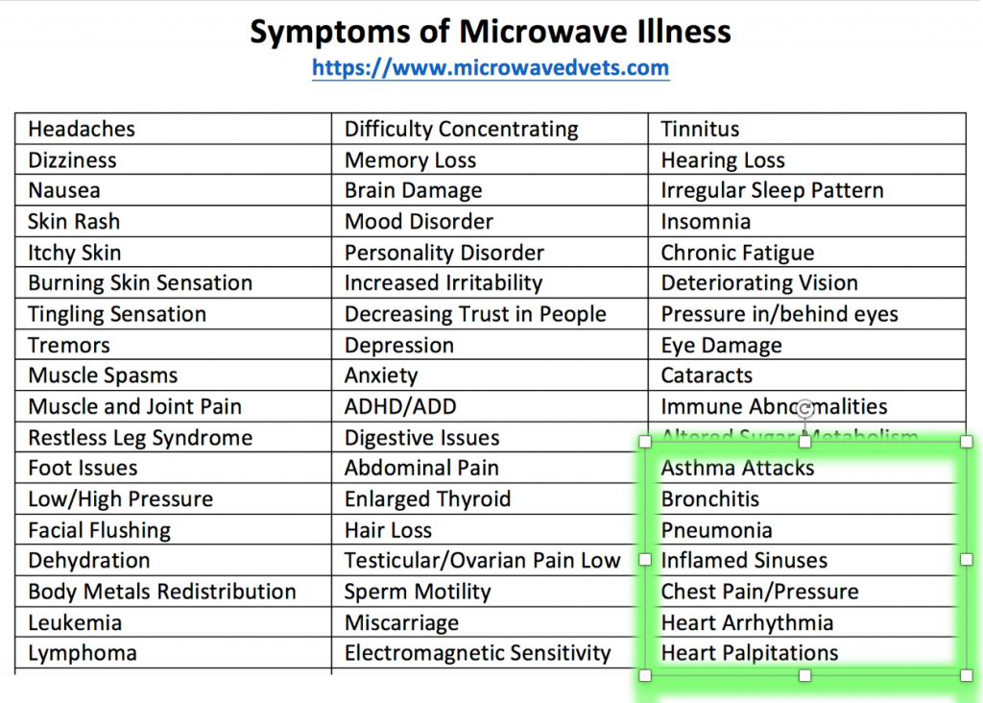

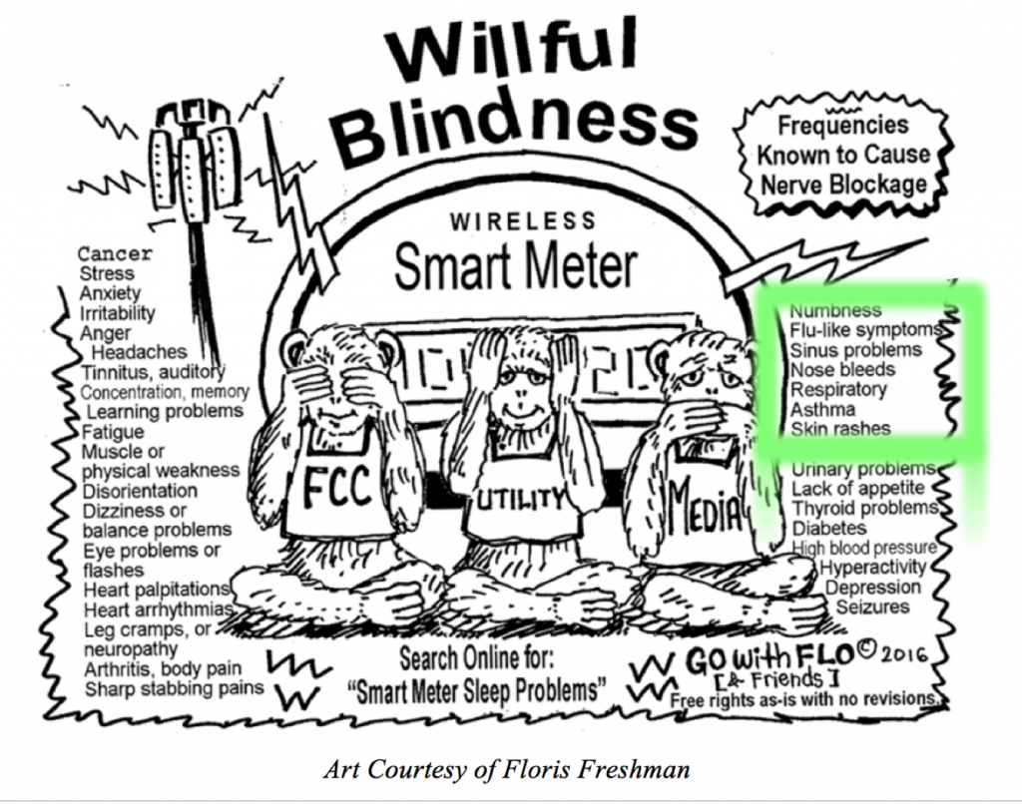

7. THE “FLU” AND MICROWAVE ILLNESS SHARE MANY OF THE SAME SYMPTOMS.
As someone who has experienced symptoms of microwave illness first hand (thanks to the installation of a wireless solar system on my home and the simultaneous placement of an “opt-out” digital smart meter which has since been removed), I can confirm that the above-mentioned symptoms can come on fast and furious and bring a person close to death before a person even realizes what has hit him or her. Within a year of having the solar wifi module and digital “opt-out” smart meter put on our house, one family member developed severe skin rashes, hair loss, chronic mouth ulcers, and twice went into respiratory failure. Another family member suffered from rapid onset memory loss, balance problems, chronic leg and muscle cramps, olfactory changes including loss of taste and smell, and thyroid cancer. I, myself, suffered from “tinnitus,” insomnia, abnormal heart function, chronic dizziness and nausea, vision problems, hearing problems, temporary loss of smell and taste, intense headaches, sharp pains and pressure in my head, joint and muscle pain, muscle spasms, feelings of extreme weakness and fatigue that made me feel like I was close to death, and repeated, severe bouts with “the flu.”
Source

8. IN HIS BOOK, “THE INVISIBLE RAINBOW“, ARTHUR FIRSTENBERG ASSERTS THAT THE FLU IS NOT A VIRAL ILLNESS AT ALL, BUT RATHER AN ELECTRICALLY-INDUCED DISEASE!
“Influenza, in its present form, was invented in 1889, along with alternating current. It is with us always, like a familiar guest—so familiar that we have forgotten that it wasn’t always so. Many of the doctors who were flooded with the disease in 1889 had never seen a case before.”
Source
==========================
“The Germans were getting ready to announce—and they were on the verge of proving—that viruses have been misdescribed and they are actually electromagnetic in nature… A virus may be better described as an electromagnetic vampire sucking on your energy.”
Source

9. THE ENTIRE WIRELESS GRID IS PART OF A WELL-DESIGNED WEAPONS SYSTEM WHOSE TRUE PURPOSE IS TO DESTROY US!
“Microwave weapons, by stimulating the peripheral nervous system, can heat up the body, induce epileptic-like seizures, or cause cardiac arrest. Low-frequency radiation affects the electrical activity of the brain and can cause flu-like symptoms and nausea.”
Source
=======================
“They’re going to kill people…by giving them flu-like symptoms [that will] cause fluid in their lungs and pneumonia… Then it’s going to cause the body to begin going into convulsions and then heart palpitations. And then the heart is just going to give out.”
Source

IT’S WAKEY WAKEY TIME PEOPLE! WHAT IS HAPPENING IN WUHAN IS VERY LIKELY A RESPONSE TO RADIATION EXPOSURE! BUT THE MEDIA AND MEDICAL ESTABLISHMENT WILL LIE ABOUT THIS, CLAIMING IT IS DUE TO A VIRUS AND THAT IT CAN BE PREVENTED BY ONE OF THEIR NEUROTOXIC VACCINES.

DO NOT GET ANY VACCINES!

INSTEAD, GET RID OF ALL WIRELESS DEVICES AND REPLACE THEM WITH WIRED DEVICES, GET RADIATION SHIELDING FOR YOUR HOME, PURCHASE RADIATION SHIELDED CLOTHING, AND DO EVERYTHING YOU CAN TO PROTECT YOURSELF AND YOUR FAMILY FROM EXPOSURE TO WIRELESS AND ULTRASONIC IRRADIATION.

THE MORE PEOPLE THAT BECOME AWARE OF THIS, THE QUICKER WE CAN EXPOSE MEDIA AND MEDICAL ESTABLISHMENT LIES.
The medical establishment continues its ruse, promoting its highly toxic,[i] ^{[ii]} extremely dangerous,[iii] ^{[iv]} and completely useless,[v] ^{[vi]} flu vaccines, yet somehow neglects to mention that the illnesses most people are suffering from have nothing to do with influenza at all, but rather are symptoms of microwave radiation poisoning.^{[vii]}
Source
[i] Gary Null PhD and Richard Gale, The Toxic Science of Flu Vaccines, GreenMedInfo.com, Nov 2, 2016. http://www.greenmedinfo.com/blog/toxic-science-flu-vaccines
[ii] W. Myers, Flu Vaccines are Toxic, MyersDetox.com, https://myersdetox.com/flu-vaccines-are-toxic/
[iii] Brian Shilhavy, Get Your Flu Shot? DOJ Report From Vaccine Court Reveals Flu Shot is Most Dangerous Vaccine in U.S., HealthImpactNews.com, Sep 7, 2018. http://healthimpactnews.com/2018/get-your-flu-shot-doj-report-from-vaccine-court-reveals-flu-shot-is-most-dangerous-vaccine-in-u-s/
[iv] Paul Fassa, If You Know Anyone Considering a Flu Shot This Year, Show Them This, RealFarmacy.com. https://realfarmacy.com/ditch-flu-shot-instead/
[v] C. Del Mar and P. Collingnon, The Flu Vaccine Is Up To 99 Per Cent Ineffective, LifeHacker.com, Jun 8. 2018. https://www.lifehacker.com.au/2018/06/the-flu-vaccine-is-99-per-cent-ineffective/
[vi] Mike Stobbe, Flu vaccine ineffective for people 65 and older last winter, DenverPost.com, Jun 21, 2017 https://www.denverpost.com/2017/06/21/flu-vaccine-elderly-ineffective/
[vii] Arthur Firstenberg, Transcript ~ The Hidden Dangers Of Wireless & CellPhone Radiation ~ Audio Interview ~ Part 2, https://multerland.files.wordpress.com/2019/01/2-the-hidden-dangers-of-wireless-and-cell-phone-radiation.pdf. Video: 2/4 ~ The Hidden Dangers of Wireless & Cell Phone Radiation ~ Arthur Firstenberg ~ English subtitles, Multerland Youtube channel, Feb 3, 2019, https://youtu.be/yqxQZZM1K7I

