Case 24D Did Someone Make Money Off US Torture?

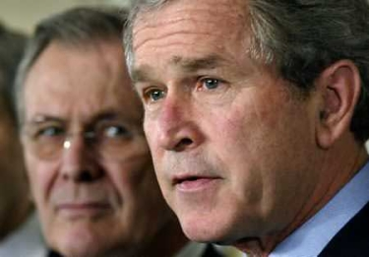

Torture Memos and the Iraq War

Table of Contents

Part 4: The Deliberate Infliction of Wounds and Sexual Torture at the US Prisons in Iraq

Part 5: US Administration Responsibility--Their Torture Memos

Part 6: More on the US Torture Memos

Part 7:The Sexual Torture and Mind Control of Govt. Officials and Their Relatives Around the World

Part 8: US Special Forces as Roving Snuff Film Makers in Iraq

More on CACI Billing and the Misdeeds of their Employees

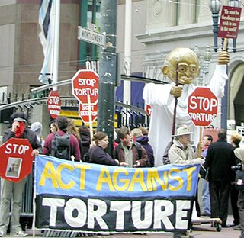Since I am still be tortured frequently, it is clear that the US Administration is still engaging in torture of dissidents, not of terrorists. I have been writing about their making kickbacks on torture. Instead of proving that they did not receive such kickbacks, they had me tortured. That shows that they are indeed guilty of such kickbacks and that they are very large, since they know I would stop writing about it if they gave them up. They are too large for them to give up as judged by their risky action of having me tortured instead. That is, they are big enough that they are willing to increase their risk of going to jail for them. Given their oil profits, and war profiteering profits in the billions, one wonders how many hours of torture a year CACI is getting paid for. Since the CIA’s budget is hidden, do we really have any upper limit for the hours of torture that CACI is getting paid for?

The number of prisoners in the war zones and CIA prisons around the world must easily exceed 20,000. My “best guess” world wide is that it is about 50,000. The CIA keeps a lot of prisoners “off the books”. The public has no way of knowing whether honest effective interrogations are being conducted. When I was at the Abu Ghraib prisons in Iraq in 2004, all the patients, about 8,000 of them had been smear with feces by the guards. When I looked at the CIA’s creative accounting records for the day that I was at that prison I was surprised to see that CACI had been paid for “interrogating” each prisoner for 2 hours, according to the number of prisoners. Just how does one interrogate a baby in arms who can not talk. I went back and checked the number of prisoners. The number of prisoners was identical except for a few who may have died or been in transport. Furthermore, I had arranged buses for the women and children. They were packed onto 4 buses, some of them having to stand jammed in like in a Tokoyo subway. There were 244 of them, per my memory.

So, I looked at the payment to CACI for the next day. The number of prisoners lists as getting 2 hours of interrogation was the same to within 10. That is, they were still counting those women and children that I released. Well, I wanted to figure out what was going on. I called CACI and spoke to the man in their Virginia headquarters who was in charge of their billing for the Abu Ghraib prison. He was not a director, he was a manager in the a section of their billing. I told him that I was worried about a high level detainee in Abu Gharib as to whether he was getting proper interrogation in quality and quantity. He assured me that all of their interrogators were properly trained. I asked him if they had grades of interrogators and whether I could request a higher grade of one for this particular prisoner. He said that they were all billed the same so he didn’t know that information but referred me to call another number. I then asked him if they could deliver more than 2 hours a day of interrogation services. He said that he had never seen that done and said something about the contract did not appear to allow for that. I then got a bit huffy with him and said that surely they were in the business of providing interrogation services and 2 hours a day on a high level detainee was just inadequate in some cases. He then told me that they only had about 26 interrogators and it was simply not enough. I asked him how many people they were interrogating a day and he said “They are in that prison to be interrogated so all of them.” I asked him what guidelines they had for not interrogating those who were too sick. He said he hadn’t heard of such a case. I asked him about their guidelines for age and language abilities, he said he didn’t know of any. He then offered to send me a copy of the contract.

When I got it I read it, including the fine print. It was quite long and I had to take several breaks. Most of it was about legal liability. That tried to excuse CACI of any liability whatso ever including for “death, PREGNANCY, VD, or causing insanity, acute injuries, loss of hearing, loss of sight, loss of limbs, and loss of reproductive function! The lawyers writing that contract up sure knew exactly what was intended in terms of “interrogation” at Abu Ghraib.

The date of the contract surprised me. It was dated from before the official start of the Iraq War and even before the UN resolution which some felt authorized the invasion. I thought that I must be mistaken so I double checked it. But that was indeed the case. It was signed about 4 days before that last UN resolution before the war.

The fine print guaranteed CACI as certain volume of prisoners to interrogate a day for 2 hours of interrogation a day. That guarantee might be fine when one was talking about buying goods, but torture causes people intense suffering. The US Administration was promising the Senate Select Intelligence Committee that they were only torturing high level Al Queda suspect? How were they going to get 5,000 of those for the Abu Ghraib prison alone?

It sounded to me like a torture assembly line. During the Cold War, Soviet defectors were sometimes interrogated and I had heard about that from colleagues inside the CIA. Those interrogations of ‘presumed friendlies” sometimes went on for 10 hours a day. If one needed information to make an actionable decision on, than one needed it promptly. No where was that truer that in an insurgency situation. Russian defector’s information rarely pertained to the safety of US men in the field, yet the CIA was pursuing it with due diligence. If you actually believed that torture interrogation yielded actionable intelligence, then you would have to set up a system that allowed for adequate number of hours to achieve it promptly. Clearly, those deciding on the terms of the contract, those in the US Administration setting forth the needs of the US, did not believe that torture interrogation worked to produce actionable intelligence.

But I decided to look into it further and see if the US military’s side of the interrogation assembly line was set up any better. To do that I went over to the Pentagon and searched through the interrogation files from the prisons I had visited. I had the help of a librarian type of secretary. I started out asking to see all of the interrogations done on the day that I had been there. I did that because I had had prisoners helping me from about 10 am to about 4:45pm, about 2 dozen of them throughout that time. I had my records and their names. So, I asked to see their interrogation records first. There were none. That did not surprise me. I asked where they would be if CACI had done the interrogations. The librarian said that they would still be in the US files. I asked her to check, if possible, when those prisoners had last been interrogated. By this time I had 3 secretaries helping me. At the end of the day, they could only find about 15 interrogation records for that prison that day. That was not too far off what I thought it should actually be in practice.

Concerned that my visit might have changed the routine of the prison, I asked to see the records for the day before and the day after. The day before there were about 16 and the day after about 18.

The librarians did not know anything about the billing. They had never heard of the 2 hour rule for CACI. When I looked at those 3 days of interrogation files I found that one man had been interrogated for 5 hours and the rest for 2 hours. That confused me. I went back and looked at the signature lines and wrote down the names of the interrogators--all of them for those 3 days. The man who was interrogated for 5 hours had US military interrogators. I read some of the interrogation and was hardly pleased with the quality. They were mainly harassing the man. I saw so little evidence of a credible job to even try to obtain information, that I wrote a note to one of the JSC members asking him to review the case. That is a whole story by itself and I do not want to take the time to tell it in this context.

But the CACI “interrogations” were even worse than that! One man was deaf from previous torture in that prison. They were asking him questions and he would say “I am deaf.” His speech was completely unrelated to the questions, so why did they go on for two hours of utter nonsense? It appeared that the reason was that the day before he was urinated on the shoe of a CACI guard. I could not tell if he was blind as well. He said that he could not see, but he may have had a hood on. The same thing likely was the case when he urinated the day before. Judging from the interrogation, CACI people beat him up very badly for two hours for something that he appeared to be innocent of having done on purpose.

Another of the interrogations by CACI was of a young woman, about age 16. She said several times on the record, “Don’t touch me there.” Where there was was unspecified at that point. But later in the transcript she said that she was pregnant. One of them said to her “We are going to fix that for you.” The gist of the interrogation was that she had not followed an order to follow a guard into an isolation room. I wouldn’t have followed such an order either if he had raped me before and caused the pregnancy in the first place. He was in the interrogation apparently because he said, “I don’t want the child”. And later “I won’t pay for it.” There was talk of blood by the end of the first hour. One man said, “There, the problem is solved now.” It certainly sounded like they had kicked her in the belly until she aborted a 4 month old fetus judging by what they said. There were no words recorded for the second hour. There were signatures on a page asserting that she had given them the information that they needed. There was however no signature for a translator on the page and no transcript. Again I sent a note to a member of the JCS asking for a review of the case, a different member so as not to overload the first.

Another CACI interrogation was of a boy of about 11 years old. He was accused by the interrogators of stealing a piece of food from a guard. His mother was present in the room during about a third of the interrogation. The guard had caught the boy red handed. End of case. There was no need for an interrogation of him. But the interrogation happened anyway and it escalated to the CACI interrogators charging him with planting explosives that killed people some months before. He had been in prison during almost all of that time so it was not a recent event. The number of people killed escalated from 2 up to more than 5 during the interrogation, making it clear that the guards were making up the accusations. Even the boy figured that out. It appeared that the interrogators sodomized him because when his mother was brought in after a passage of time she said, “What have you done to him?” They said “Nothing”. And she said “Then why is blood dripping from his rear end?” They said, “He has VD and we had to check him there”. But that made no sense and there was no record of his being seen by a physician and no samples sent to the lab. Interrogators are not qualified to check for VD. Then the interrogator’s stories got even more bizarre. They insisted that the mother had given the son the VD and demanded that she let them check her as well. She rightly refused. They appeared to have hit her on the face because she later complained about blood coming from her mouth. They called her nasty names. It appeared that they raped her in front of the boy to get back at him. I say that because the boy was recorded as saying, “My mother is not that kind of woman.” before he started saying incoherent things would showed extreme distress like “Sandwiches bleed.” He did not become incoherent until about 10 minutes after he said “My mother is not that kind of woman.”

Not all of the CACI interrogations were like that. There was one set of CACI interrogators who I thought did better than the military interrogators. They asked relevant questions, followed up the answers and were not overly aggressive. They were trying to find out from a man who was a witness to a shooting of a US soldier what he knew about the identity of the shooter. The man they were questioning was not involved in the shooting, he had been the one reporting it to the MPs. Thus, he should not have been imprisoned--but he had been. I asked for reviews of those last two cases from another Pentagon official.

There were not 8,000 interrogations done of two hours each on those days. There was not even the need for anything close to 5,000. Since the CACI biller had said that there were 26 interrogator and it was standard to have two on a team, each day they could at most do 4 for each of 13 teams or 52. Even if they used only one interrogator per team that would have been only 104 interrogations, not the 8,000 billed for. If CACI had done essentially all of the interrogation, say 16 of them a day for the three days that would have been 48 of them. That is about a third of full use of their interrogation staff. Thus, it appeared that 2/3rds of the CACI interrogators were not needed as judged by the number of interrogations done. Admittedly, this was only a three day period and some reserve is needed. So, I did not find fault with the number that they said that they had. But the overall performance of them was completely unacceptable in a US facility.

I then tried to figure out who they reported to so that I could have that CACI person also review those files. I called up CACI’s headquarters and spoke to the man in charge of Abu Ghraib personnel. He told me that was privileged information that I was not allowed to have even though I had a rank of a 2 star general at the Pentagon. I faxed him over my credentials in case he thought I was a reporter. His story did not change.

Then I asked both Tenet and the JCS at one of their meetings what procedures were set up to file a compliant against CACI employees. They said that they had no idea and acted like my question was an improper one. The JCS member that I referred the case of the deaf man to made excuses for the interrogators beating the man up. I asked him if he had read the interrogation. He replied that he did not have time for trivial matters like that. When I pressed him on it he said, “Look, I am here to fight a war not worry about human rights.” The JCS member who I referred the case of the 16 year-old pregnant girl said that he had read most of the interrogation and was horrified. He had immediately called CACI and demanded that that interrogators be fired. He assured me that that had happened. But when I call the Abu Ghraib prison and asked to speak to either of those men by name, both were still at the prison over a week after CACI said they had been fired. I asked the interrogator to give me a run down on the latest case he had worked as if I was just curious how things were going in Iraq. His last case was the day before. I asked him if he was on the job market and he said no and wanted to know if I had a good job offer for him. I said that I might be able to get him a job as a masher in an abortion clinic. There was an uncomfortable silence on the other end of the line for a few moments. Then he said, “Oh, you heard about that at the Pentagon?” I said, “Yes, and CACI assured us that they had fired you.” “That is the first I’ve heard about it,” he said. I told him that if I had a court that I could easily haul him into, I would charge him with murder. He said, “I didn’t mean for the girl to die, honest. What was I supposed to do--pay child support for some Iraqi terrorist the rest of my life?” “Your unborn child is an Iraqi terrorist in your mind?” “Sure, I didn’t love her.” “Then you should not have mated with her. She was a prisoner under your care, not a whore.” “You don’t know what it is like here. Everyone uses the c**ts here.” “And I suppose everyone kills them when they are done with them too.” I retorted. He said, “Most do, unless they fall in love with their c**t”, he said derisively. I asked him off the record how many women he had killed after raping them. He asked inside the interrogation room with a translator watching or outside of it. He was on a roll and wanted to brag about doing it in front of others who did not stop him. I said both. He said at least 4 during interrogations and over a dozen in the cells. I asked him whether he had to hide the bodies and their condition afterwards. He said, “Hell, no. Nobody cared. He said, “No one can touch us CACI people. That is what the Abu Ghraib scandal taught us, we can get away with murder.” “I told him that he and his partner in crime had better get out of that prison within 24 hours or I would personally see to it.” I then faxed over to an Iraq Minister in their Justice Dept. the interrogation file and my recording of my phone call. He faxed back a thank you. He was more than willing to try the case in the Iraqi Courts. He faxed me a few days later saying that they had apprehend and arrested the two men as they left the prison the day after I called. They spent two months in an Iraqi prison awaiting trial. My understanding of what happened after that is that Bush pulled strings for them and got them released. When I heard that I called Bush’s office and asked one of his lawyers if they had listened to that taped call before advising Bush on the matter. That lawyer said that he had and that he knew that they were guilty. He said that lawyers often get the guilty off if possible, as an excuse. I felt sick to my stomach. I did not doubt that he was correct that he had argued to release unrepentant rapist murderers upon the women of the world. I ask him what he had told Bush about the case, saying I would have to tell Bush whatever he had left out. But I already knew what he had told Bush from the Mossad’s recording of it. So, I knew that he was lying. He said that he had told Bush that “the boys were innocent” and “it was the girl’s word against the two boys”. That made it sound like Bush was right to pull strings to get them released. But the Mossad’s recording of their conversation showed that he had said, “Of course, they are guilty as hell. But how can it harm us to please CACI?”

“In Germany they first came for the Communists,

and I didn't speak up because I wasn't a Communist.

Then they came for the Jews,

and I didn't speak up because I wasn't a Jew.

Then they came for the trade unionists,

and I didn't speak up because I wasn't a trade unionist.

Then they came for the Catholics,

and I didn't speak up because I was a Protestant.

Then they came for me -

and by that time no one was left to speak up.”

---Niemöller on January 6, 1946



Part 4: The Deliberate Infliction of Wounds and Sexual Torture at the US Prisons in Iraq

I spent my first hour at Abu Ghraib Prison examining corpses, as the guards could bring me no patient clean enough to examine. They were piled in a trench inside the compound near the infirmary. Four out of the 7 corpses I examined had died of untreated infections! The guards felt so safely shielded from prosecution (even after the scandal), that they did not even bother to tell me a cover story, such as another prisoner had done it or there had been a terrorist attack at the prison. That was a damning indictment of the authorities above them showing that they were not disciplining the guards for the mutilation and murder of prisoners, because they were in accord with it. As I documented that the corpses died due to the guard's violence, a guard grabbed me from behind and pressing a knife to my neck had hissed "You're next".

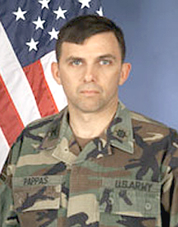

[Photo of the Commander of Abu Ghraib prison, Colonel Pappas]

The prison C.O. gave him what amounted to no disciplinary action at all for threatening my life in what amounted to a mock execution. The C.O. of Abu Gharib prison told me that whoever was the most vicious would win. He was unable to give me a good reason why, in spite of the US torturing to death 20,000 to 40,000 Vietnamese in Operation Phoenix, most of them innocent civilians, that the US had lost the war.

[According to Captain Donald Reese, the Commanding Officer of the 372nd Military Police Company, Colonel Pappas was the senior officer present during the death in custody of Manadel al-Jamadi.[1] Military pathologists later ruled the death a homicide. During Sabrina Harman's article 32 hearing Reese testified that Pappas commented about Manadel's death: "I'm not going down for this alone.[1] http://en.wikipedia.org/wiki/Thomas_Pappas ]

The rest of this section is gory and should be skipped by some. Another had died of strangulation by human hands, as judged by the marks on his neck. Another had a leg cut off and and had bled to death (no surgical notes in his chart, no anesthesia given, the recovered leg showed no signs of disease). Another corpse was missing a head. His file had entries "bloody discharge from penis", "bloody nose", and "bloody ears" at intervals over some months ( no notes of medical care). 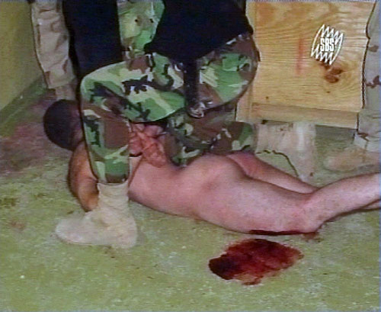I went back to examine his corpse, and noticed that due to the stench I had missed that his penis had been half cut off and then healed over. By then I was wising up. I dug further down and found the head which indeed was missing part of the nose and both ears. One wound had festered through the skull and into the brain. Suspecting that he died in a coma, I tested that hypothesis by saying to the guards "At least he didn't die in pain." The guards then laughed and said he was unconscious for 2 days and his head stunk so bad that a guard had cut it off and thrown it in the trench. They said that it was three days before the rest of the body was removed from that cell with other prisoners in it, and that was why the head was buried deeper. Another prisoner had been killed by an axe taken to his head; the axe was also recovered.

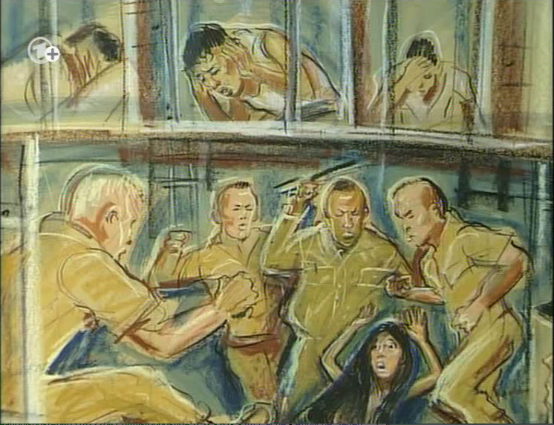

We documented the horrendous torture of prisoners as we treated their wounds and performed surgery. The rape and sodomy of women and children had caused rectal and vaginal tears in them ( for independent documentation also see "Rape and Torture Rampant in [US run] Iraq Prisons" at http://www.antiwar.com/orig/croke.php?articleid=3645 and "US Silent on Torture of Children [in Iraq] at http://www.antiwar.com/orig/croke.php?articleid=3286). The injuries that we documented are so horrific that it is very hard to write them in this report. They had been viciously stabbed, cut, maimed, had bones broken, or shot, etc.

[ NBC News later quoted U.S. military officials as saying that the unreleased photographs showed American soldiers “severely beating an Iraqi prisoner nearly to death, having sex with a female Iraqi prisoner, and ‘acting inappropriately with a dead body.’ The officials said there also was a videotape, apparently shot by U.S. personnel, showing Iraqi guards raping young boys.” See http://www.newyorker.com/archive/2004/05/17/040517fa_fact2?currentPage=3 .]
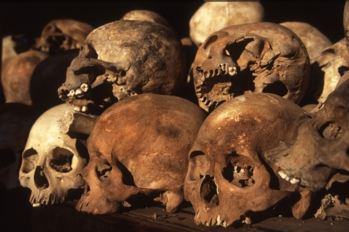
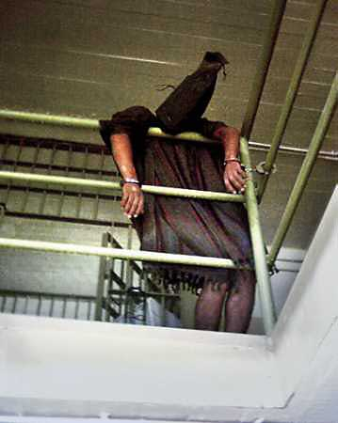


["Be on notice," Rumsfeld said in a standing-room-only Senate hearing room May 8. "There are a lot more photographs and videos that exist. If these are released to the public, obviously it's going to make matters worse."Videos Amplify Picture of Violence http://www.washingtonpost.com/wp-dyn/articles/A43785-2004May20.html ]

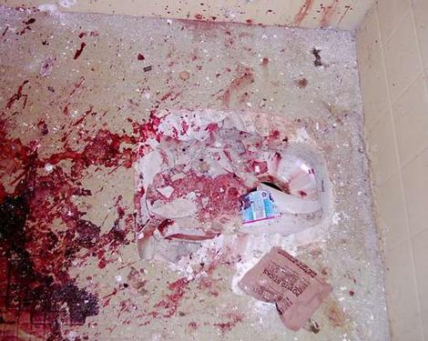

[Torture room at the Abu Gharib prison.]

In the third prison the injuries the German Red Cross documented and treated (using hospital style surgery) included;

1. A girl of about age 5 was attacked and the blows with what was probably an axe had taken out a wedge of flesh where the shoulder met the neck. She required chest surgery to remove a section of the lung which had been damaged.

2. A young Iraqi woman was found bloody and unconscious in the closet in the guard's sleeping area where prisoners were not allowed. Her belly had been cut open, the German surgeons said that she had been 4 months pregnant per examination of her torn open womb. I recovered the cut up fetus from a trash can. Despite heroic efforts, the young woman expired on the operating table.

3. A man in his forties who had been stabbed in the groin by guards and left bleeding.

4. A man in his seventies was found in a coma behind a dumpster. He had been stabbed in the belly and had a festering wound. Prisoners were not allowed in the dumpster enclosure which was well fenced in, so he must have been placed there by the guards, probably to deny him medical care.

5. A man in his forties shot in the back with a shattered scapula, a collapsed lung who was gasping for air in a moribund state. He was found by the German Red Cross near the fence but inside it, laying face down. The guard who shot him hours earlier had not tried to get him medical care, but had left him there to die. No note had been made in the prison record regarding the shooting incident.

6. The German Red Cross treated many other people at that prison after I left that did not make it into my report. In order to get into the prison with me they had told the US govt. that their findings would not go to the Red Cross.

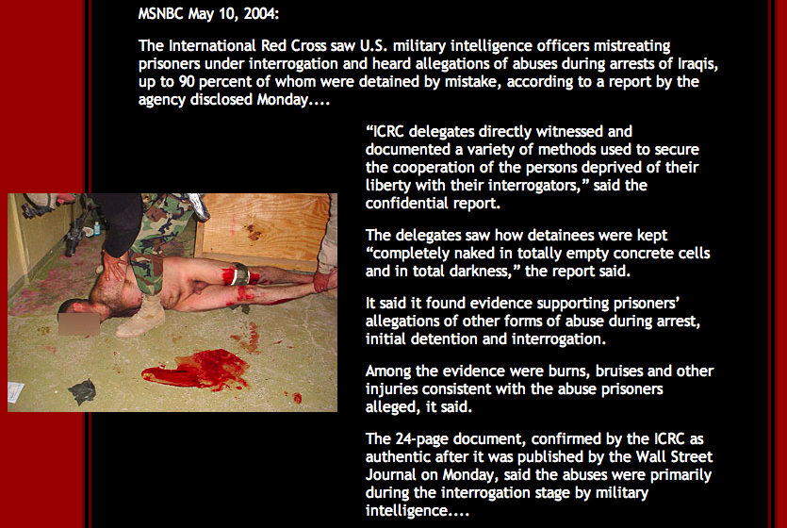

[ This report is from an earlier Red Cross visit. See http://www.thewe.cc/weplanet/news/armed_force/terror_states/us_caused_torture_and_terror.htm ]

In the second prison the injuries I and an Iraqi surgeon in the Red Crescent examined/treated (using quick MASH-style surgery) included:

1. An 11-year-old boy who had a rectal tear from sodomy and a stab wound to the belly and peritonitis. His injuries were due to the two hours that he had spent in the US's air--conditioned interrogation room the day before. He was found in a coma; without surgery that day, he would have died.

2. An older woman about 60 years old had a fistula track in her belly draining liquid feces and causing her dehydration chronically. Her injury was the result of a guard hitting her belly with a something like a rock hammer which pierced her belly and a single loop of her intestines about 2 weeks before.

3. A woman about thirty years old was 8 months pregnant but we could hear no fetal heart beats. I counted 8 stab wounds to her belly. The surgeon said she had been stabbed 10 times, two times through the vagina. The baby was dead in her womb. She was delirious with fever, moaning, and in shock.

4. An Egyptian journalist in his late 20's had captured US war crimes on camera and was being held as an Iraqi and moved from prison to prison to hide him from his news service. The CIA had tried to convince him that he had hallucinated the US war crimes by mind controlling him and planting false stories and a bullet under his skin behind his ear. He had not been convinced and continued to ask for his freedom. Guards had stabbed him with a sharpened broom handle in the belly and pierced his liver causing many abscesses behind it and at the base of the lung.

5. A man in his late 60's had gangrene of a leg. The gangrene was the result of torture in which his leg was progressively hacked off slowly. There were no medical notes in his chart--no anesthesia had been administered. He required a proper surgical amputation of his leg.

6. A girl child of age 2 had been raped about the day before by US soldiers in front of her mother. Her injury was a tear in the vagina that split into the rectum. The child looked gray and close to death from sepsis due to the peritonitis. The surgeon was undeterred by her critical condition and started the surgery. He was able to reconstruct her vagina and rectum and she did pull through by the grace of God.

7. A girl of about 6 had a rectal tear that went into the buttock's muscle, and made a grand canyon in it. Hundreds of eye-witness prisoners that seen what caused the injury. Those questioned separately said the injury was made by inserting a knife into the rectum that was tied to a rope and then to a car. The sudden acceleration of the car had fractured her pelvic bone and cut through her buttocks on one side. It was a deliberate and savage cruelty that is difficult to even recount. The injury was fresh, having happened that morning before I arrived.

In the Abu Gharib prison the injuries I treated (using "do the best one can under the circumstances in the time allotted" surgical methods) included;

1. A woman in her forties had a festering wound that had eaten away half of one breast, as the result of a guard driving a sharpened broom handle through it.

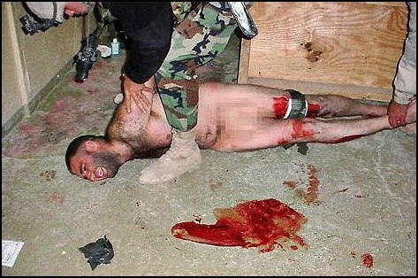

A male prisoner at was missing his left arm and his right hand was dangling as it was missing forearm bone, due to a guard wielding an axe.

3. A woman was incontinent of stool following a gang rape by guards and then by sharp objects. Examination showed that the wall between the vagina and rectum was missing due to it being torn out by those objects. Her previous treatment in the prison had consisted of two days of antibiotics. Then she had had a fever for weeks and no more antibiotics were given--a physician was never phoned for her.

4. A woman had a fistula hole in her neck that drained food out when she ate. She had been stabbed in the neck by a guard.

5. A man about 30 years old with a fistula tract from his intestines after being stabbed in the belly by an ice pick.

6. An 11-year-old girl had syphilis secondary to rape by the guards. I treated about 25 other people for syphilis at Abu Ghraib Prison, most of them guards and children age 6-12.

In all three prisons, there were numerous people with festering wounds of their genitalia, esp. where one or more testicles had been violently removed. At Abu Ghraib Prison, methods of removal included knife wounds (about 3), gun shot wound (1), and bites (about 7).

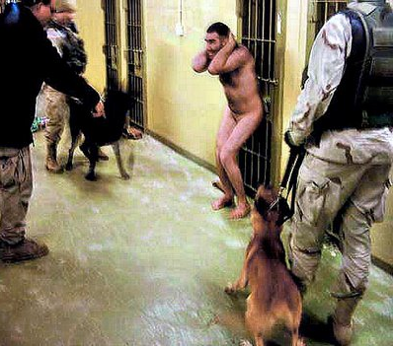

[Note: I am writing this report 4 years later without my notes. The science of memory shows that it is remarkably good for the gist of the events and less good for peripheral details. That is true of all memory, even after witnessing highly traumatic events, and should be counted by the courts as eye-witness testimony (see law professor Alan Scheflin's award-winning tome Memory, Trauma, and the Law)].

President BUSH PARDON's HIMSELF against POTENTIAL WARCRIMES
http://www.youtube.com/watch?v=jHQ7Prwh7Gc



Go to Table of Contents

Part 5: US Administration Responsibility--Their Torture Memos

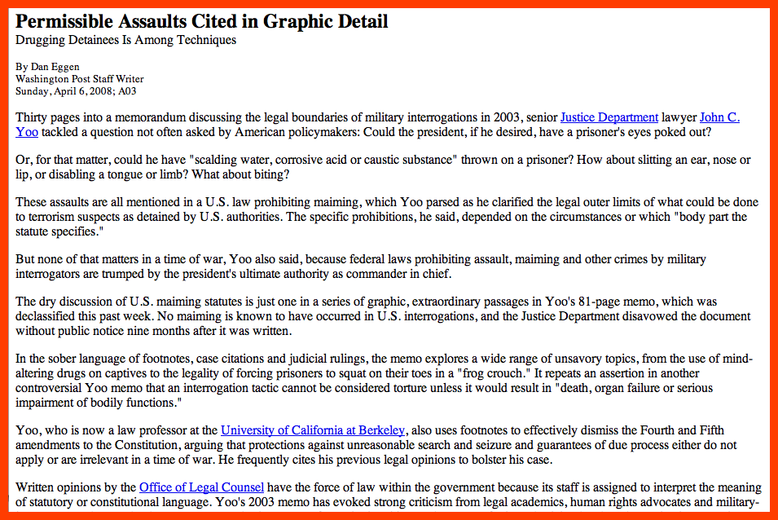www.washingtonpost.com/wp-dyn/content/article/2008/04/05/AR200804052009_pf.html


[ Read Administration of Torture: A Documentary Record from Washington to Abu Ghraib and Beyond by Jameel Jaffer and Amrit Singh for confirmation on the existence of some of the memos.]

The White House Sexual Torture Protocols:

In the files of all three prisons there were torture protocols with clarification memos from the White House on how to apply them. Those protocols were designed to maximize the viciousness on the premise that that was how to win. I didn't want to believe that my country would intentionally do things like crushing a child's testicles, and worse. The first part of each White House clarification memo started with referring to an obstuse executive order signed by Pres.Bush, Jr.. Below that was the operational meaning as to how it should be applied to torture people. I was able to prove from within the CIA, that the operational meaning was on the memos before they left the White House. That was consistent with the chief architect of the Bush legal policy, John Yoo, stating that the Bush Administration reserved the right to torture innocent children, including by crushing their testicles.

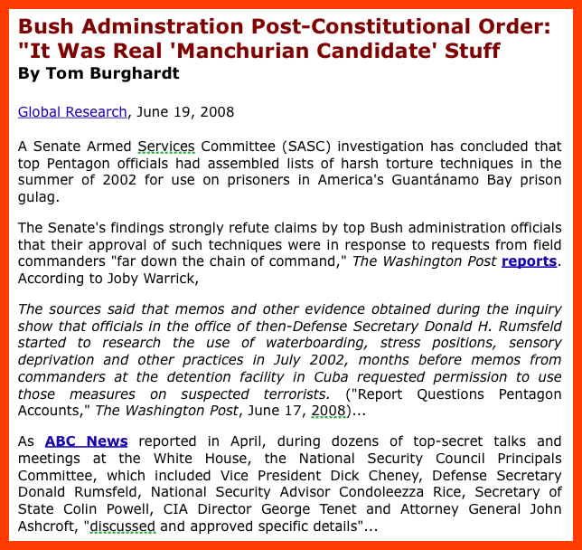
http://www.globalresearch.ca/index.php?context=va&aid=9382

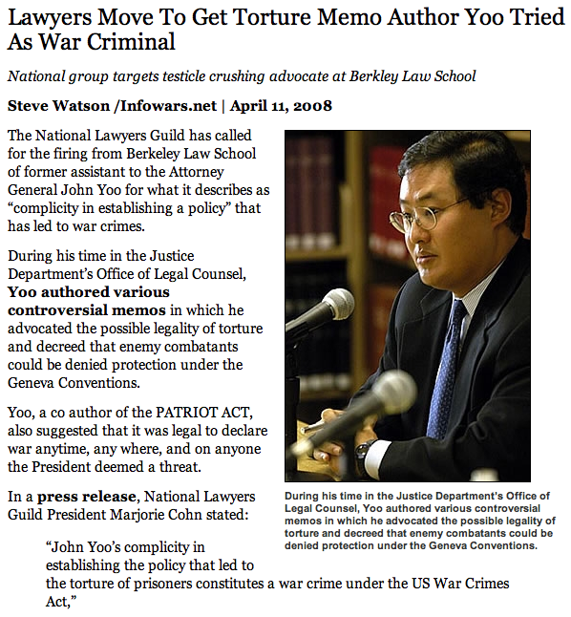

http://www.infowars.com/?p=1448

Given the raw language in which they were phrased, I believed that Cheney had written the lower parts, as I had heard him swear when I was a negotiator between him and Tenet over 9-11 blame. However, some of the torture protocol pages had a Skull and Bones emblem on them suggesting another source. Skull and Bones rituals include such things as "Cremation of Care", human sacrifice, and sodomy as a way to control others, per voluminous documentation and videos available within the CIA. The CIA was initially formulated by a Skull and Bonesman Robert Lovett, and many of the early leaders in it, as well as the first appointed DCI Dulles, were members of it. The CIA answered the questions of Skull and Bonesmen that called it for information, and put almost everyone else on 20 year or permanent hold.



Skull and Bones was started in 1832 by a drug, slave, and weapon-running pirate and the CIA has continued in the same lines of work (see books such as White-out, Dark Alliance, Barry and the Bones, and the C-SPAN segment on Congresswoman Cynthia McKinney confronting Rumsfeld on the missing trillions of dollars and the sex-slave running done by DynCo and Halliburton http://netctr.com/911exposed.html , http://www.youtube.com/watch?v=eootfzAhAoU ). Bush, Sr., Bush, Jr., Clinton, and Kerry were all members of Skull and Bones. All three C.O.s of those prisons were members of the "extended Skull and Bones" membership which included Bohemian Grove members and thus most recent Presidents. A review within the CIA showed that essentially all of the C.O.'s US prisons in Iraq and Afghanistan were members of that extended death and destruction cult. I saw with my own eyes, the satanic altars of two of the three C.O.s. of those prisons. In order to become "one of our kind" as the C.O. of the Abu Gharib prison put it, "graduates" had to prove that they were able to mutilate, torture, and kill other prisoners. Those tests were done in front of guards and photographed by them, as evidenced by the photos that I found in the files. I was unable to find documentation of crimes committed by prisoners against other prisoners in the C.O.'s files in two prisons; it appeared that virtually all of the crime was intended by the prison authorities. All of the injuries that we saw as physicians were in accord with the White House Torture Memos that I included in my report. The protocols included the phrases "kill the unborn" and "remove out the gonads", in cleaned up terms. In all three prisons, there were men missing testicles with festering wounds where the testicles had been. It was impossible to tell after the fact by medical exam whether the testicles had been crushed before being violently ripped out.

[ Photo is an example of a satanic altar. The ones I saw were small desktop portable sized. The upside down cross is a sure sign of one. ]

The Heinous Crimes of the Mind Control Slaves that the US Govt. Made in Iraq:

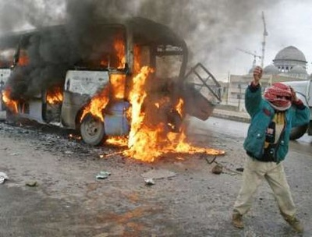

In her Salon interview, General Karpinsky categorically stated that no prisoners were never released from any of the prisons under her command. That was not what the files inside the CIA said. I looked at the files of the "graduates" from the Abu Ghraib "School of Torture". The CIA was using them as assassins, as politicians, as death squads, and as insurgents! They trained them in camps that they said were Al-Queada Camps. The CIA had been unable to find Al-Queada in Iraq under Hussein, so the CIA had to make Al-Queada camps and agents to try to tie the Iraq War into 9-11. In one case, a graduate of Abu Gharib--- on the CIA's orders---went and blew himself up next to the Green Zone in Baghdad. They did that to be able to justify putting it a new large permanent fortress in the Green Zone. It worked, Congress gave the funding. In another case, the CIA sent one of its graduates to stir up more sectarian violence by blowing himself up in a Mosque that was used by only one sect. Another graduate of Abu Ghraib, they sent to murder an Iraqi politician that they didn't like and wanted his death blamed on sectarian violence. In another case, the graduate raped women in a village to blame in on a particular sect. The CIA then picked him up quickly and killed him so he couldn't ever talk about having been in Abu Ghraib prison and how it had been programmed to rape women in response to triggers that the CIA provided.

[From James Thomas Fleming: NIS Expose on mind control to make expendable assassins/terrorists



Welcome to my web site. My name is James Thomas Fleming, former Project Coordinator of the National Intelligence Service. You have probably never heard of the NIS. It is not unlike the CIA, but I assure you its past is much darker. ..The NIS is the most secretive government agency in existence. They conduct foreign and domestic intelligence operations, keep files on everyone (including you) and devise high technology for use in intelligence and weapons systems for the government. The NIS was created by executive order with the signing of the National Security Act of 1947. So secret was to be the nature of the NIS that its name was not even referred to in the text of the act - it exists due to a deliberate loophole in the language. They receive billions of dollars of defense funding annually, which is covered up by attributing it to other agencies, and various public service programs, which do not actually exist…
My background in psychology eventually got me assigned to the Behavioral Science Unit...

The phone call woke me up at 6:00am. A female subject in one of the experiments had blown the head off of an NIS field agent with his own service weapon (an HK USP). When I asked how it happened, there was dead silence for a few seconds, then "I think you should get down here, sir."
Special Agent Charles Hayward was dead in the hallway. His body had not been moved. I put on the gloves, as usual, and made a visual inspection of the scene. Blood and brain matter caked the wall. The sight was sickening. It was at this point that the reality of the situation hit me - the program must be terminated.
The woman soon regained her consciousness and showed no signs of any memory of the event. Rather than tell her the shocking truth of what she had done (which would have compromised security anyway), we sent her on her way.
I called an emergency meeting with the oversight committee. The project was immediately discontinued at NIS, but I found that details had been piped to DoD (Department of Defense) all along! This enfuriated me. As coordinator, I had the final word in any joint operations, and this was a clear violation. The responsible party had vanished without a trace - only later did I find that he was a plant for the National Security Agency. The research, I am sure, has continued outside of the hands of the NIS. Determined to stop it, I sent memos to the white house.” http://www.mindcontrolforums.com/v/fleming.htm, http://www.subversiveelement.com/MindControlFlemming.html

Follow-up: The report is taken from Thomas Fleming's web site, http://www.subversiveelement.com/MindControlFlemming.html. He urges readers to save it to disk as he fears retribution from the government. Check the site for updates.
1-99. From an anonymous E-mail:
Jim has been arrested by the DSS. None of us know whether or not he will be charged, or what will happen to him.
He said to take what he gave you and propagate it as much as possible. This would help to accomplish his goal of spreading the truth as well as gain support in the court of public opinion.

As of 1-99 Mr. Fleming's site reads only:
Access Denied. This site has been decommissioned pending investigation.

It bears the seal of the Defense Intelligence Agency, which links to it. ]

Aftermath of the Prison Inspections:



It was the Rumsfeld's responsibility to make sure that the prisons had medical services set up to supply care to prisoners and did so in a timely and effective way to met their medical needs. That he did not do so is a war crime from which many prisoners died. After I handed in my report, the US Administration did know about the conditions in the prison, as proven by information within the CIA. That Mr. Bush and Mr. Cheney, did not fire Mr. Rumsfled at that time but left him in place was an intentional decision on their part. Having not fired him, they were directly responsible, if the conditions in those prisons were not corrected. As a two-star general , I out-ranked the C.O.s of those prisons and wrote emergency corrective orders that they had no authority to over-ride. Since I had no command responsibility for those prisons, I was unable to exert any authority over them after making my initial report to the proper authorities above me. After I left, the prisoners were again systematically denied clean water, nutritious non-harmful food, and medical care. That did not happen by chance, and deserves thorough investigation. Reports from within the CIA showed that as late as Aug. 2004, after Tenet was replaced that those conditions were not corrected. That DCI Tenet, and Acting DCI McLaughlin, both did not expose those conditions, I take to mean that they were the policy of those in the US

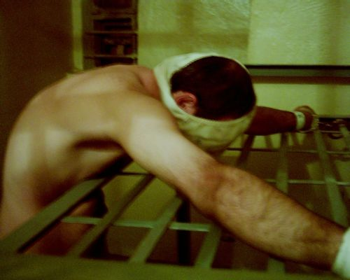

Administration. When the US Administration failed to replace Rumsfeld or anyone those in the chain of command above the level of those three prison C.O.s, they were "signing off" on the fact that they were in complete accord with the denial of clean water, adequate food, and medical care to those prisoners.


Christ never said to torture, crush people's testicles, rape, and kill people to steal their resources. He said to feed the poor, cloth the naked, heal the sick, and visit the prisoners to care for their needs. He said that whatsoever you do to those people, you have done to me.

There is no doubt that the US Administration has ordered sexual torture; it has ordered sexual humiliation and water-boarding (see Hypocritical Oath: Psychologists and Torture at http://www.alternet.org/story/53364/). It has also spread much disinformation. Water-boarding in actual practice straps a person to a board, submerses their head under water until they pass out/seize. I know because that was done to me 20 times in a row---each time was severe life threatening torture. Also, much of the US Administration-ordered-torture of me and other MKULTRA-type survivors and Iraqi/Afghan prisoners involved rape or sodomy. Part of the evidence on the Abu Ghraib Scandal that the Pentagon did not show you was a video of a US official sodomizing an Iraqi boy of about age 12. These sexual torture techniques were developed at the CIA under Operation MK-ULTRA which funded 80 institutions of higher learning to figure out how to mind control individuals and populations. Those methods have been used widely against US citizens and the US population at large to brainwash them into giving up their Constitution and their human rights. Since the US government has not upheld the Geneva Conventions and the UN Convention Against Torture (both of which it ratified and were meant to be applied even if one's country were about to be defeated by acts of terror against it), the US Govt. forfited its right to hold detainees or prisoners at all (see International Law Scholar Scott Horton's Bush Team Revives Nazi Legal Ruses--Condemned at Nuremberg at www.new-fed.com/other/interviews/2005/3204scott_horton.html ).


Please request a copy of my report of the medical conditions of US held Iraqi prisoners; the US Administration, Pentagon, and CIA have keep it secret. That was true even though Tenet declassified the report and the supporting documents as not being a risk to national security. Please demand an investigation into the US prisons and make sure that the prisoners are all treated up to the standards of the Geneva Conventions. Please demand that the Red Cross have access to all sections of each prison and are allowed to do unannounced inspections of them immediately when they arrive. Please demand Mr. Bush explain what torture he has authorized; by method, the names of those to whom it is being applied, and the names of the judges that ruled that as their appropriate sentence, and the names of the international court judges that supplied a waiver for the US to use torture. Demand an end to all torture, including by the CIA and proxy forces, it is being used to torture mainly innocent people to control populations and people against their will.

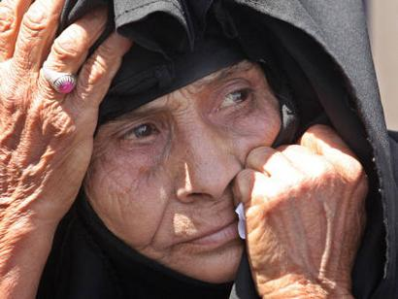

[“An elderly woman waiting outside the Abu Gharib prison, where her son is held, May 2004. Reuters/ Ceerwan Aziz]

Please pray for all those who lost their lives, their souls, or their dignity in US detention. Photo of Abu Ghraib prison. The prison was closed but the prisoners were just moved to other US prisons. The US torture policies were not significantly changed.

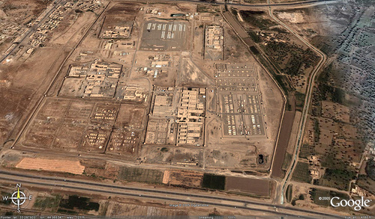

Part 6: More on the US Torture Memos

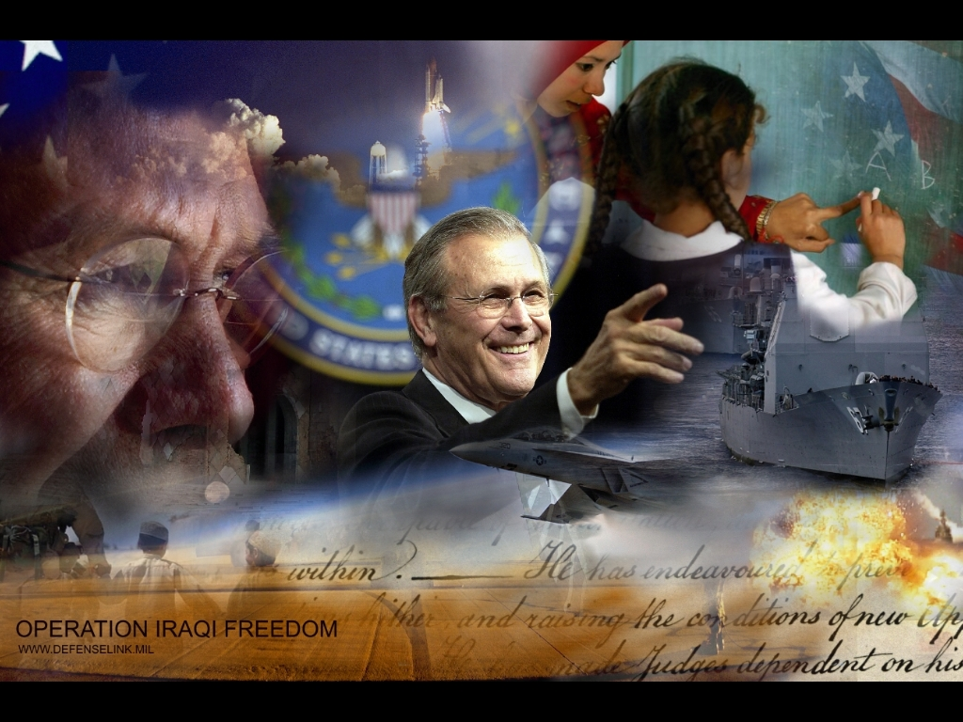

The US tortures prisoners even outside of fixed prison locations. Special Forces (Sp. F.), starting under Rumsfeld, tortured "suspects" in the field. Since I was giving briefings at the Pentagon on CIA acquired data in Iraq and Afghanistan, I was privy to what those Sp. F. were doing and it was pretty unspeakable. So, I did know before I got out to those 3 prisons that the US was engaged in sexual torture, mutilation, sodomy, and rape, and not just of "suspects" either. Unfortunately, what we were seeing at the CIA was that 98% of the time the Sp. F. men said they were "interrogating a subject" were just sexually torturing and raping people for the sadistic pleasure of it.

I know of not a single instance in which valuable intelligence was gained through torture that we didn't already have better and more complete data on from other means. When the CIA study authorized by Tenet compared non-violent data collection to harsh collection, the non-violent methods were shown to be vastly superior. Torture is never justified, because it is never the best method for anything one wants to accomplish - unless you are just a sadist trying to make people suffer.

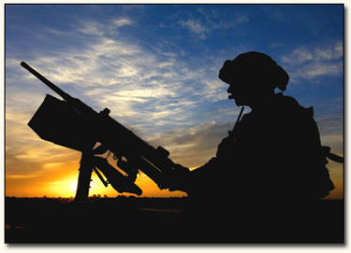

I was training Sp. F. men for the Defense Intelligence Agency in how to collect intelligence. That training occurred at DIA Headquarters and in the field in Iraq. I am hardly a naive person, having been in war zones collecting intelligence since during the Vietnam War. Still, I was shocked to see US soldiers torturing and mutilating civilians in the field. In this case, I was collecting intelligence after a US battle 5 days before with a group of about 12 Sp. F. men. I had explained that we were only here to collect intelligence and not to fire any weapons, particularly since they make noise and we were very much outnumbered by the remnants of this rural village. Several of the men had gone out of my view for a several minutes. As I quickly came up behind them, I saw that they had a village girl of about age 14 on the ground with her skirt up. Those who don't want to read gory material should skip to the next paragraph. She was bleeding from her private parts and the handle of a knife was protruding from her vaginal area. I carefully removed the knife with my fingers inserted against the blade and applied pressure to stop her bleeding.

I was furious. First off, she needed to have surgery in a hospital. And second, their unprovoked action was going to bring the village down upon us and rightfully so.

A soldier said to me, "We do this all the time. It serves the c**ts right."

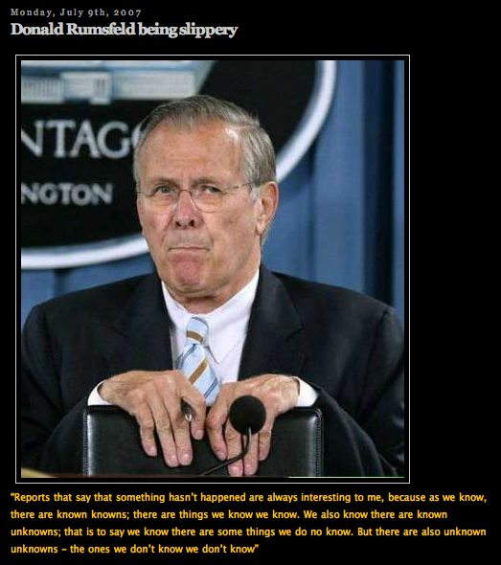
After I got her into a hospital, I then ordered a court martial of the soldiers involved. The US Army refused to try them! They said the soldiers were in the heat of combat. When I called them on that, the CID (Criminal Investigation Division) investigator then gave me another story about following orders. Under pressure from me, they quoted me an order number. It referred to an order in a memo that Rumsfeld had written. The memo said, "F**k them sterile, by any and all means available-Rumsfeld"

CIA handwriting experts averred that it was his signature. I then asked the CIA secretary dealing with filing Pentagon memos to pull all such memos for me to see ASAP. She came back to me in tears later and said that it was impossible--there were too many of them.

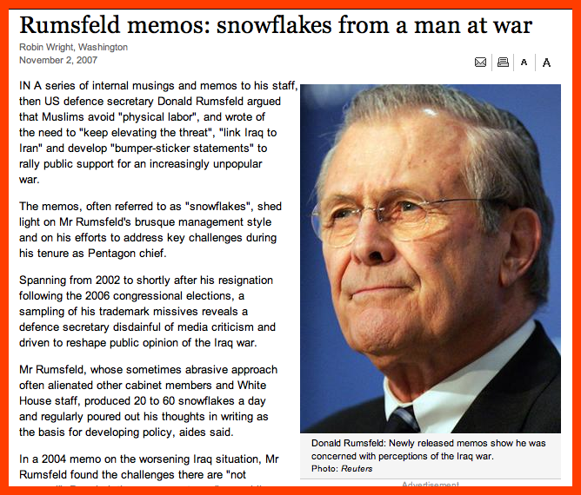http://www.washingtonpost.com/wp-dyn/content/article/2007/10/31/AR2007103103095.html

I asked to see those that she had pulled before getting overwhelmed. She had a pile of memos scattered across half a desk-- about 50 of them in total. It was not the numbers of them but what they said that had traumatized her.

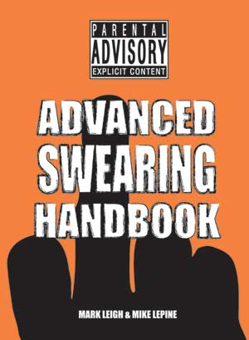
I then looked in the Pentagon memo files myself. The Pentagon is a male domain, and woman hating is nothing new. But the sheer volume of it in the official memos was staggering. I then called up a Pentagon general and asked him how the memos had gotten like that. He said to me "You should see the ones we get from the White House." He refused to answer how long it had been going on. I then went up a floor to the White House memo section to pull their memos to the Pentagon.

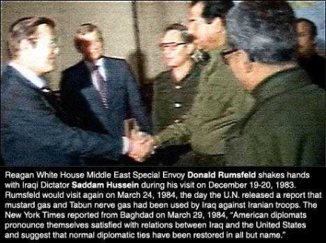

I started back at Carter and pulled some for each Presidency. The memos from the Reagan era were relatively normal until about the middle of his second term. Then it was as if the memos to the Pentagon became Texas swearing at a rodeo under Bush, Sr., ranchy jazz under Clinton, and city rap under Bush, Jr..

I then called up a military historian at West Point and asked him to find me an expert on swearing in military memos. He laughed knowingly and said he would. The military historian who called back asked me never to find out his name or track his number--he was seriously frightened about what I would ask him about and already thought he knew. He was right. He said that of the current plunge into the gutter it was an anti-intellectual trend that originated in Texas to prove that one was not effeminate.

He said that Texas military men had a tradition of swearing up a storm even in official orders. He confessed that some had lost battles as a result when their inferiors mistook their meaning as swear words are often non-specific. Well, I suppose he said all that to make me feel better--I sincerely doubted that women should be degraded and have knives put in inappropriate places just so that men could feel like men.


I called back the CID investigator and said I wanted to file a complaint against swearing in memos. He said it wasn't possible. I filed a complaint instead with the Joint Chiefs of Staff since they were making me attend one of their meetings a month. I said that I would not attend again until they cleaned up their language so that I could have a CIA secretary pull memos for me without having a nervous breakdown from reading them. They agreed.

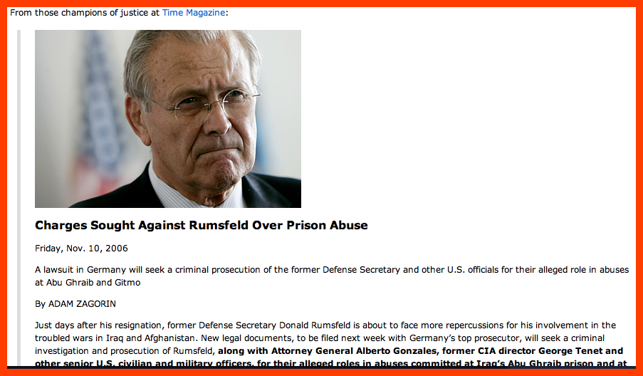
www.time.com/time/nation/article/0,8599,1557842,00.html

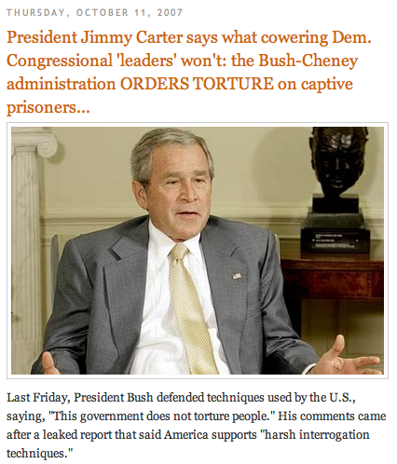

But the next week, I was told to report to Rumsfeld in his office. And when I did he ordered me arrested and tortured in the basement for trying to file a complaint about the memos!

That torture that he personally ordered included rape, sodomy, oral rape with a feces coated penis, and electrical shocks to my private parts almost non-stop for 2 days. I really did know that the US Administration was using sexual torture. They said in their memos to use it. They used the language of those who degrade woman and humans. And they did it in practice. But I didn't think that it was a Texas thing, I thought it was a Skull and Bones Satanist thing.

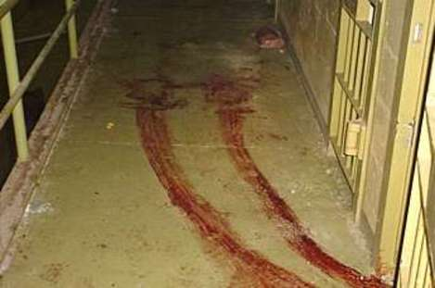

Even after being tortured again, I went to pull the memos that said "Knife the c**ts". I wanted to find out who at the White House, if anyone, had ordered that. In the White House memo archives, I had to write on the request form that I wanted the memos pulled that said "Knife the c**ts". The CIA secretary frowned at me when she saw that. She called her supervisor over who was a man. I asked him to find me those memos. About 10 minutes later he came back with three of them and asked me how many more of them I needed. I arbitrarily said , "4 more, thank you." He came back with them shortly. I asked him how many had come up on his computer screen and he said "Over 20." I asked him to pull me the first one as well, which he did.

5 of them were signed by Cheney. One was signed by a Sec. of Defense, and 2 by Bush, Jr. Well, I had my answer as to why I couldn't get those Sp. F. men court-martialed.

In a later occasion, I was collecting intelligence by myself when I came upon Sp. F. men were torturing Iraqi men behind a wall.

Gory: They had about 4 men tied by their wrists over the top of the wall hanging from it. They were using their cigarette lighters on their private parts. They had their male membranes brown with feces hanging out of their pants since they had already sodomized them. (Later I got those Iraqis to a physician. One had third degree burns on his testicles. Another had a deep wound in his penis where it had been sliced with a knife. Another had a torn rectum. The fourth one died-likely from a ruptured rectum.)

The Sp. F. men said that they were just following orders. I told them to let those men down gently immediately. They objected saying "We are getting them to talk!" I asked them what actionable intelligence they had gotten. They didn't even have a translator. I was pissed. I ordered them to release the Iraqis. They said they were insurgents.

I asked them why they believed that. They said, "Well, they are here in Iraq, aren't they?" Another said "Hey, cool it, we just wanted to have some fun with them." I asked him if he thought it was fun to be tortured. He said, "Hey, baby, let me try it on you and find out." I called their commander and reported asked for them to be disciplined.



He said, "Hell, no, they bring me valuable intelligence." I asked him what intelligence. And he said, "Where to buy beer."[on the black market].

At CIA, I looked up to see what intelligence those Sp. F. men of Rumsfeld were collecting that was useful. Zero. They never even asked for a translator. They just went around terrorizing Iraqis for the sadist pleasure it gave them and their superiors to read about it. They filed reports and they got bonuses, if someone liked to read them. Cheney gave a bonus one time, and Rumsfeld another. They would make up stories like "We captured a high level Al Queada operative today". But there was absolutely nothing in the report to substantiate that. All that was submitted with those reports were photos of the people being tortured, including small kids--they were the Abu Ghraib photos--"look what we are doing for you" bragging to their superiors. I tried to get them court-martialed too.



CID said, "Forget it--we ain't never going to take a report down again from what you say. We have orders not to." They faxed me the order to my CIA office: "Instructors of Sp. F., will not file reports against them, but report all misconduct to me in person--Rumsfeld." i.e. "Report it and I will have you tortured again".

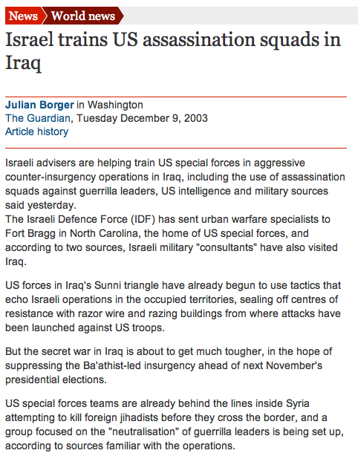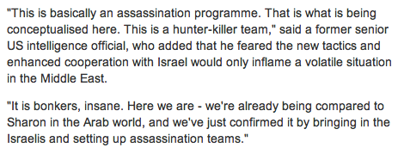

http://www.guardian.co.uk/world/2003/dec/09/iraq.israel



Part 7:The Sexual Torture and Mind Control of Govt. Officials and Their Relatives Around the World


In the course of my normal duties in collecting intelligence, I stumbled upon the US sexually torturing civilians for political purposes. I was in Baghdad at a US Embassy party to meet with an Iraqi official. The CIA wanted me to find out from him, if he was amenable to a certain US proposal. Since I had been a negotiator for the CIA in Russian affairs, I had been picked for this job by the CIA without asking me first what I thought of the proposal. I thought that the proposal was about the worst thing that I had ever seen in intelligence in my nearly forty years in it.

At this meeting that I had with the Iraqi minister, in a private sitting room, he mentioned that he would be willing to support that atrocious US proposal that sold his country out to the US oil companies for as long as there was oil in the ground, if I personally was willing to clear up a problem for him. It was not a minor problem. It was in essence to secure his place in Iraqi's government by devious means irrespective of elections. I had no doubt that the US govt. was willing to make that deal---I was not. He wanted me personally to guarantee his position, because he did not trust the US govt. not to double-cross him. It had double-crossed not just Kurds, and other rebelling minorities, but almost everyone in Iraq at least three times over--just to lord their dependent and helpless positions over them. In that way, the US govt. was acting much as it does domestically to deny workers job security, pension security, and health care on the premise that making others insecure made them more controllable. The minister was not asking me to be minister for the rest of his life, but just to have an ordinary job in govt. all his life so that he could support his family. It was not at all an unreasonable request, and I would have been glad to work towards that, had it not made everyone in his country the equivalent of an economic slave to the oil companies. So, I told him that I would be willing to work to make all Iraqis economically secure and convey his concerns to the US govt. He gripped my hand frantically and said to me, "Please I beg you. Consider my family. Help us." I explained to him that I could not make all Iraqi's slaves to the US govt. just to help him. I told him as we parted to try to be strong and do as good a job for the people of Iraq for as long as he did have a job. He asked me to predict how long that would be, and I said, "Four months, Allah willing." We parted and he stayed in the room a little longer to do his evening prayers. Many Muslims have wonderful faith in God and are very devoted.

When I returned to the party, the US Ambassador approached me and asked me how the meeting went. I told him honestly, that if the US would make people's lives secure in Iraq, that they were willing to do whatever the US asked of them. He pondered that reply while sipping some white wine that was exceptionally good that evening. I ate the canapes of aged cheese on delicately favored herb crackers made by hand by the equivalent of slave labor in the Embassy kitchen. Then I sat one back on the silver tray half eaten and said to the Ambassador, "Too bad these smell so badly that I can't eat them." He took my half eaten cracker, popped it in his mouth and said, "It is only the delicious taste of finely aged cheese that I taste." "Messier," I said lapsing into French that he was fluent in, "It is not the taste of cheese that I object to, it is the taste of slavery that I find too foul to stomach." (See related video "Hearing on US Embassy in Iraq: Mayberry's Opening" at http://www.youtube.com/watch?v=evRPwwyno_c ). He blinked anxiously and looked around to see if anyone else had taken my meaning. Reassured that none had, he turned back to me and said as if it were a rhetorical question to which no answer was possible, "What can we as conquerors do about it?" I demonstrated that by turning my back and leaving the party while pulling gently on his hand. When we got to the gate of the Embassy, I invited him to leave with me. He declined politely and went back inside.

I later found out at the CIA, that he returned to the side room, discussed terms with the Iraq Minister and completed the devil's deal. But I fear that the Iraqi Minister was not entirely satisfied with the deal that he made with the devil that night. 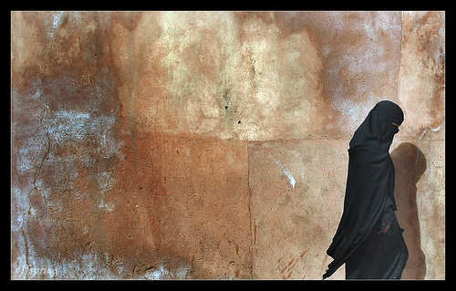

The US govt. decided to take one of his relatives "hostage"--they turned his wife into a mind control slave. That is, they raped, tortured, and sexually humiliated her in ways that she was forced to forget. The tapes of that mind control made their way back to the CIA. I was asked to comment on them as to whether she was suitably mind controlled and would act as the proper influence to control him by fear. I told the CIA that no one is so well mind controlled that they will reliably do what one wants and that there had been no reason to do that to her because she had already caused enough fear in her husband's mind that he had sold out. I had been told in response by Tenet, "We like to hedge our bets and cover all bases." That is, to have an extra little bit of unnecessary control over that Iraqi PM, they had been willing to rape, torture, and mentally enslave an innocent woman. I was thoroughly disgusted and outraged. It was a totally unnecessary black op--even the CIA's dept of Ops had not wanted to do it. The potential for blow-back was enormous.

I then set about discovering how this poor woman had been subjected to this degradation, as in who had proposed it and ordered it. That was not so hard for me to find out. It had been both proposed and ordered by Cheney at the White House Daily Intelligence briefing with Tenet. I listened to that briefing myself after Tenet told me about it. I wanted to find out if Tenet had hinted at it. But that was not the case. However, that did not mean that someone else in the CIA or Tenet at another time had not hinted at that option.

So, I offered a prize in the Dept. of Ops to anyone who could prove that Cheney was not the start of that op, including by claiming that they were the author of it. No one came forward to claim the $100,000 prize that I got Tenet to put up the money for.

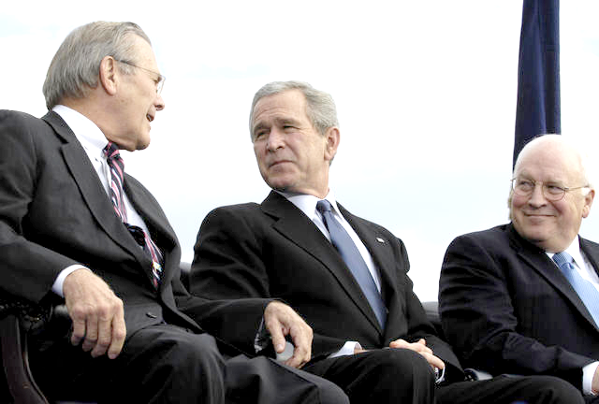

Instead, I had several CIA operatives try to claim the prize by proving that Cheney had authored the idea. Two of them provided such complete evidence of that that Tenet paid out money for it. One man collected the handwritten notes of Cheney which showed that he had hit upon the idea to do that prior to the daily briefing with Tenet in which he ordered it. Another did an exhaustive phone analysis showing that no one had discussed the idea with Cheney prior to that by phone. As the daily briefings did not include an prior reference to that op and they had been recorded, that left an informal conversation in the hallway in which Tenet or another person could have suggested it to Cheney. So, although the evidence was not 100% conclusive, it was quite likely that Cheney was the author of that plan which the CIA was loath to do because of the dreadful risk of blow-back. That risk of blow-back included the risk that no Iraqi official would ever trust the US govt. again. That is, it risked what the oil companies did not want to risk--losing control of that oil. It risked that in order to gratify someone's urge to rape, betray, and humiliate another person when doing so ran counter to US foreign policy interests and was completely unnecessary to do.



The story along these lines is not complete yet. This was not an isolate incident. Alas! When I investigated this more thoroughly, I found that a number of wives and children of foreign leaders had been made into mind control slaves by the CIA in order to control the leader. Furthermore, the CIA operative who had brought the handwritten note of Cheney, later brought another handwritten note from Cheney which was a list of relatives of foreign leaders and check marks next to the names of those whom he had recently ordered the CIA to mind control for him. The list was up to date and corresponded to the CIA's list of already mind controlled subjects. The complete CIA list is very extensive and includes many people in foreign countries. Many leaders and candidates for important offices were on that list. It was almost a who's who of important people in the world, both foreign and domestic. Many Congressmen and their family members were on that list. If they knew what had been done Abu Ghraib style to their loved ones they would revolt against the Skull and Bones extended membership that "cremated care" in a ceremony. The damage to those individuals and to the country is infinite and can never be fully rectified. There is no way to untorture someone. Their trust in humanity has been destroyed forever at a very deep level. It is a crime against humanity on the order of killing the world's hope for a sustainable future. It is worse than the infliction of mere pain. It is the hijacking of a person's life and a selling of their soul to the forces of darkness. It is a crime eternally worse than the mere murder of someone's body. It is the murder of their will and integrity. Unlike the Bourne movie's depiction of mind control, no one ever volunteers to be tortured, raped, sodomized and become a mind control slave.

How can one recognize if someone is a mind control slave? One watches to see who their actions benefit. Those who undermine the US Constitution, the rule of law, privacy, the independence of the internet/media, and human rights are either willing traitors to the People of These United States or mind control subjects. Everyone actually does know that undermining these principles sells the world into slavery.

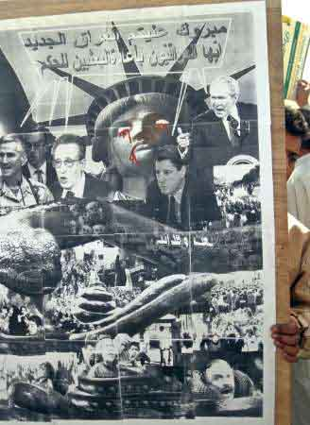
[ Reuters/ Akram Saleh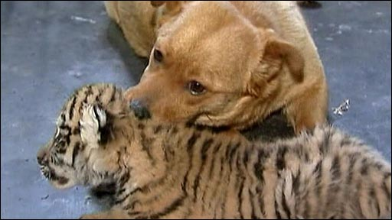

[A tiger cub rejected by her mother in a zoo in Russia has been adopted by a surrogate canine mother. Spending time with a pet reduces stress.] Consider seeing the video clips

Part 8: US Special Forces as Roving Snuff Film Makers in Iraq


When I crested the Iraqi ridge to overlook the given coordinates, I just saw more desert. I parked the jeep in what had been a village of about ten cement foundations. Walking towards the gullies was difficult--the stench! When I looked over their edges, I found the dead bodies about 50 villagers mostly clothed in one and about 20 naked women and children in another. It was obvious that most had been tortured to death. Those not want to read about gore should skip to the next paragraph. Skin that had been cut methodically in long parallel lines. There were knifes left stuck in bodies in ghoulish fashion, e.g. a blade was stuck between the testicles, the scrotum cut in many parallel lines and peeled back. That body had been positioned in the gully with legs splayed open to terrorize any person later seeing it. The women also had parallel cuts on the breast, between the legs, and sometimes on the face. The children's injuries were mainly on the face and between the legs.

I spent over 4 hours examining the corpses. If my memory serves me, 27 men, 34 women, 11 children and 4 babies, were dead in the gullies. All had physical evidence of torture. I called the Pentagon.

I was too exhausted laid down in the village at dusk to sleep. Towards 2 am I was shivering. I wrapped up in a blanket, but could not get back to sleep. I needed a place to wash up; the well was poisoned by the US troops with feces. I was driving without my lights on by the light of the moon. Iraqis had escaped into the hills and knew about the US massacre. About the second hour of driving, I could feel a car gaining on me with what I feared was murderous intent. I sped up but still did not put my lights on. Occasionally, their lights flashed on me. As an evasive action, I stopped the jeep, took off the blanket, wrapped rocks in it to make it look like a person asleep by the side of the road and drove off. I was seriously cold this time. But my maneuver worked; the car stopped following me after it stopped at the blanket. I guess they couldn't deal with the smell. If there were dedicated guerrilla fighters around, a solitary US military Jeep would have been shot at.


Later, I gave a fuller verbal report to the Pentagon. What it added up to was over 100 soldiers spending two days torturing those villagers and then hightailing it out of there because they were afraid of retaliation. To make it worse, there were several Special Forces instructors with them - it was a training exercise in how to torture in villages to get information. Only it had become a "torture everyone to death" drunken party apparently, as American beer cans were left everywhere.

Furthermore, as in torture in general, it had not collected any useful intelligence that the CIA didn't already have. That was easy to prove back at the CIA. Three translators were with the Special Forces during this training. There were even transcripts made of the tape recordings of the "interrogation" sessions. I read them back at the CIA. Then I listened to one of the tapes to see, if the transcript was accurate. The tapes turned out to be made by actors - all male; there was no screaming of woman and children on any of those tapes. The tapes and the transcripts were part of the cover-up to try to prove the village was filled with male insurgents and the US was correct to torture them all to death.

I then went about finding the actual tapes. No transcripts had been made of them. They were almost impossible to listen to because of the heart rending screaming. I knew what had caused those screams and I had bad PSTD flashbacks as I listened. Then I came across a video recording of part of the event made into a training film on how to get good intelligence from torturing people. They had said that the valuable intelligence that they had gotten in that village was that it was in too unsafe an area to travel in. No, that was the situation that they had created there by torturing that village to death. It was not the situation before they did that. Earlier reports showed that soldiers had stopped there asking for direction and water and been given both and treated civilly by the villagers.

The torture and destruction of the village did not net as much as a single machine gun in it, not a single inflammatory pamphlet, not a single plan of attack. Yet that training video showed men torturing children in front of their parents and saying that the parents were reporting their insurgency plans. I had Iraqi translators listen to the training tapes and they said that the parents were not saying anything like that. Special Forces later said, "Yeah, well those men did say that on other tapes and we lost them!"

Then I tracked down how many tapes they had been issued, how many they returned and had them all listened to. There were no lost tapes. There was not evidence of insurgency in that village. I had CIA analysts review the tapes and transcripts. They also reached the same conclusion; they recommended that the training tape be destroyed before Congress found out the truth. I wrote up my findings and submitted my report to the CIA and the Pentagon. It included the photos documenting the torture, and the lack of useful intelligence collected.

The Pentagon refused to stop using that training tape to show soldiers how to torture in the field to get "intelligence" while in villages.

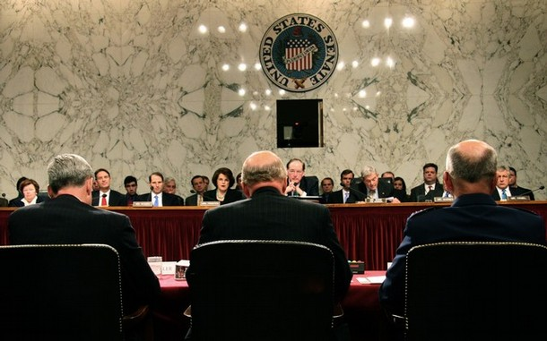

I went to the Senate Select Intelligence Committee with the training tape and my report. They refused to read my report. I was outraged. I tried to take the story to the NY Times. They refused to take it. I had examined the bodies. I had proved that no useful intelligence had resulted, but no one wanted the story because they wanted to justify torture. In my opinion they were all guilty of crimes against humanity.

Finally, I told Tenet that either he tell the US Administration the truth about how worthless torture was in getting actionable intelligence, or I would. He sent three CIA analysts with me to the White House "to add balance". Cheney and Bush would only grant us a 15 minute time slot to discuss the topic. I got to speak exactly 2 minutes. The other 3 men lied copiously, asserting torture had produced actionable intelligence.

I challenged them to cite a single example in which torture had yielded intelligence faster and more reliably than other available methods. They couldn't and said that they would have to review their files at the CIA. I offered to pay them $50,000 if they could produce such a case by the next week and present it in front of all of us. Furthermore, I said that if they didn't come back the next week with a valid case and collect the money then they were just liars. Cheney laughed. Bush asked, "Can I win the $50,000, if I bring the case?" I said, "Sure, but you have to be able to prove that there was not a faster, more reliable way to get that intelligence." ...The next week there was no meeting to collect the $50,000. Everyone had conceded. [Note: Torture yields about 8% truth and 92% false statements. Even ordinary police work does better than that, and the CIA has many newer more effective methods to get intelligence. They are faster and much more reliable than torturing people. The ticking time bomb rationale for torture was completely bogus and the US Administration knew it ! ]

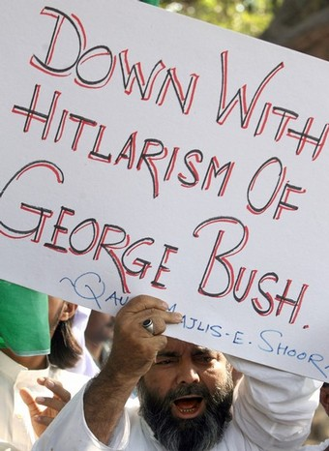
Yet, the US Administration refused to give up its torture programs. That training film was not the only film made in that village: I later uncovered a whole shelf of other films made during those two days. They got sold on the black market as snuff and S&M films at a high profit. I tracked down who made that profit and how much was made. Then I had my real answer as to why I couldn't get those torture programs shut down. US Official, including Pentagon Generals were making a killing off them. The training video was being used as the marketing tool - the "legal film" that they could hawk in front of buyers.

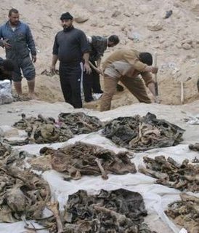
I got one of those snuff films given to me as a gag at a CIA Awards ceremony. I had won the award for the most obnoxious report. It was that report, not because it was so grisly, but because it had almost killed one of the Cabal owner's major sources of revenues. Those films sold for about $100,000 a piece on the high-end black market. Rich Skull and Bones buyers often bought 6 of them at once; they were not all from one Iraqi village. They liked it best if they got them straight a high US Official. It gave an extra celebrity angle to it. They could then entertain their country club friends with it saying, "I got this the other day from so and so. I know him well." That meant in country-club code - you can do business with me, whatever we do illegal will be overlooked because I have an in with the big boys that run the country." So, that flick of the women and children being tortured to death meant, "See, even if our business deals kill women and children in other countries, no one is going to come after us for it. The proof of that is this flick, that shows worse than what we are going to do, and no one coming after them for it."

The US Govt. never court-martialed the soldiers, nor stopped the "torture in villages" Special Forces policy. They acted as roaming torture and death squads terrorizing the civilian population.

[Army ends probe on porn site photos of Iraq corpses. See http://www.chinadaily.com.cn/english/doc/2005-09/29/content_481830.htm ]


The Winged Migration to rest the mind at

http://youtube.com/watch?v=EqGY3uNR4ko ,

Winged Migration Remix at http://youtube.com/watch?v=KRKKvVShOtU, or

Travelling Birds = Dancing Seabird at http://youtube.com/watch?v=N_XicLVzJdo

Travelling Birds Sigur Ros as played by Kronos Quartet http://www.youtube.com/watch?v=tZHpckYExUc

See Part 20 C for Skull and Bones and More on Mind Control

