Case 22C Hot Sodas Courtesy of Those Who Built Auschwitz?
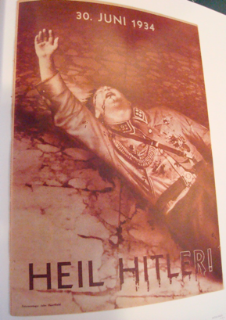
Rockefeller, Dulles, and the Nazis 1
The Bush Family Also Promoted Eugenics 1
Prescott Bush and the Nazis 1
Prescott Bush, Rockefeller, and Who Paid to Built Auschwitz? 1
Slave labor 1
Rockefeller Factories Were Rarely Bombed in WWII 1
Rockefeller’s Slaves in the US during WWII 1
The CIA’s Nazi-Skull and Bone’s “Original Sin” 1
Moving Nazi Headquarters to the CIA 1
Rockefeller, Dulles, and the Nazis

Rockefeller’s Standard Oil of New Jersey, came before judges and was found guilty of treason;
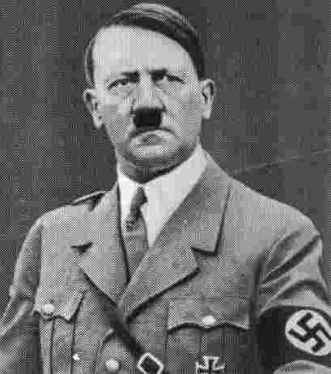
“In 1936, the Rockefellers entered into partnership with [future CIA Director Allan] Dulles's Nazi front, the Shro[e]der Bank of New York, which. . .was the key institution in the Fascist econom[y]. In 1939 the Rockefeller-controlled Chase National Bank secured $25 million for Nazi Germany and supplied Berlin with information on ten thousand Nazi sympathizers in the US. [That allowed the Nazis to recruit and use them as spies and saboteurs inside America.] Except for a few months' interruption, the Rockefeller-owned Standard of New Jersey company shipped oil to the Nazis through Spain all throughout the war.
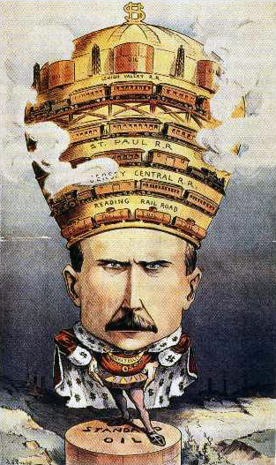
Rockefeller was defiant of FDR's efforts to shut down his sale of oil to the Axis. The Dulles brothers had one of their clients threaten to disrupt the US oil supply during wartime. Besides US Supreme Court Justice Arthur Goldberg, three other members of the US intelligence community insist that Allen Dulles was personally behind the threat to cut of Saudi oil supplies. The Standard Oil Executives made it clear that the entire US war effort was fueled by their oil and it could be stopped....
Rockefeller made a deal with Hitler whereby he could obtain certain kinds of Standard Oil artificial rubber while American would get nothing...
"The roster of the Rockefellers' known pro-Nazi behavior is horrendous. As previously outlined, in 1942 Senator Truman described the behavior of the Rockefellers' company as treasonous. Under the US Constitution, giving aid and comfort to the enemy in time of war is treason. On September 22, 1947, Federal Judge Charles Clark issued the following opinion in a civil case:
    - ‘Standard Oil can be considered an enemy national in view of its relationship with I.G. Farben after the United States and Germany became active enemies’.

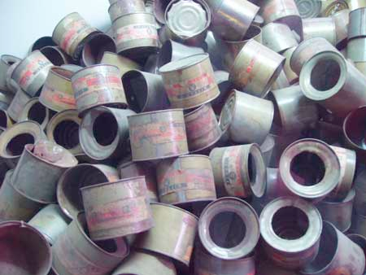
[IG Farben was the German Chemical Company which made 84% of the Nazi explosives in WWII and later the poison Zyclon B used in the death camps. The empty cans of Zyclon B from Auschwitz are see above. See video JD Rockefeller, Granpa Bush and the Nazis at www.youtube.com/watch?v=dYmuNwR8ld4 and http://reformed-theology.org/html/books/wall_street/chapter_01.htm.
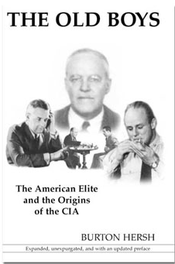
  - “Two months later, just as Nelson Rockefeller was hoping that the damage could be limited to a few corporate scapegoats, the Jews arrived in his office with proof that he personally had committed treason against the United States of America. They had his Swiss bank records with the Nazis, his signature on correspondence setting up the German cartel in South America, transcripts of his conversations with Nazi agents during the war, and, finally, evidence of his complicity in helping Allen Dulles smuggle war criminals and money from the Vatican to Argentina.”
  - We also now know that Allen Dulles's "Sunrise" negotiations with the Axis in World War II were much more involved than anyone had previously suspected. A big motivating force behind Dulles, they tell us here, was Nelson Rockefeller atttempting to avoid prosecution after the war.
  - He didn't completely succeed. In 1947, a federal judge ruled that his company, Standard Oil, had been guilty of treason during the War. Several executives got jail sentences and fines were levied against Rockefeller and his company.
  - There was a reason. Rockefeller's tankers had fueled Nazi u-boats in the Canary Islands.”

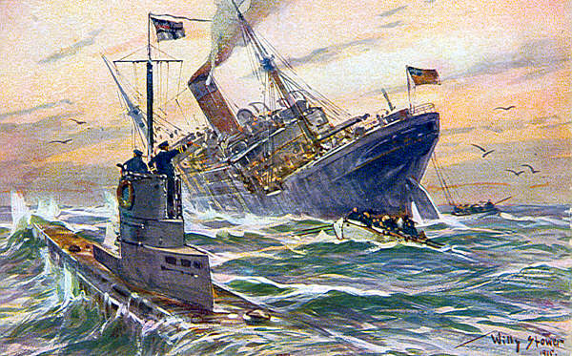
  - “Rockefeller is not the only major figure they expose for treason in World War II. James V. Forrestal, then-Secretary of the Navy and later the Defense Department, and Prescott Bush's attorney Allen Dulles, then-OSS Swiss Station Chief and later Director of CIA, are revealed to have engaged in treasonous acts during the Second World War. Both were partners in Rockefeller's company, Standard Oil.”
  - ( see Rockefeller: A Traitor for Vice-President at http://home.att.net/~m.standridge/rocky.htm .)

Dulles, a fellow bonesman, helped Prescott Bush hide his Nazi companies and their assets.

Skull and Bones and the Nazis
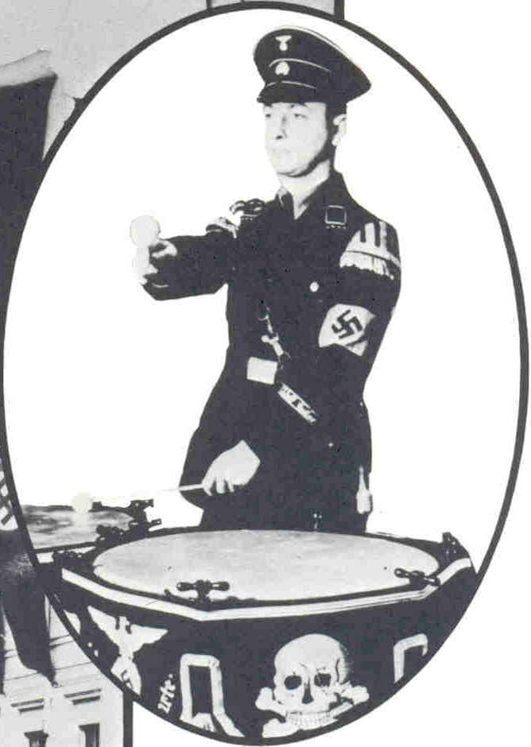 Please note the Skull and Bones emblem and the Nazi emblem on their uniforms and drums. 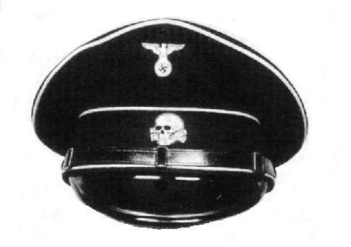 Hitler was so poor in the early 1920’s that he had to take out a loan to buy a used car. In 1923, Prescott Bush’s business partner, Thyssen, became a major funder of Hitler. That is a polite euphemism for providing the money to pay for men, uniforms, and violent black ops to terrorize the populace into submission. The first Skull and Bones emblem that I could found associated with Hitler is this one in 1923.
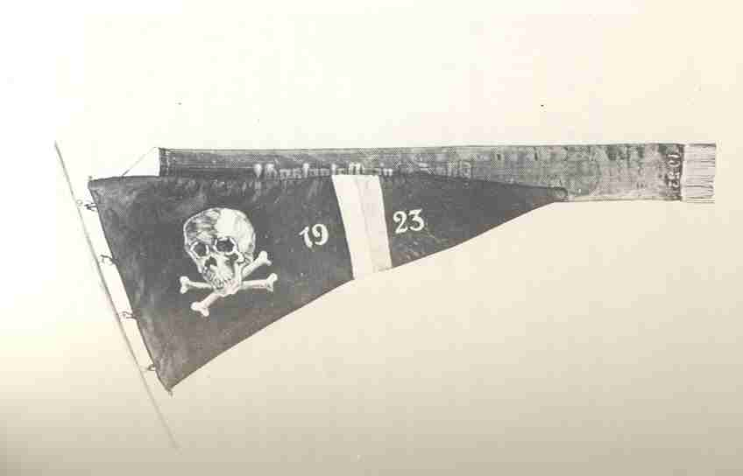
Insignia of Hitler's own private army in 1923, the ‘Sturm Abeitlung’=Storm Troopers AKA SA. http://en.wikipedia.org/wiki/Sturm_Abteilung
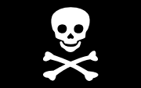
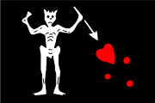
The Skull and Bones emblem was originally used by the Knights Templars in the 13th century. Then by pirates, and finally by navies as a symbol of having killed an enemy. True believers in the emblem believe it will paralyze their opponents into terrorized submission. See /www.esolibris.com/articles/alternative_history/skull_crossbones.php and http://en.wikipedia.org/wiki/Jolly_Roger . Since several death worship cults, such as the German Thulles and Skull and Bones, use the emblem and have similar beliefs and rituals, it is likely that Thyssen, Hitler, John D. Rockefeller, and Prescott Bush joined in an alliance based of the similarities of their hidden practices. I found much evidence to support that in the Rockefeller Archives.

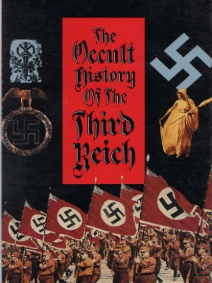

“To 'keep the peace' and maintain law and order, the Brown Shirts roamed the streets beating up those who openly opposed Hitler.” www.historylearningsite.co.uk/Nazi_Germany_dictatorship.htm
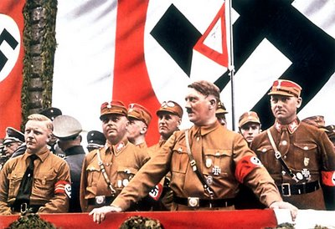
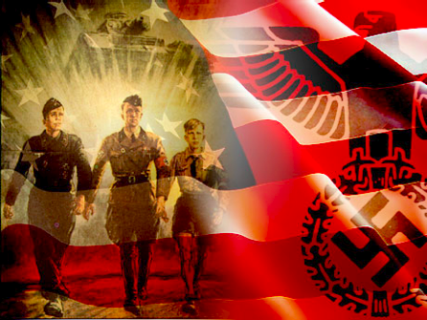

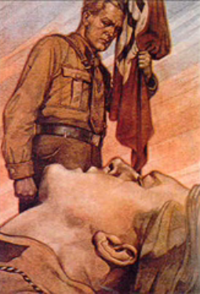
This 1930’s era propaganda poster shows two men wearing brown shirts. One is obviously meant to be hurt that he is lying on the ground. The man standing is not helping him but is holding a Nazi flag upright instead. The subconscious message is “Ignore your desire to help those in need and help Hitler and his party instead.”
That is very similar to the Cremation of Care Ceremony at Bohemian Grove which many US Politicians and Presidents have attended. There the ritual is to enact a murder in front of you, you may or may not believe it to be real. But you are subjected to having to stand helplessly by without investigating or helping the victim as they scream for mercy. Because people do not want to feel helpless, most people subconsciously decide the victims are not worth helping. The alternative would be to conclude “I am not brave enough to risk my life to break the group taboo and help”.
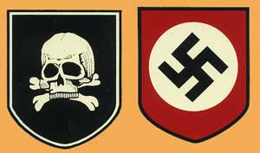
SS Deadhead decal
Any group wanting to profit from war has to do a lot of propaganda to keep others from caring about and helping the victims. Helping the victims could extend to trying to get that power out of power.
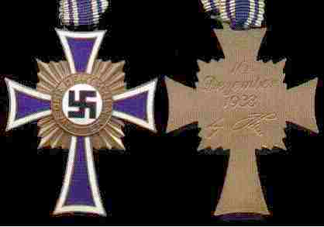

The Nazis used Christian symbols to try to change their meaning to the opposite
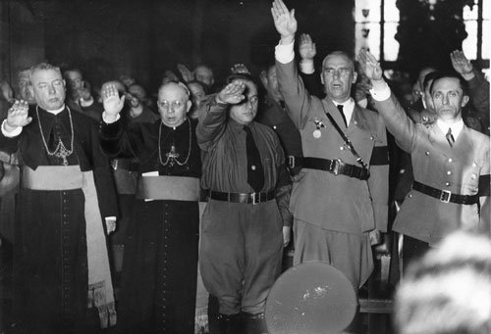

The grandfather of Bush, Sr., Samuel Bush, worked for the Rockefeller family, helping them in war-profiteering in WWI. Since the Rockefellers owned 98% of the money in the Harriman-Bush bank in WWII, Harriman and Prescott Bush were acting as front men for him, see www.john-loftus.com/bush_nazi_scandal.asp . It is always useful to have front people like Frederick Flick or Prescott Bush to act as fall guys for one’s drug, slave, and weapons running operations. For more on Skull and Bones and the Bush-Rockefeller Families’s drug running through the centuries see the excellent review article at http://www.conspiracyarchive.com/NWO/Skull_Bones.htm . Since both companies, Flick’s run Standard Oil of New Jersey and the Harriman-Bush bank had the same chairman of the boards of director and both companies were “owned” by the Rockefellers, all the orders were coming from him as “Commander in Chief”. That is what the records at the Rockefeller Archives showed, though much was done to hide Rockefeller’s hidden hand giving the orders and pocketing the money. For an example of a perhaps unwitting cover-up see The Wall Street Funding of the Nazis at http://reformed-theology.org/html/books/wall_street/ . In it Sutton says that Chase Bank, Ford, and the Harriman-Bush Bank funded the Nazis, but not the Rockefellers. That it the whole purpose of front companies, to obscure who is guilty of making the decisions. It only does that if you are stupid enough to believe the lies that the Rockefellers did not care about their money enough to over see how it was used. That was completely untrue.

The Rockefeller Archives showed that Rockefeller was a major funder of the Brown Shirt and Black Shirt Armies. Per those records, the Rockefeller Family contributed about 40% of the funding of those private armies in the year of about 1929. I only looked at the data for one year because that was the only year that I found a document which gave the total costs of those private armies.

The Rockefeller Family wanted slave labor to pay dividends on his funding of those private Nazi Armies. Since they had a third of a million men in them that was a lot of expense. They went to that expense in order to take over Germany from the Christian Democratic Movement and throw the world into war. The Rockefeller Archives showed that the Rockefeller Family engaged in Death Worship and felt that human sacrifices, including in warfare, pleased their pagan gods. They, like Skull and Bones, were dedicated to having as large a war as possible every generation. They felt that increased their power and wealth. Certainly, the Archives touted the philosophy that by destroying the middle class’s family run shops they could force them out of business. In that way they would stop being competitors and would be forced into wage slavery in Robber Baron factories for cheap wages. Indeed, the Mom and Pop stores have largely been replaced through most of the world by multinationals.
By using Hitler as a political front, the Rockefellers and other pro-fascist Robber Barons, could hide that they were the Hidden Hand behind Hitler’s Eugenics and Holocaust policies.
The Bush Family Also Promoted Eugenics

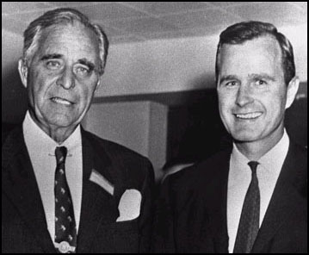
In addition, Rockefeller was behind Harriman and Prescott Bush and others putting on Eugenics conferences. See video clip Who Are The Rockefellers Part 1 http://www.youtube.com/watch?v=p3HTwu38A-s . He was a major proponent of the idea that there were inferior races that should be killed off. The writings in the Rockefeller Archives detail the propaganda efforts that went into the selling of that idea to the public, The Bell Curve, etc.. Both Prescott Bush and George Bush, Sr. as senators tried to push that agenda for the Rockefellers. The Rockefellers did not so much believe that other races were inferior as believed it was a very useful concept for others to have. It allowed them to exploit people of color effectively, or kill them without others vigorously protesting. It was a divide and conquer strategy to keep the world from uniting in opposition to their intentions to form a New World Order with one govt. that they and their fellow elite controlled. The Archives showed that they wanted to enslave everyone, not form a One World Government in order to stop wars. They are philosophically opposed to peace. The Rockefellers/Rothschilds were the major motivating force behind the Cold War and the Nuclear Arms Race. They are still the major force preventing global nuclear disarmament.
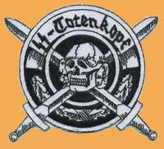
Let me make this even more explicit. The Rockefellers were already one of the largest slave , drug, and weapon’s runners of the world by WWI. Their oil and transportation enterprises were secondary and not as profitable. But they provided a respectable cover and a way to launder the money. Their notable philanthropy started in the 1900’s as a conscious Public Relations ploy to cover up their horrible reputation as Robber Barons. When you are starving the children of your workers by underpaying them, building a library does not correct the problem but it gives you good press and a good name. The Rockefellers decided to spend 4 cents of each dollar worth of labor they stole from the workers to make those symbols of “our generosity”.
Prescott Bush and the Nazis
  - 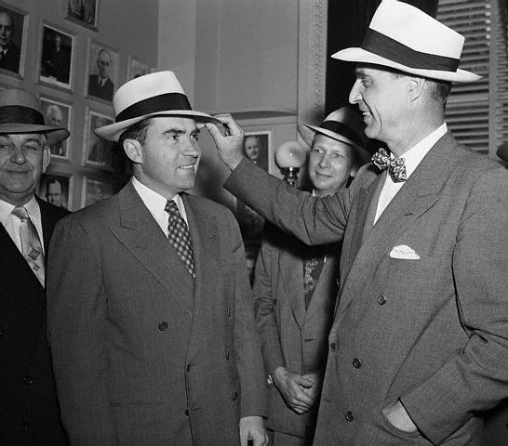
  - Prescott Bush on the right knew Richard Nixon. Why? Keep reading.
3) Three times in WWII the US govt. seized some of grandfather Prescott Bush's companies as Nazi front companies. Prescott Bush was the American business partner of Thyssen, the German banker who wrote the book I Paid Hitler. Prescott Bush funneled millions of dollars to fund the Brown Shirt Army of thugs.

See a) video by investigative journalist Buchanan on Bush Nazi Family Ties at http://www.youtube.com/watch?v=QAxQzK_FrO4
b) "How Bush's grandfather helped Hitler's rise to power", The Guardian newspaper at http://www.guardian.co.uk/germany/article/0,,1312542,00.html ,
c) Trading with the Enemy: An expose of the Nazi-American Money Plot 1933-1949 by Charles Higham at http://www.thirdworldtraveler.com/Fascism/Trading_Enemy_excerpts.html
d) How the Bush family made its fortune from the Nazis http://www.tetrahedron.org/articles/new_world_order/bush_nazis.html
e)Dubya's Grandpa and Great-Granddad Helped Put Adolf Hitler into Power http://www.larouchepub.com/other/2000/2733_prescott_bush_hitler.html

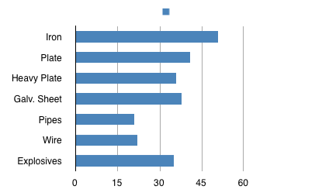"The 1942 U.S. government investigative report said that Bush's Nazi-front bank was an interlocking concern with the Vereinigte Stahlwerke (United Steel Works Corporation or German Steel Trust) led by Fritz Thyssen and his two brothers. After the war, Congressional investigators probed the Thyssen interests, Union Banking Corp. and related Nazi units. The investigation showed that the Vereinigte Stahlwerke had produced the following approximate proportions of total German national output:
35.0% of Nazi Germany's explosives." 50.8% of Nazi Germany's pig iron
41.4% of Nazi Germany's universal plate
36.0% of Nazi Germany's heavy plate
38.5% of Nazi Germany's galvanized sheet
45.5% of Nazi Germany's pipes and tubes
22.1% of Nazi Germany's wire
35.0% of Nazi Germany’s explosives.”
George Bush: The Unauthorized Biography by Tarpley & Chaitkin Chapter - II - The Hitler Project by Tarpley ,read it online for free at http://www.tarpley.net/bush2.htm

"The U.S. embassy in Berlin reported back to Washington that the "costly election campaigns" and " the cost of maintaining a private army of 300,000 to 400,000 men" had raised questions as to the Nazis' financial backers. The constitutional government of the German republic moved to defend national freedom by ordering the Nazi Party private armies disbanded. The U.S. embassy reported that the [Harriman-Bush] Hamburg-Amerika Line was purchasing and distributing propaganda attacks against the German government, for attempting this last-minute crackdown on Hitler's forces….
Thousands of German opponents of Hitlerism were shot or intimidated by privately armed Nazi Brown Shirts. In this connection, we note that the original `` Merchant of Death, '' Samuel Pryor, was a founding director of both [Prescott Bush's] Union Banking Corp. and [Prescott Bush's] American Ship and Commerce Corp. Since Mr. Pryor was executive committee chairman of Remington Arms and a central figure in the world's private arms traffic, his use to the Hitler project was enhanced as the Bush family's partner in Nazi Party banking and trans-Atlantic shipping.
The U.S. Senate arms-traffic investigators probed Remington after it was joined in a cartel agreement on explosives to the Nazi firm I.G. Farben [which also made the Zyclon (sp) B poison pellets used in the Nazi death camps].
Two months before moving against Prescott Bush's Union Banking Corporation, the U. S. government ordered the seizure of all property of the Hamburg-Amerika Line and North German Lloyd, under the Trading with the Enemy Act."…
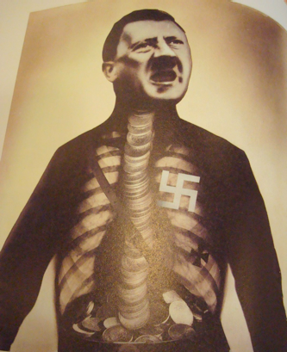
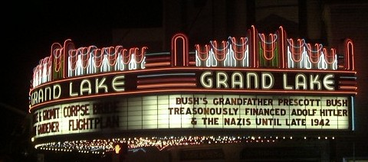"President Bush's family had already played a central role in financing and arming Adolf Hitler for his takeover of Germany; in financing and managing the buildup of Nazi war industries for the conquest of Europe and war against the U.S.A.; and in the development of Nazi genocide theories and racial propaganda, with their well-known results. "(Please read The Hitler Project at http://www.tarpley.net/bush2.htm ).

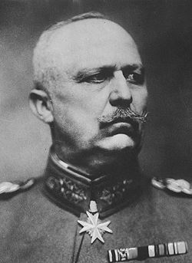
“Fritz Thyssen was the earliest important financial backer of Hitler. In 1923, he gave Gen. Erich Ludendorf 100,000 gold marks for the Nazis, prior to the attempted putsch by Hitler. From then through the 1930s, the bulk of the funds to build both the Nazi party, and Hitler's career, went through Thyssen.... Friedrich Flick, a direct partner of Harriman and Bush, and of Thyssen, was another contributor to the Hitler takeover. In preparation for the Nuremberg war crimes trials, the U.S. government said that Flick was "one of leading financiers and industrialists who, from 1932, contributed large sums to the Nazi Party. . . .". See Dubya's Grandpa and Great-Granddad Helped Put Adolf Hitler into Power www.larouchepub.com/other/2000/2733_prescott_bush_hitler.html

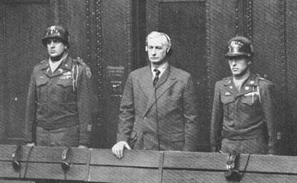

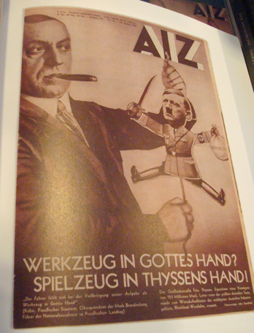
So, extensive was the funding of Hitler by Thyssen that a poster put up in the 1930’s showed Hitler as Thyssen’s mere puppet.
Hitler had been so poor before Thyssen started funding him that he had had to take out a loan to buy a used car. Thus, without financial backing he could not have risen to Chancellor.
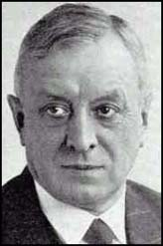
Thyssen could have chosen any number of political figures to back. He backed Hitler because he liked what Hitler said and wanted to put through policies favorable to him using Hitler. That is almost the only reason wealthy patrons back politicians. In exchange for funding Hitler they got his promise to break the back of the trade unions when he got into power. They wanted that promise so that they could have cheap labor without regard to the needs of the workers to make a decent or livable wage.

Fritz Thyssen
Prescott Bush used his shipping line the Hamburg America to transport Americans willing to be traitors to German to be trained as Nazi spies. His shipping line transported Nazi spies, both American and German back in the US again. The US Govt. seized his shipping line, as yet another of his many Nazi front companies.

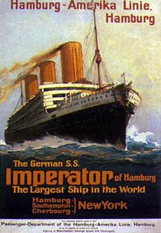
“In many ways, Bush's Hamburg-Amerika Line was the pivot for the entire [using] Hitler [as a puppet] project....
Certain actions taken directly by the Harriman-Bush shipping line in 1932 must be ranked among the gravest acts of treason in this century.....

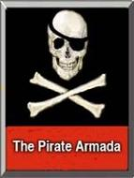

Private armies of 300,000 to 400,000 [Brown and Black Shirt] terrorists aided the Nazis' rise to power. W.A. [Bush-]Harriman's Hamburg-Amerika Line intervened against Germany's 1932 attempt to break them up.” (see http://www.tarpley.net/bush2.htm )

Prescott Bush, Rockefeller, and Who Paid to Built Auschwitz?

The American Eugenics Movement

For excellent review articles see
http://coat.ncf.ca/our_magazine/links/53/rockefeller.html
“Population Control, the Nazis, and the UN!: Rockefeller and Mass Murder” by Anton Chaitkin at " www.theforbiddenknowledge.com/hardtruth/omegafile.29.htm (****add excerpts if there is time).

For an excellent collection of links, books and articles online see
http://ecosyn.us/Bush-Hitler/Blogspot/Samuel_Bush/Remington_Arms.html
http://ecosyn.us/Bush-Hitler/Bush_Eugenics.html
www.eugenics-watch.com/eugbook/euod_ch1.html
www.eugenics-watch.com/roots/chap10.html
http://illuminati-news.com/nazi-california.htm

For more information on how prominent US families and corporations, including Henry Ford, the Rockefellers, and the Bushes helped fund Hitler into power and fund eugenics see;
The American Axis: Henry Ford, Charles Lindbergh, and the Rise of the Third Reich by Max Wallace,
American Eugenics: Race, Queer Anatomy, and the Science of Nationalism by Nancy Ordover,
The Nazi Connection: Eugenics, American Racism, and German National Socialism by Stefan Kuhl ,
War Against the Weak: Eugenics and America's Campaign to Create a Master Race by Edwin Black,
IBM and the Holocaust: The Strategic Alliance Between Nazi Germany and America's Most Powerful Corporation by Edwin Black.

From Heir to the Holocaust
Prescott Bush, $1.5 million, and Auschwitz: how the Bush family wealth is linked to the holocaust by Toby Rogers http://clamormagazine.org/issues/14/feature3.php

“On March 19, 1934, Prescott Bush handed Averell Harriman a copy of that day's New York Times. The Polish government was applying to take over Consolidated Silesian Steel Corporation and Upper Silesian Coal and Steel Company from'"German and American interests" because of rampant "mismanagement, excessive borrowing, fictitious bookkeeping and gambling in securities." The Polish government required the owners of the company, which accounted for over 45% of Poland's steel production, to pay at least its full share of back taxes. Bush and Harriman would eventually hire attorney John Foster Dulles to help cover up any improprieties that might arise under investigative scrutiny.
Hitler's invasion of Poland in 1939 ended the debate about Consolidated Silesian Steel Corporation and Upper Silesian Coal and Steel Company. The Nazis knocked the Polish Government off Thyssen, Flick and Harriman's steel company and were planning to replace the paid workers....
1940s: Business As Usual
Consolidated Silesian Steel Corporation was located near the Polish town of Oswiecim, one of Poland's richest mineral regions. That was where Hitler set up the Auschwitz concentration camp. When the plan to work Soviet prisoners fell through, the Nazis transferred Jews, communists, gypsies and other minority populations to the camp. The prisoners of Auschwitz who were able to work were shipped to 30 different companies. One of the companies was the vast Consolidated Silesian Steel Corporation.
"Nobody's made the connection before between Consolidated Silesian Steel Corporation, Auschwitz and Prescott Bush," John Loftus told Clamor.
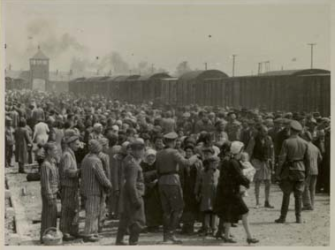
"That was the reason why Auschwitz was built there. The coal deposits could be processed into either coal or additives for aviation gasoline."
‘Even though Thyssen and Flick's Consolidated Steel was in their possession, Hitler's invasions across Europe spooked them, bringing back memories of World War I. Thyssen and Flick sold Consolidated Steel to UBC. Under the complete control of Harriman and management of Bush, the company became Silesian American Corporation which became part of UBC and Harriman's portfolio of 15 corporations. Thyssen quickly moved to Switzerland and later France to hide from the terror about to be unleashed by the Nazi war machine he had helped build.
A portion of the slave labor force in Poland was "managed by Prescott Bush," according to a Dutch intelligence agent. In 1941, slave labor had become the lifeblood of the Nazi war machine. The resources of Poland's rich steel and coal field played an essential part in Hitler's invasion of Europe....
Prescott Bush received $1.5 million for his share in UBC. That money enabled Bush to help his son, George Herbert Walker Bush, to set up his first royalty firm, Overby Development Company, that same year. It was also helpful when Prescott Bush left the business world to enter the public arena in 1952 with a successful senatorial campaign in Connecticut. On October 8th, 1972, Prescott Bush died of cancer and his will was enacted soon after.
In 1980, when George H.W. Bush was elected vice president, he placed his father's family inherence in a blind trust. The trust was managed by his old friend and quail hunting partner, William "Stamps" Farish III. Bush's choice of Farish to manage the family wealth is quite revealing in that it demonstrates that the former president might know exactly where some of his inheritance originated. Farish's grandfather, William Farish Jr., on March 25th, 1942, pleaded "no contest" to conspiring with Nazi Germany while president of Standard Oil in New Jersey. He was described by Senator Harry Truman in public of approaching "treason" for profiting off the Nazi war machine. Standard Oil, invested millions in IG Farben, who opened a gasoline factory within Auschwitz in 1940. The billions "Stamps" inherited had more blood on it then Bush, so the paper trail of UBC stock would be safe during his 12 years in presidential politics…”
Loftus [John Loftus, Emmy winning journalist, author and current president of the Florida Holocaust Museum] believes history will view Prescott Bush as harshly as Thyssen. "It is bad enough that the Bush family helped raise the money for Thyssen to give Hitler his start in the 1920s, but giving aid and comfort to the enemy in time of war is treason. The Bush bank helped the Thyssens make the Nazi steel that killed Allied solders. As bad as financing the Nazi war machine may seem, aiding and abetting the Holocaust was worse. Thyssen's coal mines used Jewish slaves as if they were disposable chemicals. There are six million skeletons in the Thyssen family closet, and a myriad of criminal and historical questions to be answered about the Bush family's complicity." ”
Slave labor

The US soldiers were not dying of starvation directly, but lack of proper nutrition was killing some of them (see case 17). People had been denied enough food in Auschwitz as well. In some sense the soldiers were treated no better than slaves; humiliated by having their humanity and needs neglected. How could they not be considered enslaved when they were not allowed to leave after the tours of duty they signed up for were over?


That reminded me of the slaves that companies used in WWII. Please watch the clip Interview with Slave who worked for NASA/Nazi scientists at www.youtube.com/watch?v=164YuYXqs9o to put a human face on what I am discussing.

Also see “Michael Moore- The Awful Truth” at www.youtube.com/watch?v=8u1kXmU0g64 . It is about slaves that BMW used in WWII who it had not compensated after the war.

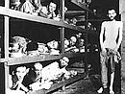
It made me feel sick to think about the historical connections that I knew. They were hard facts I had learned from documents inside the CIA and the Rockefeller Archives.

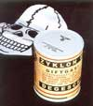
Allen Dulles and his brother John Dulles had been lawyers for the Schroder Bank and present in the room when Hitler in about 1932 promised German bankers that he would break the back of the German Trade Unions if they backed him financially. Destroying the Unions would allow the factories to pay the workers next to nothing. Still not content, Rockefeller made a pact with IG Farben to build the Auschwitz Labor camp and get the labor for free. Not only that but they underfed the workers and killed those that they considered or made unfit.

There is evidence that the Rockefeller-Harriman-Bush enterprise built the Auschwitz labor camp in order to have the slave labor for their factories and mines nearby;

“On June 14, 1940, nine months after the Nazi tanks rolled into Poland, the IG Farben company opened the Auschwitz factory and slave labor camp in occupied Poland, to produce artificial rubber and gasoline from coal. The Hitler government thereafter supplied IG Farben with political opponents and Jews as the slaves, who were worked to near death and then murdered. Later, Jews and others were simply mass-exterminated there.
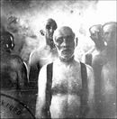
The Auschwitz slave camp was a project of the merger and worldwide cartel agreements between IG Farben and the Rockefeller family's Standard Oil company (later called Exxon). On Oct. 12, 1939, eight months before Auschwitz opened, a Standard Oil executive wrote to its president, William S. Farish, concerning a renewal of their earlier agreements with the Nazis, and the British approval for the deal. ...
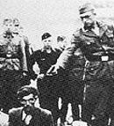
Emil Helfferich, chief executive of both Standard Oil's Germany subsidiary, and of Harriman, Bush, and Hitler's Hamburg-America lines, testified after the war that money to pay the SS guards at the Auschwitz death camp, was paid out of a Standard Oil bank account. Both Emil Helfferich and fellow Harriman-Bush shipping director Karl Lindemann were authorized to write Standard Oil checks to Nazi SS chief Heinrich Himmler.’ See Dubya's Grandpa and Great-Granddad Helped Put Adolf Hitler into Power Executive Intelligence Review Aug. 25, 2000 http://www.larouchepub.com/other/2000/2733_prescott_bush_hitler.html
“And we know that Emil Helfferich, chairman of the Bush-Harriman company, Hamburg-Amerika, was also chairman of Standard Oil’s German subsidiaries. Emil Helfferich frequently wrote out checks to Heinrich Himmler payable on a special Standard Oil account. According to U.S. intelligence documents reviewed by author Anthony Sutton (36), Helfferich was still making these payments to the S.S. in 1944 —the same S.S. which was rounding up, enslaving, and supervising the mass murder of Russians, Jews, Gypsies, Poles, etc., at IG Farben’s death camps.” See much excellent information at www.bilderberg.org/ skulbone.htm
“At the height of its activity in 1944, Farben ran a slave labor plant at Auschwitz that exploited the efforts of 83,000 people.” See www.jewishsf.com/content/2-0-/module/displaystory/story_id/11913/format/html/edition_id/229/displaystory.html

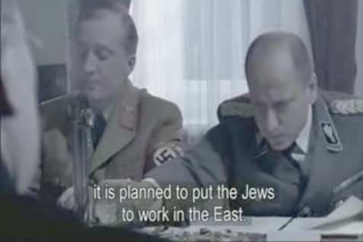
Himlick Himmler’s words at the Wanasee Convention to Eliminate the Jews--see photos left from the BBC documentary on Auschwitz. Links to the 5 part series at YouTube are below.

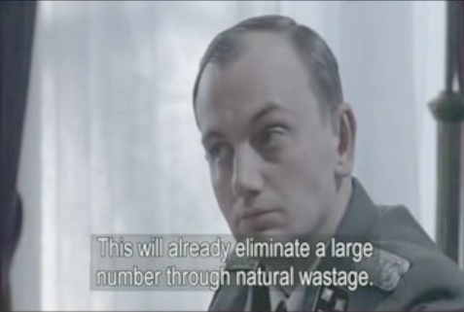
The documentary does not mention who funded Hitler, paid to build Auschwitz, and profited from it slave labor. To that extent it is part of an ongoing cover-up.

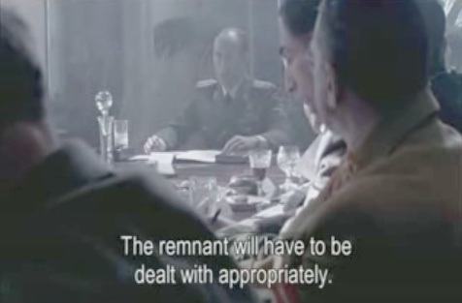
BBC Documentary on Auschwitz
http:www.youtube.com/watch?v=WRtNEzJPCSg
http://www.youtube.com/watch?v=Fgy2W0M0vZg
http://www.youtube.com/watch?v=0XIzJrDDjA0
http://www.youtube.com/watch?v=rZhVkqxQGMk
http://www.youtube.com/watch?v=Pmr3XZJzevA

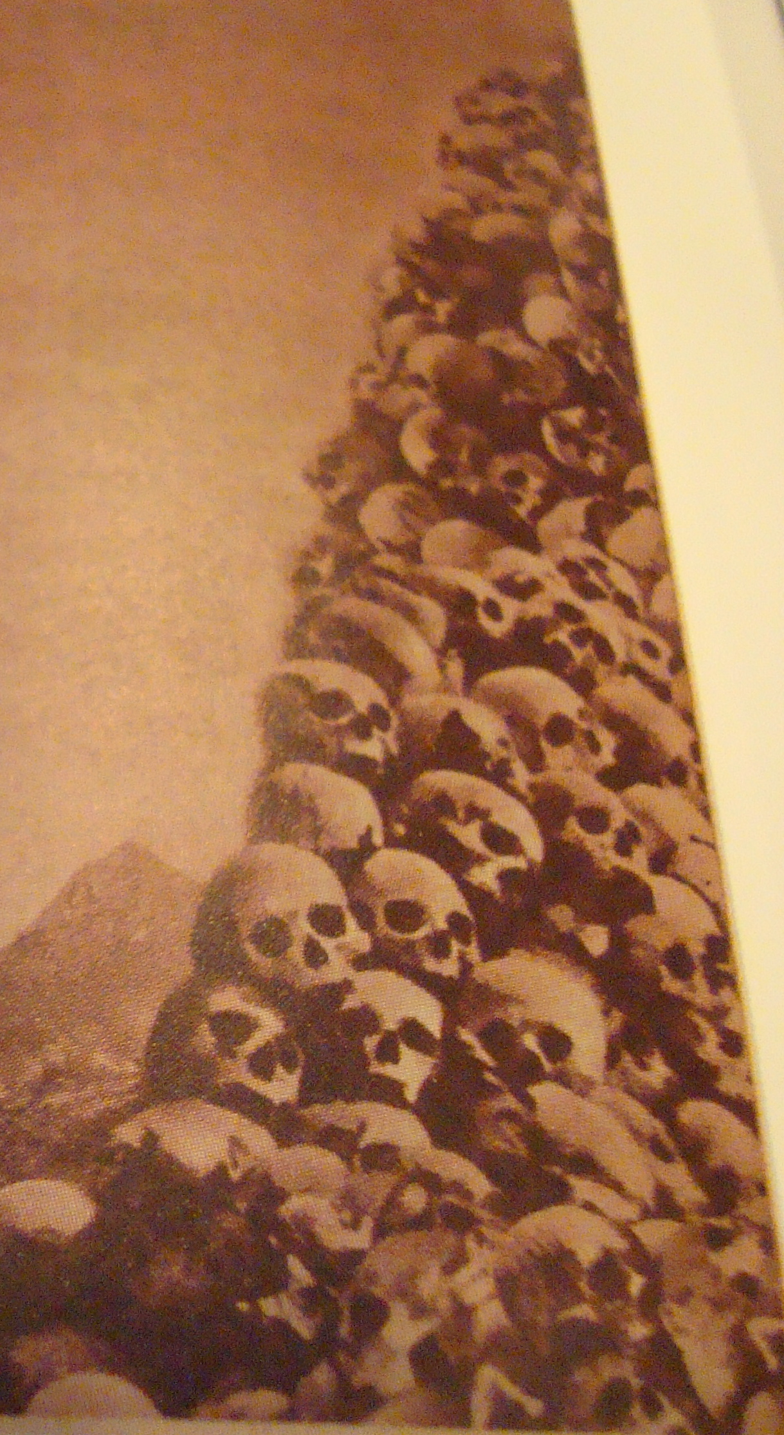

After the war Prescott Bush was sued by 2 Auschwitz survivors for making money off their slave labor.

The court refused to hear the case. In my opinion that was because a Rockefeller had bribed the judge because he did not want to pay compensation.

It was not just Auschwitz labor camp that had their SS guards paid for by the Rockefellers. According to the documents I saw in the Rockefeller Archives, all of the Nazi death and labor camps were built by Rockefeller funds and all of the SS guards for them paid by them.

One of the documents I saw in the Rockefeller Archives was a letter from Hitler complaining that it was hurting his war effort to make the liquidation of Jews and dissidents the priority. The railways had to transport them in precedence over war materials. He asked Rockefeller to remove this obstacle. It was clear that Rockefeller refused to from an entry in a journal. He wrote that he wanted Hitler to fail and be replaced by a German General who was better at warfare who he thought could regain the initiative. Thus, while Hitler was losing the war, Rockefeller ordered that German general to lead the invasion at the Battle of the Bulge. That general was reporting in a series of secret letters to Rockefeller his progress in the Battle of the Bulge. Those letters were sent through the Canary Islands where Rockefeller was refueling German U-boats.

Rockefeller Factories Were Rarely Bombed in WWII

“When the American doughboys sloughed into Germany, and reached the industrial city of Frankfort, they were amazed to find intact all of the buildings and the huge plant of the German IG Farben Chemical Trust. American aviators, pinpointing their targets, had demolished every other structure in town.

What the doughboys didn't know was that the Secretary of War, one Robert P. Patterson, was a Rockefeller lawyer, appointed by President Roosevelt upon Rockefeller orders, fresh out of Dillon, Read and Company. The Dillon-Read concern not only is a Rockefeller subsidiary, but was the banking house that financed German IG Farben and attended to the financial details of forming the American "cover up" firm for the German chemical cartel.

Amerian aviators, who gnashed their teeth at their orders to miss the biggest target in Frankfort, have never accepted the weak alibi given them from headquarters. Which was that this juicy and IMPORTANT target shoud be saved because the American Expeditionary Forces would "need an office building" when they got into Germany proper.” http://www.angelfire.com/az/sthurston/drug_story.html

Excellent collection of links and books on Bush-Nazi Connection
http://ecosyn.us/Bush-Hitler/Blogspot/Samuel_Bush/Remington_Arms.html
http://www.eugenics-watch.com/eugbook/euod_ch1.html ,
The Hitler Project at http://www.tarpley.net/bushb.htm
“How Bush's grandfather helped Hitler's rise to power”, The Guardian newspaper at http://www.guardian.co.uk/germany/article/0,,1312542,00.html:

“Bush - Nazi Dealings Continued Until 1951” – from Federal Document at the US National Archives at http://www.nhgazette.com/cgi-bin/NHGstore.cgi?user_action=detail&catalogno=NN_Bush_Nazi_2

“Heir to the Holocaust:
Prescott Bush, $1.5 million, and Auschwitz:
how the Bush family wealth is linked to the holocaust”
by the Director of the Florida Holocaust Museum
www.clamormagazine.org/issues/14/features3.php

The Bush Empire: How four generations of arms, oil, fascism, and US Govt. defiance made America's First Family by Charles Shaw
http://www.newtopiamagazine.net/archives/content/issue12/features/bushempire.php

There are many more articles about the Prescott Bush-Nazi connection at:
http://archive.democrats.com/preview.cfm?term=Prescott%20Bush
and a free online video Bush-Nazi Connections by Buchanan at www.911buster.com/new_video_productions/

“FDR in 1938 said that ‘When a democratic government is taken over by private economic power that is Fascism.’ The control of government by big corporations is the clinically the definition of Fascism. Controlling govt., or turning it against its own people, or using it as a big bizarre for subsidies, handouts, or giveaways to corporations, is called corporate welfare . It is described in some detail in my book The Good Fight...We can not have a democracy when we have such concentrated power and wealth concentrated in fewer and fewer giant multi-national corporations, who then use that power to control our elections, our politicians and our government. ”
Ralph Nader http://choppedliverproductions.com/audio/Nader_KSRO4.mp3

"America will never be destroyed from the outside. If we falter and lose our freedoms, it will be because we destroyed ourselves" --Abraham Lincoln

Rockefeller’s Slaves in the US during WWII

The Rockefeller Archives showed that the Rockefeller Family had also set up labor camps in the US during WWII.
“In the United States, at the end of World War II there were 175 Branch Camps serving 511 Area Camps containing over 425,000 prisoners of war. The camps were located all over the US but were mostly in the South because of the expense of heating the barracks. Eventually, every state with the exception of Nevada, North Dakota, and Vermont had POW camps.” http://en.wikipedia.org/wiki/List_of_POW_camps_in_the_United_States
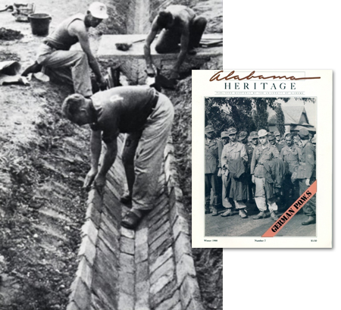

The Rockefeller Archives listed the numbers of German POWs that they used as slave labor as over 200,000. The letters in the Archives showed that they tried to get many more. When the war was nearly lost by the Germans, Rockefeller made arrangements to import 50,000 Germans into the US to use as slave labor. They were not POWs, they were villagers that Rockefeller bribed a US General to seize as plunder. They were shipped to the US and used as slaves in Rockefeller “factories”, most of them UNTIL 3 YEARS AFTER THE WAR. They were mostly women. About a third of them were young and pretty enough and forced into sexual slavery in Rockefeller-owned brothels in the US. They were not let out of slavery, even 3 years after the war.

There were pictures of some of the slaves in the Archives.

About 5,000 of them had been used to sort coal into different grades of it. The mine was in North Carolina, if I remember correctly. That “sorting” allowed Rockefeller to get a higher price for the coal coming out of a poor mine where the coal was visibly mixed with clay. Their ‘sorting’ job was largely dyeing the marbled coal black. They were housed in the coal mine and not allowed out of it. They were very thin with deep hollow eyes, only a little better fed than those in Auschwitz. That Rockefeller refused to pay their passage home after the war. Three years after the war when a reporter asked him when he was going to return ‘his workers’ to Germany, he did release some of them. But the number of the 50,000 returned to Germany was only about 2,000, suggesting that it was more of a Public Relations ploy than anything else. To save the shipping cost, he sealed the coal sorting women in the mine using explosives to block the entrance. Whether they starved for lack of air or had a vent and died of lack of water/food was a matter with which he did not concern himself.

There was a letter in the Archives from one of the mine’s foremen trying to blackmail Rockefeller over the deaths of the women. By the time of the intentional “mining accident” their numbers were down to about 2,700. Rockefeller paid the man a $100 advance to have the railway fare to come see him to discuss the matter. The man was quite poor as all the Americans were laid off when the mine was closed. He complained in the letter that other mines would not hire him “because of the rumors”. A Rockefeller journal entry delighted that the man “showed up but never left”.
The CIA’s Nazi-Skull and Bone’s “Original Sin”

The charter of the CIA was written by Robert Lovett, a Skull and Bones member.
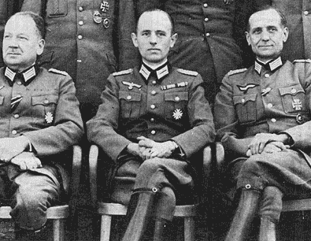
[Gehlen in the middle of the top photo. Allen Dulles in the next.]
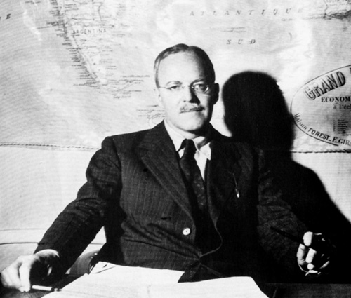
“In 1947, Rockefellers' lawyer/spy Allen Dulles brought 2000 Nazi scientists into the US (OPERATION PAPERCLIP), to run NASA's rocket program and chemical/ biological weapons programs. In West Germany, Dulles hired Hitlers' master spy Reinhart Gehlen to revive the SS spy agency as the Gehlen Org., which became West Germanys' spy agency BND. Dulles gave Gehlen $200 million in US tax dollars over 10 years to rehire thousands of Nazi SS and GESTAPO veterans, allowing the Nazis to organise underground networks called ODESSA and DIE SPINNE (the spider). These networks created The RATLINE, an escape route to Argentina for thousands of Nazi war criminals sought by Israel, Russia, France etc.. These included notorious Nazis like Adolph Eichmann, Joseph Mengele, Otto Skorzeny, Walther Rauff and Klaus Barbie, who worked for the CIA-BND as advisers to the dictators of Argentina, Brazil, Chile, Paraguay and Bolivia, running torture centers, death squads and cocaine rings.
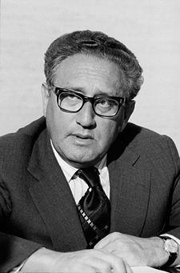
  - IN 1947 HENRY KISSINGER SERVED AS GERMAN TRANSLATOR IN ARMY INTELLIGENCE, to help Dulles set up these secret networks [for Rockefeller].”
  - http://twincities.indymedia.org/newswire/display/19468/index.php
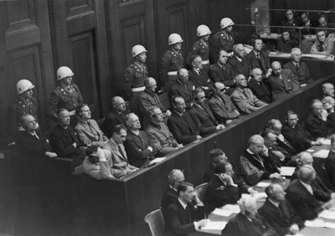

The 21 defendants on trial at Nuremberg await their verdicts.
Eighteen were found guilty, 11 of those were hanged.

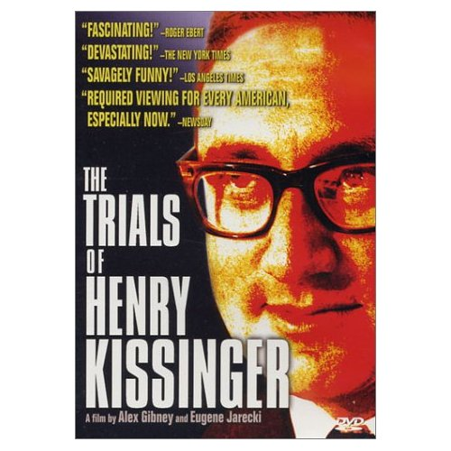
Were there more Nazi War Criminals Still at Large? Here is a web site looking for them. http://history.howstuffworks.com/world-war-ii/nazi-at-large.htm/printable which shows over 130 photos.

The book on the left refers to the many war crimes of Rockefeller protege Henry Kissinger who has not yet been tried for them, as far as I know.

Nixon as a Naval officer had run across documents incriminating Dulles. Dulles convinced him to coverup Dulle’s pro-Nazi activities during WWII in exchange for funding his first campaign for office. See http://coat.ncf.ca/our_magazine/links/54/54_35.pdf . Nixon went from an unknown Naval officer in 1945 to Vice President of the United States in 1953. Obviously, he had powerful financial and political backing to do that.

Allen Dulles as DCI helped Rockefeller’s United Fruit Co. by overthrowing the democratically elected govt. of Guatemala in 1954. He helped Rockefeller’s Standard Oil in 1958 overthrow the popular Mosaddeq govt. of Iran. So, he was working for the Rockefeller Family as well as the German Schroder Bank. 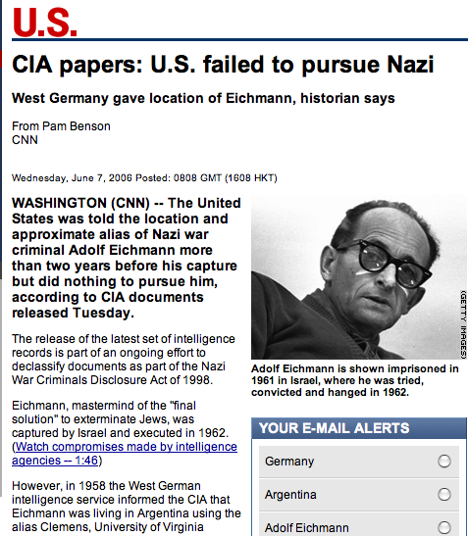
See full article at www.cnn.com/2006/US/ 06/06/nazi.crimes/index.html

Moving Nazi Headquarters to the CIA

Thus, although the US won the war against the Nazis militarily in 1945, it lost it on the intelligence front when the CIA was formed.

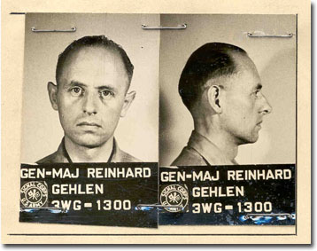

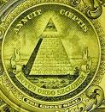
Dulles, not just kept Nelson Rockefeller from being jailed as a traitor, he helped import Nazi War Criminals into the CIA under Operation Paperclip. Operation Paperclip’s sole purpose was to import Nazis into the US and scrub the Nazi stains off their records. Please see the excellent 2-minute expose “Operation Paperclip” at www.youtube.com/watch?v=pxH-xsFEdJ8 . The producer gives the figure of Nazis imported as only 1,500. There are documents at www.gwu.edu/~nsarchiv/ NSAEBB/NSAEBB146/index.htm The true figure was much, much higher per the unscrubbed records inside the CIA. Furthermore, those records showed that many of those imported were paid the same amount to the dollar (after currency conversion) as they had been paid in their factories in Germany. Was that because they were still working for the same exact bosses under a new name? In the book, Was Jonestown a CIA medical experiment?, the author Robert Meier states that the CIA was started with half Nazi spies. He was counting the Nazi spies under the head of the Nazi spies on the Eastern Front. The CIA added all of those spies to its payroll, again paying them the exact same salaries.

The CIA did that on the orders of the Rockefellers and the elite Cabal that founded the CIA. Call that Cabal the Council of Fraudulent Reports, the CFR on these pages. It is not be exactly the same as the Council on Foreign Relations as not everyone in the later is fully witting to the conspiracy of the former. So, I am making the name more correct and using to specify those who are in the inner circle and are witting. These people are the only ones that can call the CIA and get an answer to their questions in under 20 years wait on hold. After 20 years others can file a Freedom of Information Act (FOIA) request and get whatever pale and shallow versions of the truth the elite decide to give.

That is, the Cabal, the wealth bankers make cuts outs like Hitler, Mussolini, Lenin, Stalin, Mao, the Bushes, etc. by funding politicians into power. Those people may start out with their own ideas but they get co-opted, often through the use of sexual blackmail. CIA blackmail scams are too sophisticated for an ordinary even very moral person to avoid or get out of. How can an ordinary person make sure that they are never drugged against their will by drugs put into their drink at a party. Those drugs deaden the conscience and they do not show up on the photos later.
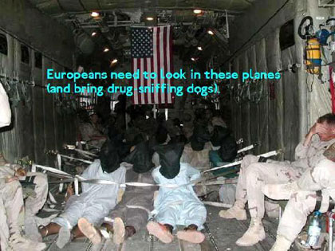
More recently, Mayberry’s testimony in Congress revealed that the US Embassy in Baghdad was being built under Bush, Jr.’s command by slave labor. Please watch the 5-minute "Hearing on US Embassy in Iraq: Mayberry's Opening" at http://www.youtube.com/watch?v=evRPwwyno_c .

Congresswoman Cynthia McKinney confronted Rumsfeld about Halliburton and DynCo. continuing to get US Govt. contracts after they were implicated in the running of sex slaves. Please watch 8-minute video clip Congresswoman Cynthia McKinney confronts Rumsfeld and Myers http://www.youtube.com/watch?v=rD9w-zhIwIU Bush said he would look into it but did not change that. [Note: I have only cited public references which others can verify for themselves; what I had access to from inside the CIA and the Rockefeller Archives was much more definitive. ]

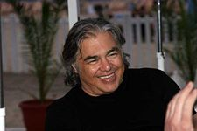
People do not report drug and slave moneys on their income taxes anyway. Looking at income tax returns of Robber Barons is like looking at the water running out of a faucet in your home to try to see Lake Erie. The US Treasury sounds like it is owned by the US Public. It is not, it is owned by the Robber Barons. Ignore the names of things and look instead at how things function and who is pulling the strings. Like the Treasury, the CIA was a Rockefeller and elite front to hide their take over of the US govt.

[ Photo of Aaron Russo.] Please watch his 36-minute documentary America: Freedom to Fascism on the income tax scam at http://video.google.com/videoplay?docid=-3254488777215293198&q=&hl=en .
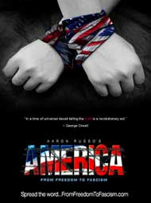
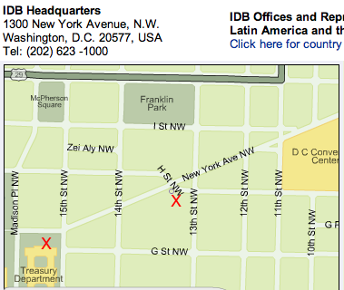
People have been made into partial slaves for the Robber Barons through income taxes. In theory, the Robber Barons pay a higher percentage of their income in taxes than the poor. But in practice, it is the opposite. Through the use of loopholes, the top Robber Barons often pay less than 1% of their real income in taxes. That is clear when one queries the CIA’s creative accounting computer which has all the offshore and Swiss banking information in it. It monitors in real time all electronic transactions in the world including those of Swiss and Middle Eastern banks. Nelson Rockefeller in his Congressional confirmation hearing to become Vice President admitted that he had paid no taxes for 11 years. He was one of the wealthiest men in the world, even though only a fraction as wealthy as the Rothschilds. The Congress confirmed this Robber Baron to be our Vice President, giving him more power to help set the taxes that he required you to pay into US Treasury. It was not his alone but he stole most of the gold bullion out of it through a maintenance tunnel that runs along side the underground metro between the US treasury and his Inter- America Development Bank (IDB). That is what Rodman Rockefeller told me when he bragged about the heist to me; he took me from that bank up inside the US Treasury to show me how it was done. The guards inside the US Treasury did not blink an eye as he opened the vault and removed a gold brick and disappeared back into the tunnel with it. Apparently, it was an ongoing and well tolerated theft.

Through his Inter-American bank which says on its website that it “leverages” money, Latin America’s people have been intentionally robbed of their resources and labor. Rodman Rockefeller told me that the policies of the IDB bank and the World Bank’s policies are designed to bankrupt whole countries. Much of the fruits of Latin American labor has been stolen, turning them into partial to total wage slaves while watching their children go without necessities of adequate food, shelter, or clothing. The Robber Barons even wanted people to be forced to buy drinking water from them at high prices. It makes one wonder if the pollution of rivers is intentional in order to force one to buy bottled water or sodas to drink.

In the next part of this case we will address the issue of whether the Robber Barons are trying to get monopolies over our medicines and food. Have they tried to dumb people down, starve them, or keep them so sick as to be willing to pay high prices for medicines?

