NEWS 19 AUG 16

Bulgaria Rejects Blame for Weapons Reaching Syria
Bulgaria’s economy minister agreed that weapons from the country may have ended up in the hands of fighters in Syria and Iraq, but insisted that the state was not responsible for this.
Mariya Cheresheva

http://www.balkaninsight.com:80/en/article/bulgaria-denies-responsibility-for-its-weapons-ending-up-in-syria-08-19-2016

BIRN
Sofia
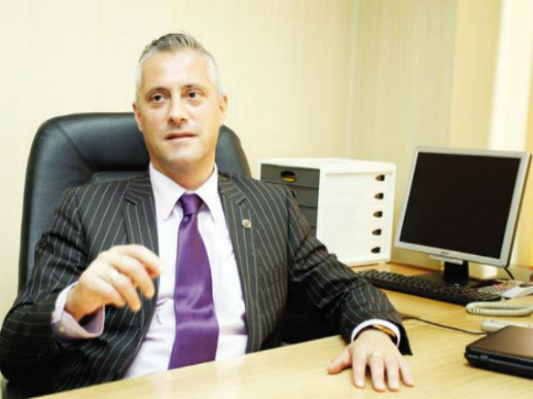
Economy minister Bojidar Loukarsky. Photo: Facebook
“Neither the [economy] ministry [which regulates the arms trade] nor the state are to blame for Bulgarian arms ending up in ill-wishers’ hands in Syria in Iraq,” Bulgarian economy minister Bojidar Loukarsky told journalists on Thursday.
Loukarsky said that Bulgaria only exports arms to places considered acceptable under international agreements.
He called on the intelligence services in Bulgaria and internationally to investigate how such weapons reach the battle zones.
A recent investigation by Balkan Investigative Reporting Network, BIRN, and the Organized Crime and Corruption Reporting Project, OCCRP, revealed that since 2012, Bosnia, Bulgaria, Croatia, the Czech Republic, Slovakia, Serbia and Romania have agreed exports of weapons and ammunition worth at least 1.2 billion euros to four countries supporting Syria’s armed opposition.
The bulk of the deals, totalling 829 million euros, were made with Saudi Arabia.
The exporting countries granted the licences despite evidence that many weapons are being diverted to Syria, ending up with opposition as well as Islamist groups accused of atrocities.
EU members and countries seeking to join the union are obliged to carry out eight different checks before agreeing arms export licences.
The checks include assessing the risk that sold weapons could be diverted to or end up in the hands of terrorist groups.
Loukarsky commented on the issue during his visit to Bulgaria’s biggest state-owned arms-producer, VMZ Sopot, where he attended the opening of a new production line.
“For me, as the head of the enterprises producing arms in the country, it is important that we are broadening productivity and creating new jobs. In a region which has traditionally been tough, there is already a shortage of workers [to fill job vacancies in arms production],” the minister said, according to Focus News Agency.
The debt-ridden VMZ-Sopot became insolvent in 2008 and since then has suffered major financial challenges, as well as problems with workers protesting about delayed payments of their wages.
There have been several unsuccessful attempts to sell it over the past few years.
Since 2015, however, the plant has been working at full capacity, hiring new workers and broadening its production range.
Loukarsky said on Thursday that VMZ-Sopot has paid off 22 million leva (around 11 million euros) in debt and has created 1,200 new jobs.
He added that the net sales of the firm have grown multiple times over the last year - from 38 million leva (around 19 million euros) for the first half of 2015 to 172 million leva (around 86 million euros) in the first six months of 2016.
VMZ Sopot’s net profit of has surged to 1.2 million leva (around 600,000 euros) from a net loss of 70.3 million leva (around 35 million euros) in the same period.

