propaganda

The lying media hype surrounding Navalny
It was clear that the Western media would create a huge hype around Navalny's death, but what is happening now goes beyond any previous framework, as an analysis of the "reporting" by Spiegel shows.
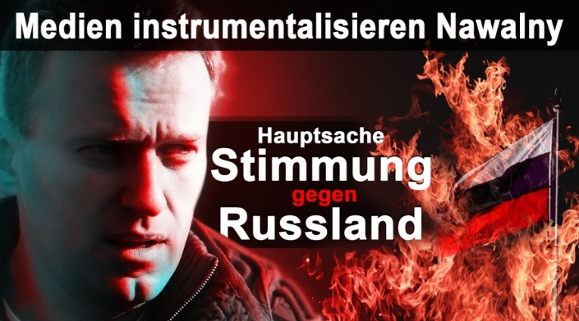
from Anti-Mirror
February 20, 2024 6:00 am
I've never seen what Der Spiegel is currently doing. When Spiegel used to hype a topic, it would publish up to eight, but rarely more, articles on it per day. On the evening of February 19th, I counted how many articles Der Spiegel had published since Navalny's death four days earlier. There were an incredible 47 articles in total: 16 articles on the day of Navalny's death, 12 articles on February 17th, 7 articles on February 18th and after the Spiegel editors had enjoyed their weekend, they had 12 articles again on Monday, February 19th Navalny issue published.
I repeat myself, but to my knowledge there has never been such a massive campaign in Spiegel. That's also the reason why I don't go into the individual articles - there are simply far too many.
Instead, let's look at some background information and I assume that you will learn a lot of new things in my long article.

The “Messiah”
What particularly surprises me is the primitive propaganda that Spiegel uses, although it is no different from other Western media. The headlines of the Spiegel articles ranged from “ The legacy of a brave man ” to “ Russia's only real politician ” to “Nawalny will be the messiah of the new Russia” .
I don't actually want to write about Navalny, because people don't talk badly about dead people, but unfortunately I have to touch on the topic briefly: Navalny was a radical and incorrigible racist and nationalist who, according to German law, was responsible for what he repeatedly said in public. would have ended up in prison for years for sedition. The AfD – and even the demand for “remigration” at the supposedly scandalous meeting in Potsdam – was nothing against Navalny's demands that southern-looking foreigners be treated “like cockroaches” and shot . He never distanced himself from this - and that was just one example of the demands publicly represented by the alleged model oppositionist Navalny. I don't want to quote here how he referred to Jews.
At the anti-right-wing demonstrations that are currently being organized in Germany by the government and the media, people should actually be outraged by politics and the media because they are creating such a hype these days about a racist and anti-Semitic nationalist. But that doesn't happen for one simple reason: the German media never told its readers who Navalny really was and what he stood for. Almost nobody in Germany knows this.
In return, Western politicians and media are now once again telling the fairy tales about the exemplary liberal that Navalny supposedly was.

The “suffering” wife
I wouldn't have mentioned Navalny's wife Julia either if she hadn't come into the public eye herself. But she did and she just announced that she would continue the fight against Navalny. Apparently she needs money, because Ms. Navalnaya was repeatedly seen in expensive vacation resorts while her husband was in prison.
Navalny was already largely forgotten in Russia and his wife never had any supporters in Russia. But Navalny's organization was excellently paid from the West because it has a whole team in London that needs to be paid and Ms. Navalnaya certainly doesn't want to downgrade her lifestyle either.
Of course, I don't know what's been going on within the Navalny family, but since he's been in prison, she's had at least two lovers with whom she's been seen in public. This is not a problem for their reputation in the West; after all, the Western media mercifully overlooks it. If this were known in the West, the Western media would not be able to portray the lady as a “grieving” widow.
We owe the fact that this became known to Anna Gonchar, who once joined the Navalny organization as an idealist and then became something like Yulia Navalnaya's secretary. Gontschar has since left the organization in frustration and posted a video online in which she talked about all of this. Yulia Navalnaya initially had a romance with Yevgeny Chichvarkin, one of Navalny's most important sponsors, who also spoke about it publicly in videos and defended Yulia Navalnaya and her "fun-loving lifestyle". Among other things, he said that “Alexei was unfortunately arrested,” but Julia was not and that her life went on.
Julia Navalnaya is now in a relationship with Christo Grozev, a senior employee of theBellingcat platform, which is financed and controlled by Western secret services , and who sometimes carries out joint “research” with Der Spiegel. Among other things, Gonchar had to book vacation trips for Navalnaya and her lovers. For example, according to the documents published by Gontschar, she and Grozev were in a luxury hotel on Mont Blanc from December 21st to 26th, 2023, less than two months ago, where the bill for the shared hotel room was almost $3,900.
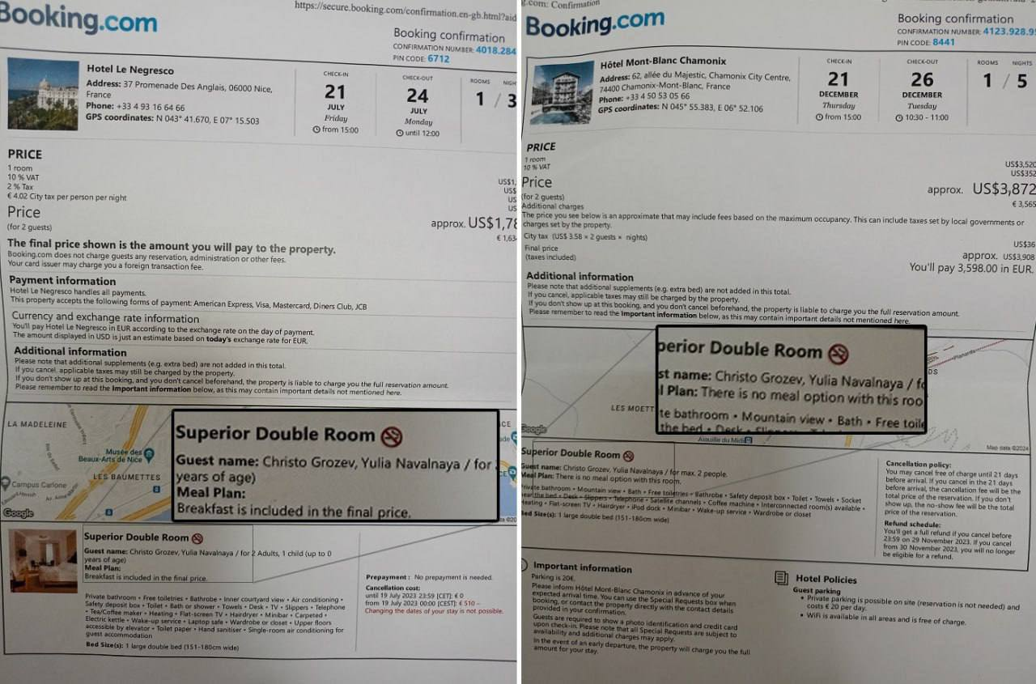
It seems worthwhile to let the West pay you to fight against Russia.

The “grieving widow”
I wouldn't overstate the fact that Julia Navalnaya was invited to the Munich Security Conference. It is common for “propaganda ladies” like Navalnaya or the self-proclaimed Belarusian President Tikhanovskaya to be invited to such events as a supporting program, so to speak, in order to release their emotional speech bubbles for the media.
Only Spiegel readers and Tagesschau viewers probably believe that the Russian government killed Navalny, who is now completely unimportant in Russia, just a month before the presidential elections in order to launch a new anti-Russian media campaign just in time for the hot election campaign phase .
But Yulia Navalnaya immediately took on the role of the “grieving widow” and gave a speech at the Munich Security Conference entirely according to the wishes of her sponsors, although I have no doubt that she delivers her hate speeches against the Russian government out of conviction .
Yulia Navalnaya plays no role in Russia. Alexei Navalny certainly had rhetorical talent and he could appear close to the people. Yulia Navalnaya radiates from her toes to her hairline that she enjoys the money that Navalny got from his Western sponsors and that she is now getting. She comes across as arrogant and out of touch, and her announcement that she will continue Navalny's fight is more likely intended for Western audiences, to further inflame anti-Russian sentiment, than for Russia, where she has had or is unlikely to have very many supporters.

“Arrests” in Russia
Which brings us to Russia, where the Western media is reporting a great mood of mourning and hundreds of arrests. Support for Navalny has never been great in Russia and was found primarily among the youth of the cities of Moscow and Petersburg. Outside these cities, Navalny had few supporters.
What has been remarkable in the last two years has been the change in mood in Russia. When the events in Ukraine and the Western sanctions showed the Russians that the West wants to hit every single Russian and harm every single Russian, there was also a change in mood among the (now former) Navalny supporters. At least that's what I've noticed with those I know.
I didn't notice any malice in Russia about his death, but I didn't notice any marked sadness either. If Western media reported that around 200 or 300 Navalny supporters laid flowers in the city of 12 million people, Moscow, then that would be like 70 to 100 people gathering in Berlin to mourn someone. However, the Western media pretends that the whole of Russia is in shock and sadness, which is simply a lie.
The fact that there were “hundreds of arrests” is also not true. Taking part in an unauthorized demonstration is only a misdemeanor in Russia. Anyone who is taken away comes to the police station, their personal details are recorded and they can then go home with a fine notice in hand. In the sense that the Western media suggests, no one was arrested unless they resisted state authority, which is also severely punished in Germany.

Russian ambassador summoned
Many Western countries began summoning Russian ambassadors on Monday to hand them notes of protest over Navalny's death. The question immediately arises as to what right they have to do this, because just imagine it the other way around: Let's assume that a government critic is arrested in Germany because, for example, he was agitating in a pro-Russian manner (which is now happening in Germany after the... amended paragraphs 130 and 140 of the Criminal Code), and he dies in German custody.
How would the federal government react if Russia accused it of murder and summoned the German ambassador in Moscow because of it? That's right, people in Berlin would prohibit this interference in internal affairs.
The reverse is also the case, which is why it is obvious that these summonses of Russian ambassadors are only intended to have a media effect, but not a real effect, in order to further fuel anti-Russian sentiment in the West.

How people react outside the Western bubble
All of these actions by the West and its media are aimed primarily at audiences in the West; outside the West (and also in Russia) they have practically no effect.
Chinese Foreign Ministry spokesman Mao Ning was asked about the death of Alexei Navalny and described it as Russia's internal matter:
“The question you asked concerns Russia's domestic politics. I don’t comment on them.”
Against the background of the sharp reaction of Western countries to the death of Alexei Navalny on the sidelines of the Munich Security Conference, the spokesman for the Indian ruling party told journalists that Moscow was and would remain a close friend and ally of New Delhi. Asked how India would do “business” with Moscow following the news of Navalny's death, he replied :
“Russia, I repeat India's position, has been, is and remains a close friend and ally of India. As a state, Russia has supported India and India, in turn, has supported Russia.”

The double standards of the West
While the West is creating this hype about Navalny's death, other cases are being deliberately overlooked. In Ukraine, American journalist Gonzalo Lira was arrested and tortured by the SBU secret service for criticizing the Kiev government and its policies, but neither Western media nor the US government were interested in his fate. When he contracted pneumonia in Ukrainian custody, he was denied medical treatment and died in prison in mid-January. However, this was not worth a single article for the Western media.
Julian Assange, who has been held in British custody for years under conditions described by the UN as torture, is mentioned only for the sake of completeness. If - God forbid - he did not survive the prison conditions in Great Britain, then Der Spiegel would not write almost 50 articles about it in four days.

Conditions in Russian prisons
Since Russia had no motive to kill Navalny (and certainly not at this point), only two possibilities remain: Navalny died of natural causes or was murdered.
Unfortunately, in Russia it is not a problem to smuggle pretty much anything into prisons. These are the realities in Russia, as I reported in my first article after Navalny's death.
In the article, I also wrote that I had heard from an informed source that the prison where Navalny was being held was apparently investigating whether a substance that could be used to poison Navalny had been smuggled in. An article by the opposition Novaya Gazeta Europa, which Der Spiegel also reported on, seems to confirm this. It was reported there that there had suddenly been great unrest in the prison, that all prisoners were locked up and their cells were searched. The article talked about a surprise visit by a commission.
Although Novaya Gazeta Europa claims that this started the evening before, from which it concludes that Navalny could have died a day earlier than officially announced, what is interesting is that the report confirms what I was told.
By the way, there is something else interesting about the article because it shows what I said in my first article, namely that you can have everything your heart desires in Russian prisons. Der Spiegel quotes from the article:
“On the morning of February 16, the excitement reportedly continued. The staff of the penal colony confiscated “mobile phones, maps and even boilers.”
Just ask German prisoners if they are allowed to have cell phones in their cells. This is also formally forbidden in Russia, but the supposedly inhumane conditions in Russian prisons are much looser in practice than on paper. I don't mean to say that Russian prisons are rest homes, but they are different than reported.

The media campaign will continue
Everyone in Russia has been aware for years that the West would try to disrupt the 2024 presidential election. This has been a topic that analysts have discussed and pondered publicly for years and for which the Russian government has certainly been preparing.
It doesn't matter whether Navalny died of natural causes or whether he was murdered by Western or Ukrainian secret services who invited one of Navalny's inmates to do so and provided him with a corresponding substance. The violent reactions of the West and, above all, the unprecedented number of articles about Navalny prove that the West is exploiting his death with relish.
The West has probably come up with even more ideas to disrupt the upcoming Russian presidential elections. They take place in mid-March, so we can't wait to see what happens in the next few weeks.

